


Deliverable 8.1
AURORA
Research & Innovation
Report on the European
Universities Alliances and
their complementarity
to the Aurora Alliance

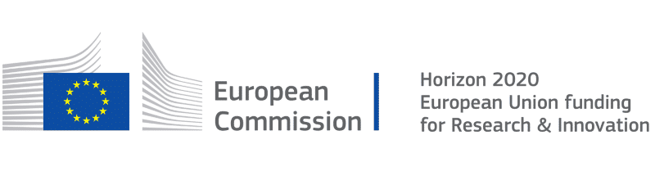
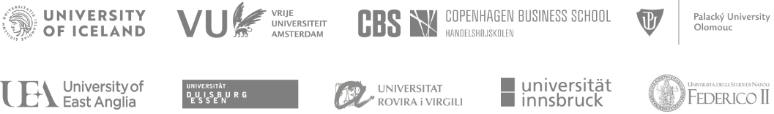

Table of content
1. Analysis Strategy 7
1.1 Introduction 7
1.2 Study purpose 9
1.3 Methodology 10
1.4 Aurora priority domains 10
1.5 Aurora and its members 11
1.6 Aurora KPIs per Academic Staff 12
1.7 Data status used in the analysis 13
2. Complementarities in H2020 projects 14
2.1 Data sources 14
2.2 General information on Aurora's H2020 projects 14
2.3 General information on each Aurora Universities' H2020 projects 17
2.4 PI Collaborations in Aurora H2020 Projects 17
2.5 Participations of each university in each project 20
2.6 Collaborations among Aurora universities in H2020 projects 21
2.7 Collaborations between Aurora and European universities in H2020 projects 22
3. Complementarities in publications 23
3.1 Data sources 23
3.2 Classify publications by domains 23
3.3 SciVal metrics guidance 23
3.4 General information on Aurora publications 25
3.5 General information of each Aurora university publications 28
3.6 Collaborations within Aurora by domains 28
3.7 Map of co-publications within Aurora 31
3.8 Maps of collaborations based on publications within Aurora by SDGs 32
3.9 Aurora collaborations with the other alliances based on co-publications 32
3.10 Details of the top 17 collaborating European Universities Alliances 33
3.11 AURORA SDG Analysis 33
3.12 The European Universities Alliances in the world 34
4. Conclusions 36
5. Annexes 40
ANNEX 1 - COMPARISON AMONG Aurora UNIVERSITIES 40
Copenhagen Business School – PIC: 998706666 46
Palacký University Olomouc – PIC: 999649506 50
Universidad Rovira i Virgili – PIC: 999880560 54
University of Duisburg-Essen – PIC: 999843312 58
University of East Anglia – PIC: 999985611 62
University of Iceland – PIC: 999884246 66
University of Innsbruck – PIC: 999869114 70
University of Naples Federico II – PIC: 999976590 74
Vrije Universiteit Amsterdam – PIC: 954530344 78
ANNEX 3 – Comparation among Aurora Universities publications 82
ANNEX 4 – Comparation among Aurora Universities publicacions by clusters 84
ANNEX 5 - General information of each AURORA university publications 85
Copenhagen Business School 87
Palacký University Olomouc 90
Universidad Rovira i Virgili 93
University of Duisburg-Essen 96
University of East Anglia 99
University of Iceland 102
University of Innsbruck 105
University of Naples Federico II 108
Vrije Universiteit Amsterdam 111
ANNEX 6 - Map of collaborations in publications within Aurora by SDGs 114
ANNEX 7 - Aurora collaborations with the other alliances 117
ANNEX 8. Details of the top 17 collaborating European Universities Alliances 119
ANNEX 9. AURORA PUBLICATIONS BY DOMAINS 137
ANNEX 10. AURORA COLLABORATIONS BY DOMAINS 139

List of figures and tables
Fig. 1 – Work Packages organization 8
Fig. 2 – Used data sources and questions 10
Fig 3 - SDGs Distribution by Aurora domains 11
Fig 4 - Aurora Alliance partners’ map 12
Fig 5 - Teaching and research staff for each Aurora University 12
Fig 6 – Aurora KPI per Academic Staff 13
Fig 7 - General information on the Aurora H2020 projects 14
Fig 8 - Evolution of Aurora funding in H2020 15
Fig 9 - Aurora H2020 funding by fields of science 15
Fig 10 - Aurora H2020 funding by type of action 16
Fig 11 - Aurora H2020 funding by pillar or thematic priority 16
Table 1 – H2020 projects data with Aurora collaborations 18
Fig 12 – Number of collaborations in Aurora H2020 Projects 19
Fig 13 - Collaborations of Aurora universities in H2020 projects 20
Fig 14 - Collaborations among Aurora universities in H2020 projects 21
Fig 15 - Collaborations between Aurora and European universities in H2020 projects 22
Fig 16 - General information on Aurora publications 26
Fig 17 – Individual Aurora publications by topic clusters 27
Table 2 – Co-publications within Aurora Universities 29
Fig 18 - Map of co-publications within Aurora 31
Fig 19 – Number of co-publications and authors with other alliances 32
Fig 20 – Number of publications by SDGs 33
Fig 21 – Heat map and top authors, fields and topic cluster in Aurora collaborations 34
Fig 22 - Map of the world’s universities by scientific production and impact. 2015-19 (annual average) 35
Fig 23 - Global position of the Aurora universities in world university rankings 35
Fig 24 – Comparison of H2020 projects among Aurora universities 40
Fig 25 – Comparison ERC projects among Aurora universities in H2020 41
Fig 26 – Comparison MSCA projects among Aurora universities in H2020 41
Fig 27 - Comparison FET and INFRA projects among Aurora universities in H2020 42
Fig 28 - Comparison Pillar II projects among Aurora universities in H2020 43
Fig 29 - Comparison Pillar III projects among Aurora universities in H2020 44
Fig 30 - Comparison other projects among Aurora universities in H2020 45
Fig 31 – Number of Scholarly Output of each Aurora University 82
Fig 32 – Scholarly output relative by research staff 83
Fig 33 - Number of publications with corporates 83
Fig 34 – Aurora Universities publications by topic clusters 84
Fig 35 – Map of collaborations in publications within Aurora 114
Fig 36 - Map of collaborations within Aurora by groups of publications 115
Fig 37 - Map of collaborations within Aurora by SDGs 116
Fig 38 – Number of co-publications and authors with other alliances 117
Fig 39 – Number of views and citations in co-publications with other alliances 118
Fig 40 – Number of views and citations per publication in co-publications with other alliances 118
Fig 41 – Number of Field-Weighted View Impact and Field-Weighted Citation Impact in co-publications with other alliances 119
Fig 42 – Details of the collaboration between Aurora and 4EU+ Alliance 120
Fig 43 – Details of the collaboration between Aurora and ARQUS European University Alliance 121
Fig 44 – Details of the collaboration between Aurora and CHARM-EU 122
Fig 45 – Details of the collaboration between Aurora and Circle U. 123
Fig 46 – Details of the collaboration between Aurora and CIVIS 124
Fig 47 – Details of the collaboration between Aurora and ECIU 125
Fig 48 – Details of the collaboration between Aurora and ENLIGHT 126
Fig 49 – Details of the collaboration between Aurora and EPICUR 127
Fig 50 – Details of the collaboration between Aurora and EUGLOH 128
Fig 51 – Details of the collaboration between Aurora and EUniWell 129
Fig 52 – Details of the collaboration between Aurora and EuroTeQ Engineering University 130
Fig 53 – Details of the collaboration between Aurora and EUTOPIA 131
Fig 54 – Details of the collaboration between Aurora and FORTHEM 132
Fig 55 – Details of the collaboration between Aurora and NeurotechEU 133
Fig 56 – Details of the collaboration between Aurora and UNA Europa 134
Fig 57 – Details of the collaboration between Aurora and UNIC 135
Fig 58 – Details of the collaboration between Aurora and YUFE 136
Fig 59 – Heat map and top authors, fields and topic cluster in Aurora collaborations by domain 1 139
Fig 60 – Heat map and Aurora collaborations by domain 1 139
Fig 61 – Heat map and top authors, fields and topic cluster in Aurora collaborations by domain 2 140
Fig 62 – Heat map and Aurora collaborations by domain 2 140
Fig 63 – Heat map and top authors, fields and topic cluster in Aurora collaborations by domain 3 141
Fig 64 – Heat map and Aurora collaborations by domain 3 141
Fig 65 – Heat map and top authors, fields and topic cluster in Aurora collaborations by domain 4 142
Fig 66 – Heat map and Aurora collaborations by domain 4 142

Executive summary
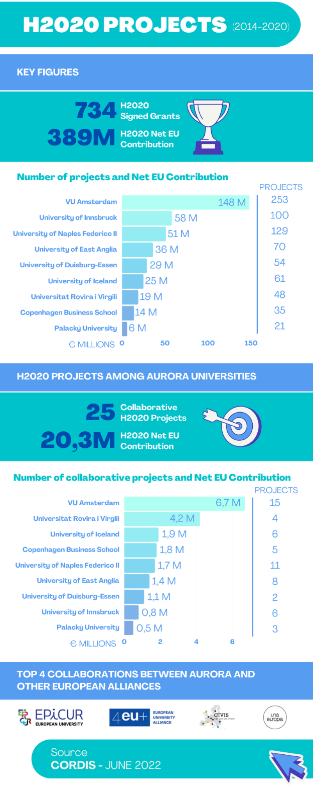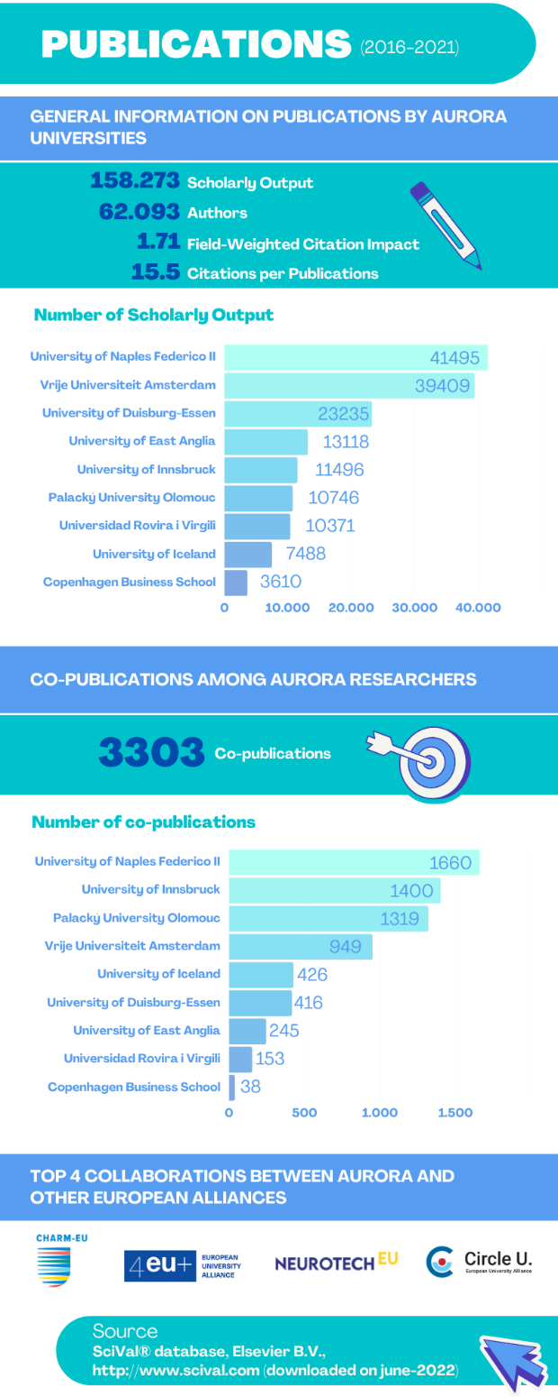

The brief schematic overview points out that the nine Aurora universities obtained over 2% of the signed H2020 grants and almost 0.6% of the total H2020 budget, predominantly in the natural and social sciences. In total, Aurora Alliance universities collaborate(d) in 25 H2020 projects in different constellations. Most of the collaborations in H2020 projects of Aurora universities were seen with universities of the Epicur, 4EU+, CIVIS and UNA Europa alliances. Regarding publications (also beyond H2020 project results) Aurora universities perform above global average (SciVal-derived field weighted citation impact 1.78%: the output is 78% more cited than expected according to the global average). Most of the co-publications were done with universities in the Charm-EU, 4EU+, Neurotech-EU and Circle U alliances. As this is the first measurement moment, it can be regarded as a zero-time point. Performance and collaborations can and will be followed up regularly, and internal and external effects of the collaboration in an Aurora Alliance setting can be monitored.

1. Analysis Strategy

1.1 Introduction

PROJECT ABSTRACT

The AURORA RI project develops closer research and innovation support structures to complement the excellent research and innovation activities within the Aurora Alliance, a European Universities Initiative funded by the European Commission. It will further deepen and expand the cooperation among these universities and strengthen their identity as research-intensive universities dedicated to societal impact and engagement. The aim of AURORA RI is to develop a research and innovation support agenda framed by the SDGs and based on the four priority domains of the Alliance:

- Sustainability and Climate Change;
- Digital Society and Global Citizenship;
- Health and Wellbeing; and
- Culture, Diversity.

The project focus is to identify and achieve an understanding of best practices and policies on sharing research infrastructure and resources, cooperation on open science and entrepreneurial activity, empowering human capital, and mainstreaming citizen engagement. Throughout the project we analyse and map best practices already in place, learn from each other. We define barriers to cooperation at national and international level and find ways to overcome them where possible. The findings will create the basis for our R&I support agenda and will be shared with the other European Universities and beyond. The actions implemented during the project period aim at creating a platform for cooperation that will sustain beyond the lifetime of the project and equip researchers and students at Aurora Alliance Universities with a broad toolkit to conduct excellent research and disruptive innovation.

Grant Agreement ID: 101035804
Project Title: Aurora Alliance - Research and Innovation for Societal Impact
Project Acronym: AURORA RI
Coordinated by: University of Iceland
Funded under: SCIENCE WITH AND FOR SOCIETY
Project Start Date: 1 October 2021; End date: 30 September 2024
Related work package: WP 8: Learning and sharing with other European Universities
Lead Organisation: Lead by Universitat Rovira i Virgili (URV)
AURORA RI WORK PACKAGES
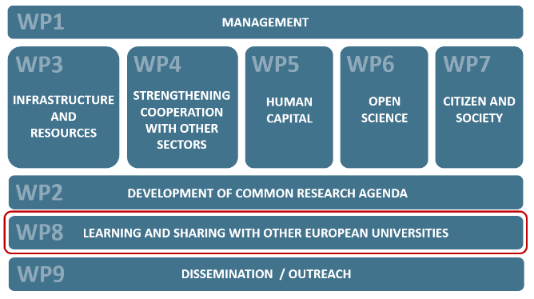
Fig. 1 – Work Packages organization

WP8 OBJECTIVES
Objectives
As a principle, we aim to share the deliverables and outcomes of our project with all other 40 European University Alliances. We will also follow the outcomes of the other Alliances and take on board beneficial results and best practices.

In practice, we will develop intensive collaboration with those European University Alliances through the Forum of European Universities #2 (FOREU2). To achieve these aims participation in and organisation of matchmaking events and workshops will be undertaken using the FOREU2 platform. This will lead to deeper collaboration where we can share our work and integrate further with the alliances that share our vision and objectives.

Aurora has a semi-permanent presence in Brussels, which will also serve as a key link with the other European Universities, the EU institutions and other stakeholders in the European Research and Education Areas.

As a starting point, we assume broad interest in collaboration with those Alliances that are built around the same or similar priority domains and are focused on a comprehensive approach to achieving societal impact.

OBJ8.1 The first objective of WP8 is to seek for further cooperation with the other European Universities through our participation in the Forum for European Universities #2.

OBJ8.2 The second objective is to exchange ideas and best practices with alliances that share our vision through FOREU2, with the goal to facilitate further and deeper collaboration on all levels of our institutions and alliances when beneficial.

WP8 TASKS

Task 8.1. – Participation in FOREU2
Task 8.2. – Comparing European University Alliances and Aurora Alliance
Lead: URV, participants: all
This task will focus on the criteria for comparing other European Universities to the Aurora Alliance, which are also the main criteria for synergy among Aurora partners. The criteria will involve research, innovation and infrastructure objectives; Taking these criteria as a base, the Aurora Alliance will then analyse other alliances, both in FOREU2 and FOREU. This analysis will start by exploring the established contacts each Aurora partner already has with members of other alliances (such as, scientific publications and European Projects), and then widen the net to all alliances. The analysis will also consider diversity, including culture and what other alliances are doing that could benefit Aurora’s objectives. This task will lead to a comprehensive dataset on European Universities and their complementarities to Aurora.
Task 8.3. – Reporting the lessons learned from cooperating with other European Universities and writing of roadmap

WP8 DELIVERABLES

D8.1: A report on the European Universities Alliances and their complementarity to the Aurora Alliance [12] (URV)
D8.2: First FOREU2 report [24] (UIce – Aurora)
D8.3: Second FOREU2 report [36] (UIce - Aurora)
D8.4: A roadmap for further collaboration with other European Universities [36] (URV)

1.2 Study purpose

The purpose of the analysis is detecting the universities that can establish complementarities (within Aurora and with the other European Universities Alliances/EUAs). Therefore, it is important to identify the interactions among the universities (in Aurora and in EUAs) in projects and publications.
As a reference, we will take the universities and EUAs that appear in Scival. We are studying 40 (out of 41 Alliances) since the Alliance for common fine arts curriculum (EU4ART) does not appear in SciVal (due to the lack of publications in their database), and its continuation in the 2022 Erasmus+ round for EUAs was not approved.

1.3 Methodology

The used methodology consists in studying of H2020 projects (CORDIS) and publications (SciVal) to answer these questions.
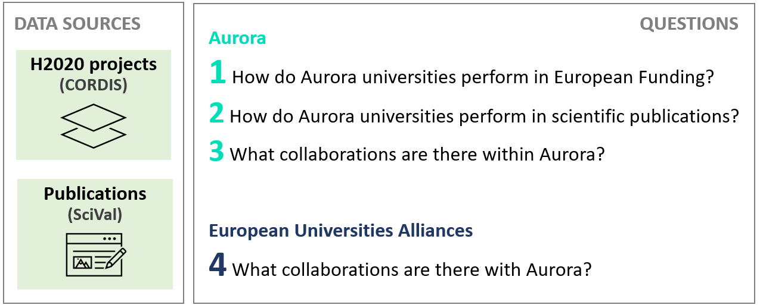
Fig. 2 – Used data sources and questions

The AURORA SDG Analysis is also used to obtain information on the publications of Aurora members related to the SDGs.

SciVal is an online tool that offers quick, easy access to the research performance of research institutions and nations worldwide using bibliometrics. It enables you to visualize research performance, benchmark relative to peers, develop collaborative partnerships and analyse research trends. The data source for SciVal metrics is the Scopus database.

1.4 Aurora priority domains

The aim of AURORA RI is to develop a research and innovation support agenda framed by the SDGs and based on the four priority domains of the Alliance. Therefore, we agreed to initially distribute the 17 SDGs within the Aurora 4 domains, and we will use this distribution for several data analysis (shown in this report).

SDGs distribution by domains
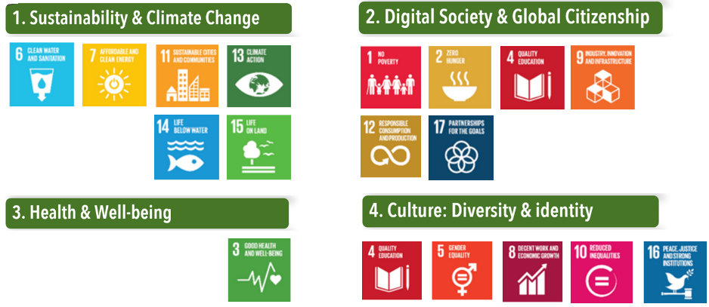
Fig 3 - SDGs Distribution by Aurora domains

1.5 Aurora and its members

The European Commission initiative to develop the European Education Area (EEA) with the aim of revolutionising higher education in Europe has called for the creation of European Universities with a call under the Erasmus+ programme. Aurora Alliance is one of the 24 European University Networks (or EUAs) selected in the second call in 2020. Aurora Alliance is built on the Aurora Universities Network, which was founded in 2016.
Aurora is a membership association of research-intensive universities deeply committed to societal impact and with a long history of engagement with their communities. The funding from the European Universities initiative through the Erasmus+ programme will support the alliance to continue the journey and set the Aurora Alliance on the path towards implementation of Aurora Network strategies and further collaboration between Aurora Alliance partners. Each university within the Alliance is fully committed to this journey, and the current proposal for the research and innovation dimension of our alliance, will further solidify our cooperation. The proposal focuses on aligning and developing the support for research and innovation with a focus on the achievement of Sustainable Development Goals, through the four specific priority domains of i) Sustainability and Climate Change, ii) Digital Society and Global Citizenship, iii) Health and Wellbeing, and iv) Culture, Diversity and Identity. These domains are fully in line with our cooperation under the Erasmus+ programme and the EC priorities under the forthcoming Horizon Europe programme and the UN Sustainable Development Goals (SDGs). They are also in line with the policy initiatives linked to the European Research Area (ERA) and European Digital Strategy.
Aurora Alliance, as shown in Figure 4, is constituted by nine (beneficiary) European universities and five associated universities, distributed around Europe.
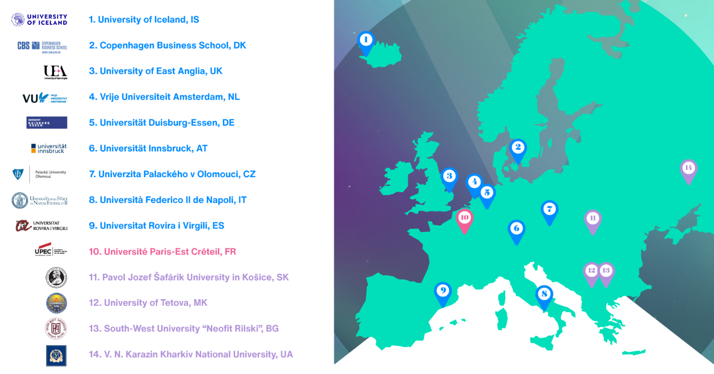
Fig 4 - Aurora Alliance partners’ map

1.6 Aurora KPIs per Academic Staff

In order to give more information on Aurora Alliance and to properly locate and compare our unviersities, the following KPIs are presented
DATA INFORMATION
data | Aurora Academic Staff
sources | SQ 2022 – Scival - cordis.europa.eu
data processing | Data on students and teaching and research staff (in full-time equivalents) are obtained from QS World University Rankings (2022 edition), except for the University of Iceland and the Copenhaguen Business School which are obtained from institutional websites.  The average number of annual publications is obtained from SciVal for the 2016-2020 period. Finally, the funds raised in the H2020 Programme are obtained from CORDIS for the 2014-2021 period (as of Febreary 2021).

Number of teaching and research staff (in full-time equivalents) for each Aurora Alliance University
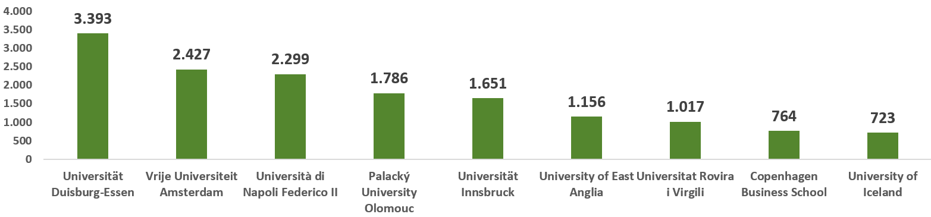
Fig 5 - Teaching and research staff for each Aurora University
The numbers in figure 5 do not necessarily reflect the extent of a university with respect to research or education. Therefore, these data were normalised as presented in figure 6.
Normalised data
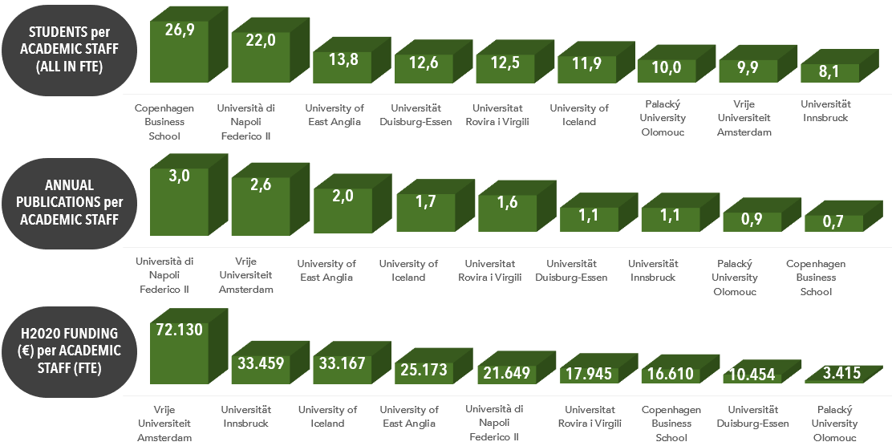
Fig 6 – Aurora KPI per Academic Staff

1.7 Data status used in the analysis

1 | H2020 projects participations (CORDIS)
There are 176,512 participations. File downloaded in January 2022.
2 | SciVal
40 alliances present in SciVal.
Alliance for common fine arts curriculum (EU4ART) isn’t included in SciVal because they do not have enough publications.
3 | 9 Aurora Alliance universities
Own excel file with Participant Identification Code (PIC) and Name.
4 | 40 European Universities Alliances
Own excel file with Acronym, name of alliance, organizations involved as full partner, country and PIC. For this analysis, we take SciVal's composition of the alliances.
5 | SDG Analysis: Bibliometrics of Relevance
https://bit.ly/aurora-sdg-dashboard-v4

2. Complementarities in H2020 projects

2.1 Data sources

1 | H2020 projects participations (CORDIS) - File downloaded in January 2022.
2 | 9 Aurora Alliance universities
Own excel file with PIC and Name.
3 | 40 European Universities Alliances
Own excel file with Acronym, name of alliance, organisations involved as full partner, country and PIC – Total 296 universities

2.2 General information on Aurora's H2020 projects

DATA INFORMATION
data | Aurora H2020 projects
source | cordis.europa.eu
download date | June 2022
data processing | Aggregated data from the 9 Aurora universities.  Graphics provided by CORDIS dashboard.

General information on H2020 projects obtained by the Aurora Alliance universities to have an overview of the alliance.
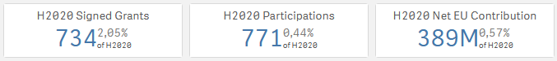
Fig 7 - General information on the Aurora H2020 projects

Figure 7 points out that the 9 Aurora Alliance universities were engaged in 1 out of 50 H2020 grants signatures, and got almost 0.6% of the total H2020 budget for their projects.
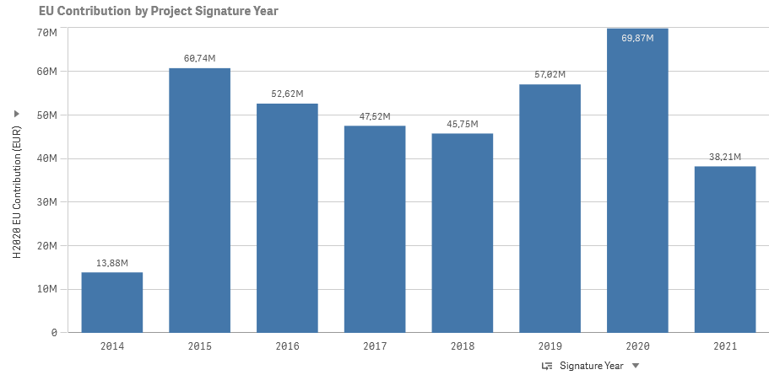
Fig 8 - Evolution of Aurora funding in H2020

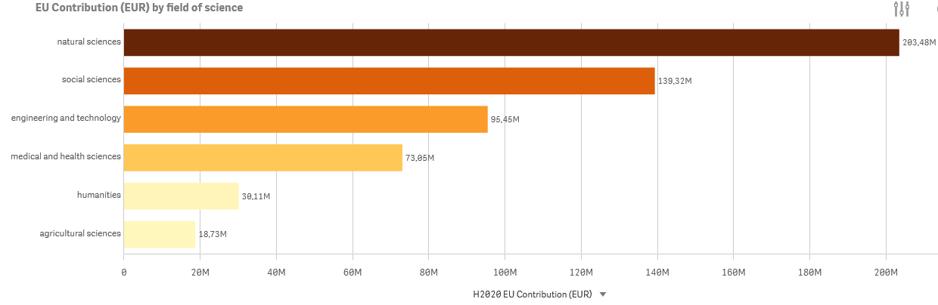
Fig 9 - Aurora H2020 funding by fields of science
Figure 9 demonstrates that Aurora Alliance universities obtained most of the H2020 budget in the field of natural and social sciences, and the least in humanities and agricultural sciences.
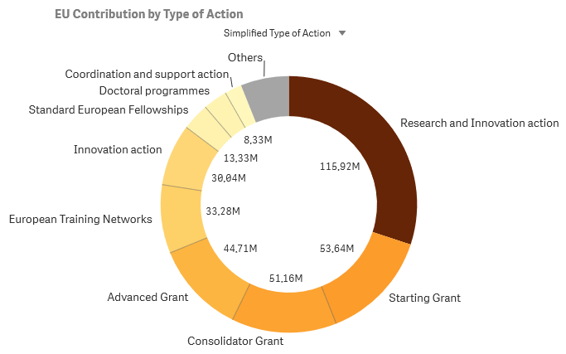
Fig 10 - Aurora H2020 funding by type of action
Figure 10 shows that the distribution of the obtained H2020 budget was approximately equally divided over ERC (individual) grants, RIA actions (collaboration), and other actions including MSCA and IA actions. Figure 11 points out that for collaborative actions the emphasis was on health-related and environmental topics, and to a lesser extent food, energy, societal, innovative and digital studies.

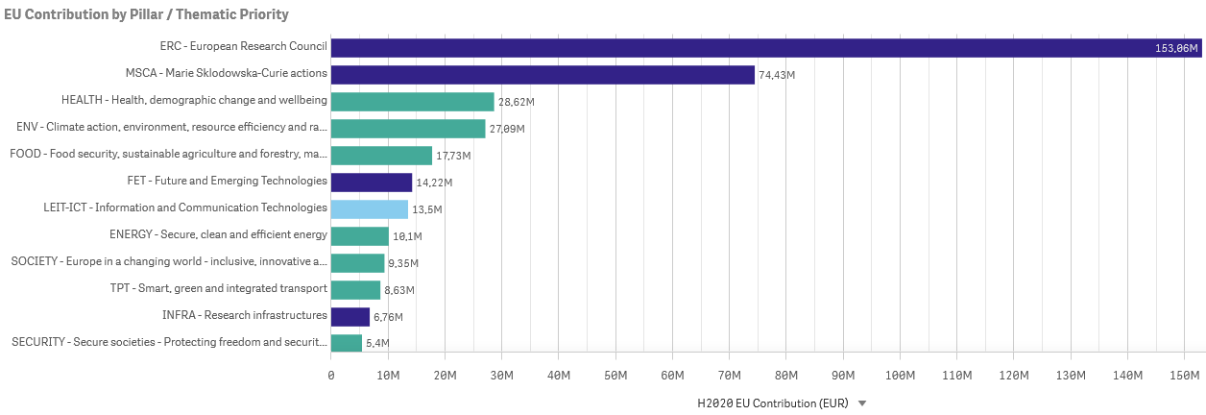
Fig 11 - Aurora H2020 funding by pillar or thematic priority

COMPARISON AMONG Aurora UNIVERSITIES

DATA INFORMATION
data | Aurora universities H2020 projects
source | cordis.europa.eu
download date | June 2022
data processing | Own graphics created with downloaded data from CORDIS
See this information in Annex 1.

2.3 General information on each Aurora Universities' H2020 projects

DATA INFORMATION
data | Aurora universities’ H2020 projects
source | cordis.europa.eu
download date | June 2022
data processing | Data from the 9 Aurora universities.  Graphics provided by CORDIS dashboard.

See this information in Annex 2.

2.4 PI Collaborations in Aurora H2020 Projects

DATA INFORMATION
data | Aurora universities collaborations in H2020 projects
source | cordis.europa.eu
download date | December 2021
data processing | Data from the 9 Aurora universities.  Own table created with CORDIS data.

Table of H2020 Projects in which Aurora universities have collaborated, classified by domain.
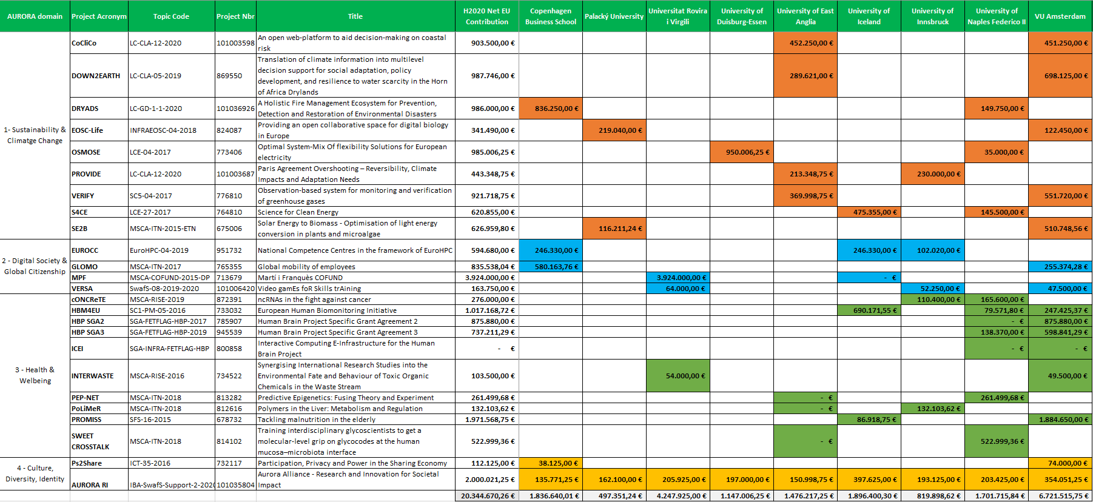
Table 1 – H2020 projects data with Aurora collaborations

Number of H2020 Projects and funding in which Aurora universities have collaborated, classified by domain
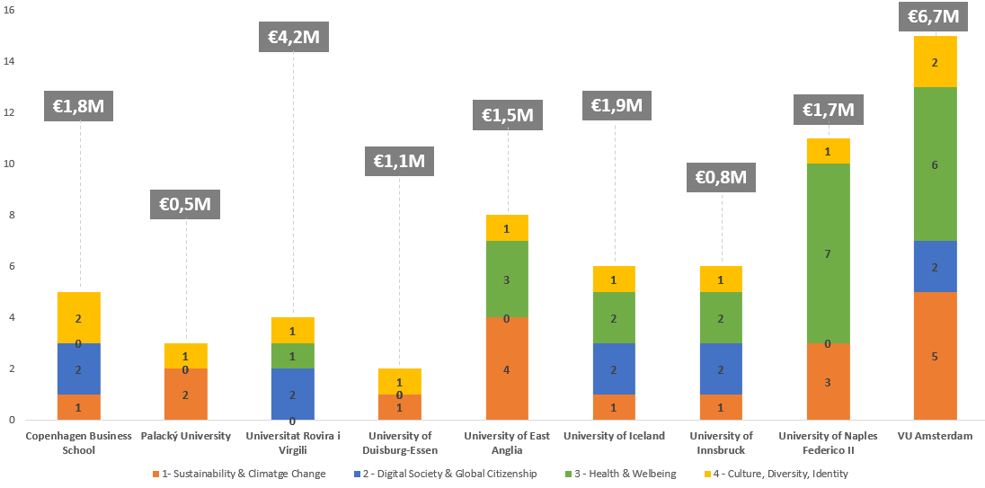
Fig 12 – Number of collaborations in Aurora H2020 Projects

2.5 Participations of each university in each project
DATA INFORMATION
data | Collaborations of Aurora universities in H2020 projects
source | cordis.europa.eu
download date | January 2022
data processing | Data from the 9 Aurora universities.  Own graphic created with CORDIS data.  Only collaborative projects are considered (projects involving more than one Aurora University)
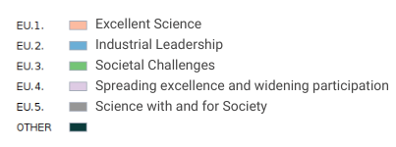
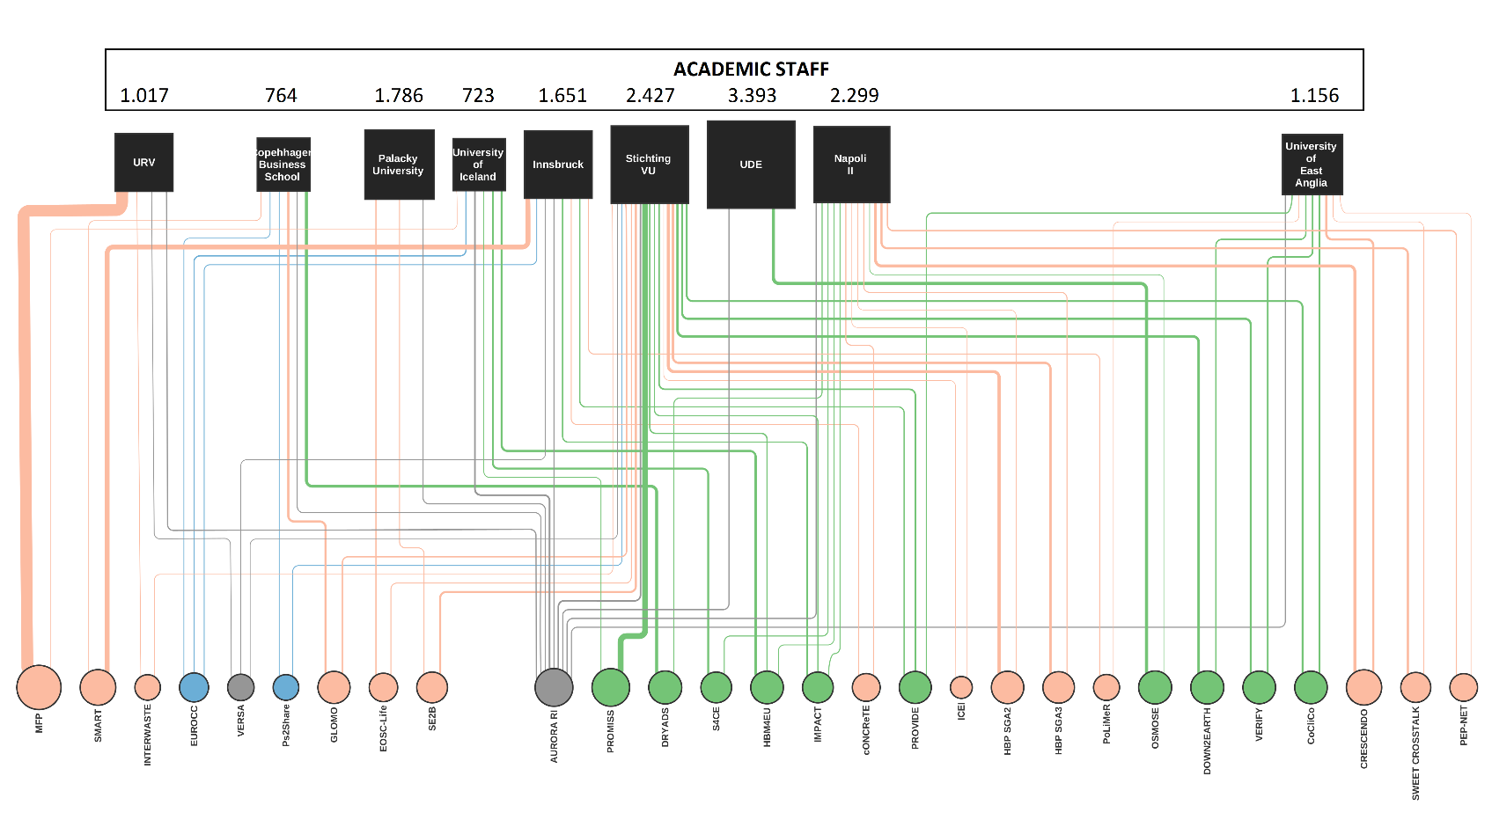

Universities and projects
- The university size (area) is proportional to their Academic Staff.
- The project size (area) is proportional to the funding that they have reported to the Aurora universities involved.
- The thickness of each connection is the contribution to each university of each project.
- The colors are by pillars.
Fig 13 - Collaborations of Aurora universities in H2020 projects

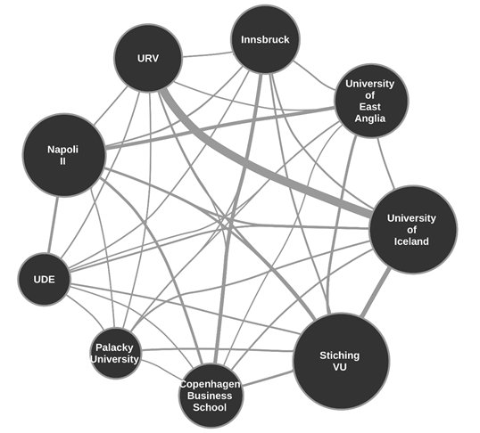
2.6 Collaborations among Aurora universities in H2020 projects
Fig 14 - Collaborations among Aurora universities in H2020 projects
DATA INFORMATION
data | Collaborations among Aurora universities in H2020 projects
source | cordis.europa.eu
download date | January 2022
data processing | Data from the 9 Aurora universities.  Own graphic created with CORDIS data.

Universities network in projects
The node size (area) is proportional to the total funding received by the universities in these collaborations.
The thickness of the connections is proportional to the total funding received by the two corresponding universities in these collaborations.

2.7 Collaborations between Aurora and European universities in H2020 projects
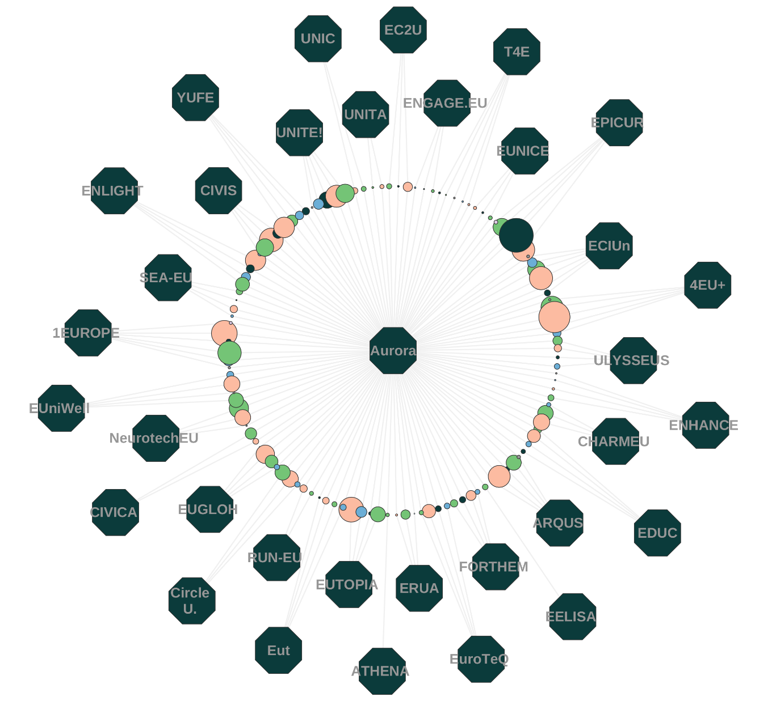
DATA INFORMATION
data | Collaborations between Aurora and European universities in H2020 projects
source | cordis.europa.eu
download date | January 2022
data processing | Data from the 40 European universities.  Own graphic created with CORDIS data.  Only collaborative projects are considered (projects involving more than one European University)

European Universities collaborations with Aurora
- The colours are by pillars.
- The circle size is aggregated project funding by H2020 pillars.
EPICUR and 4EU+ stand out for their collaborations with Aurora universities.

Fig 15 - Collaborations between Aurora and European universities in H2020 projects

3. Complementarities in publications

3.1 Data sources

1 | SciVal
40 alliances are introduced in SciVal.
Alliance for common fine arts curriculum (EU4ART) isn’t included in SciVal because they haven’t enough publications.
2 | 9 Aurora universities
Own excel file with PIC and Name.
3 | 40 European Universities Alliances
Own excel file with Acronym, name of alliance, organizations involved as full partner, country and PIC. For this analysis we take SciVal's composition of the alliances.
4 | SDG Analysis: Bibliometrics of Relevance
https://bit.ly/aurora-sdg-dashboard-v4

3.2 Classify publications by domains

Classifying by the Scival subject areas by the 4 domains.
1 | SUSTAINABILITY AND CLIMATE CHANGE | 2 | DIGITAL SOCIETY & GLOBAL CITIZENSHIP | 3 | HEALTH AND WELLBEING | 4 | CULTURE: DIVERSITY & IDENTITY
- Agricultural and Biological Sciences  - Earth and Planetary Sciences  - Environmental Science | - Computer Science  - Decision Sciences | - Biochemistry, Genetics and Molecular Biology  - Dentistry  - Health Professions  - Immunology and Microbiology  - Medicine  - Neuroscience  - Nursing  - Pharmacology, Toxicology and Pharmaceutics  - Psychology | - Arts and Humanities  - Social Sciences

3.3 SciVal metrics guidance

Scholarly Output in SciVal indicates the prolificacy of an entity: how many publications does this entity have indexed in Scopus?
Citation Count in SciVal indicates the total citation impact of an entity: how many citations have this entity’s publications received?
SciVal often displays Citation Count in a chart or table with years. These years are always the years in which items were published, and do not refer to the years in which citations were received.
Citations per Publication in SciVal indicates the average citation impact of each of an entity’s publications: how many citations have this entity’s publications received on average?
SciVal often displays Citations per Publication in a chart or table with years. These years are always the years in which items were published, and do not refer to the years in which citations were received.
Field-Weighted Citation Impact (FWCI) in SciVal indicates how the number of citations received by an entity’s publications compares with the average number of citations received by all other similar publications in the data universe: how do the citations received by this entity’s publications compare with the world average?
Be careful using this metric when the entity (e.g. a Researcher) has a small number of publications. A few highly cited publications can skew the FWCI value.
A FWCI of 1.00 indicates that the entity’s publications have been cited exactly as would be expected based on the global average for similar publications; the FWCI of “World”, or the entire Scopus database, is 1.00.
A FWCI of more than 1.00 indicates above the global average for similar publications; for example, 2.11 means 111% more than the world average.
A FWCI of less than 1.00 indicates below the global average for similar publications; for example, 0.87 means 13% less than the world average.
Similar publications are those publications in the Scopus database that have the same publication year, publication type, and discipline, as represented by the Scopus journal classification system. The discipline is defined by the Scopus ASJCs given to an article via the journal in which it is published.
SciVal often displays FWCI in a chart or table with years. These years are always the years in which items were published, and do not refer to the years in which citations were received. The citations received in the year in which an item was published, and the following 3 years, are counted for this metric.
The h5-index uses a 5-year publication and citation window on the standard h-index calculation and can be used to fairly track the metric over time in the Benchmarking module. The h5-index for an entity in 2019 takes the outputs published by that entity from 2015-2019 and the citations received by those outputs in the same time window to form a data set. It then uses the h-index calculation on the data set to compute the h5-index.
H-index gives information about the performance of Researchers and Research Areas. The h-index of an entity is 9 if the top 9 most-cited publications for that entity have each received at least 9 citations; it is 13 if an entity’s top 13 most-cited publications have each received at least 13 citations; and so on.

3.4 General information on Aurora publications

DATA INFORMATION
data | All publication types in all subject areas from 2016 to 2021
source | SciVal® database, Elsevier B.V., http://www.scival.com (downloaded on june-2022)
download date | June 2022
data processing | Graphics provided by SciVal

General information on Aurora universities publications to have an overview of the alliance.
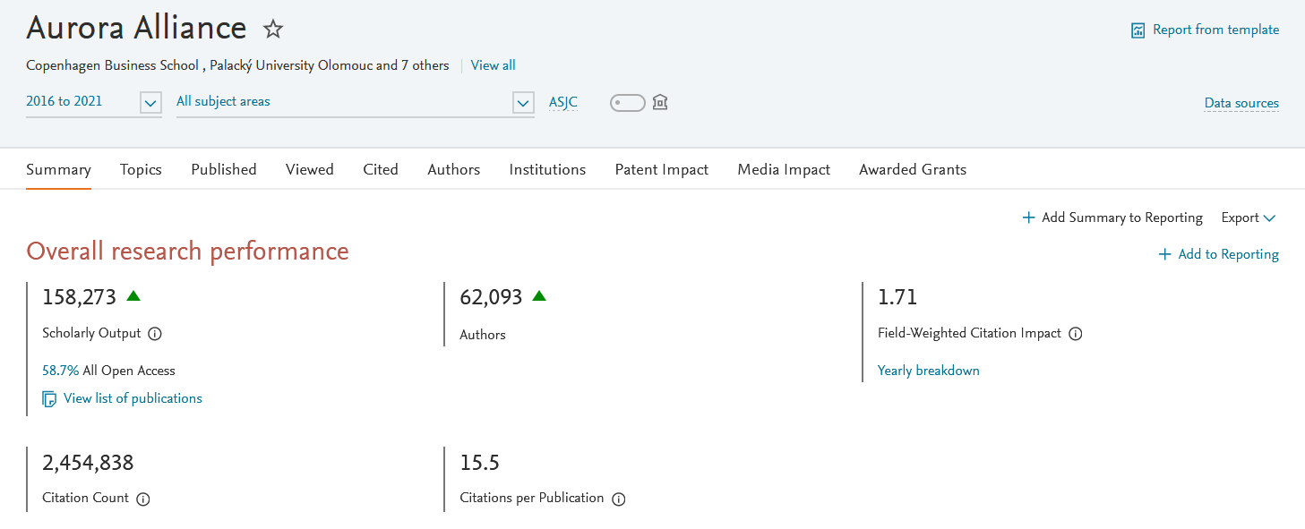
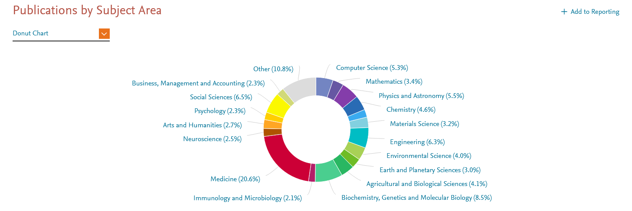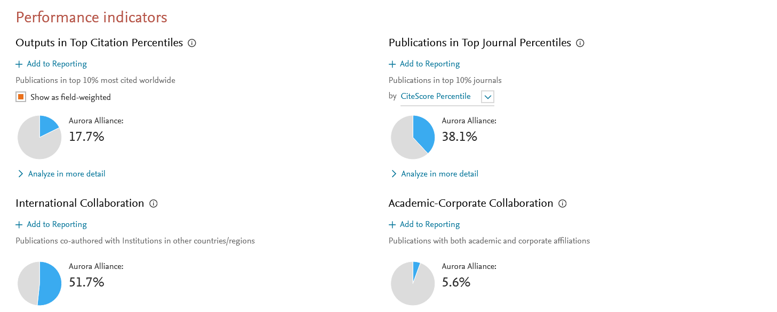
Fig 16 - General information on Aurora publications

COMPARISON AMONG AURORA UNIVERSITIES PUBLICATIONS

DATA INFORMATION
data | All publication types in all subject areas from 2016 to 2021
source | SciVal® database, Elsevier B.V., http://www.scival.com (downloaded on june-2022)
download date | June 2022
data processing | Graphics provided by SciVal.

See this information in Annex 3.

PUBLICATIONS BY TOPIC CLUSTERS
DATA INFORMATION
data | All publication types in all subject areas from 2016 to 2021
source | SciVal® database, Elsevier B.V., http://www.scival.com (downloaded on june-2022)
download date | June 2022
data processing | Graphics provided by SciVal.

Between 2016 to 2021, researchers in the Aurora Alliance have contributed to 1,485 Topic Clusters:
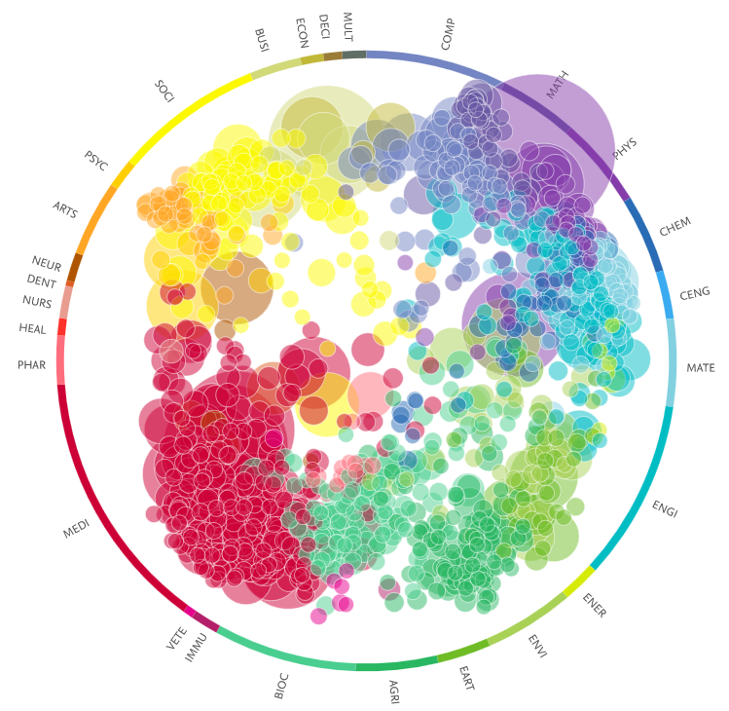
Fig 17 – Individual Aurora publications by topic clusters
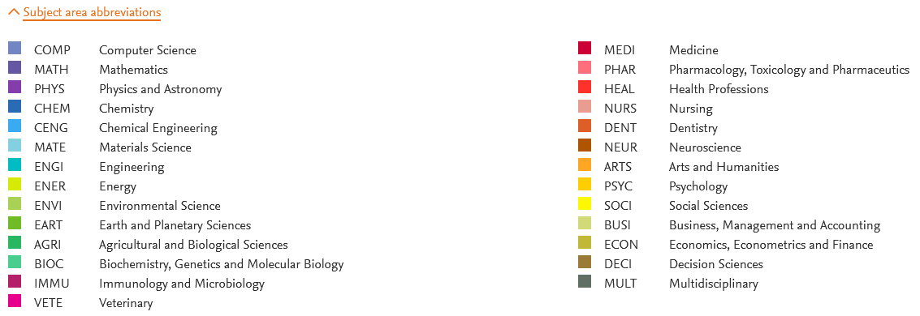
Figure 17 shows a distribution of all publications by individual Aurora universities’ researchers quite evenly over the topic clusters. Some more focus can be seen on natural sciences and (bio)medical and health sciences, and multidisciplinary studies in health-related, natural sciences, social sciences and environmental sciences (centre of circle).
COMPARISON AMONG AURORA UNIVERSITIES PUBLICATIONS BY TOPIC CLUSTERS

DATA INFORMATION
data | All publication types in all subject areas from 2016 to 2021
source | SciVal® database, Elsevier B.V., http://www.scival.com (downloaded on june-2022)
download date | June 2022
data processing | Graphics provided by SciVal.

See this information in Annex 4.

3.5 General information of each Aurora university publications
DATA INFORMATION
data | All publication types in all subject areas from 2016 to 2021
source | SciVal® database, Elsevier B.V., http://www.scival.com (downloaded on june-2022)
download date | June 2022
data processing | Graphics provided by SciVal.
See this information in Annex 5.

3.6 Collaborations within Aurora by domains

DATA INFORMATION
data | All publication types in all subject areas from 2016 to 2021
source | SciVal® database, Elsevier B.V., http://www.scival.com (downloaded on june-2022)
download date | May 2022
data processing | Graphics provided by SciVal.

ALL DOMAINS
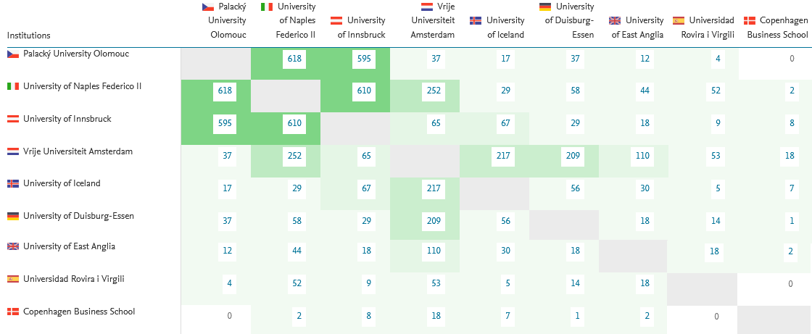
Table 2 – Co-publications within Aurora Universities
Based on co-publications, table 2 (in conjunction with figure 18) points out that of all Aurora universities Naples Federico II, Palacky University and University of Innsbruck seem to collaborate most, followed by VU Amsterdam, University of Iceland and University of Duisburg-Essen.

BY DOMAINS

DATA INFORMATION
data | All publication types in some subject areas (classified by domains) from 2016 to 2021
source | SciVal® database, Elsevier B.V., http://www.scival.com (downloaded on june-2022)
download date | May 2022
data processing | Own graphics created with SciVal data

Domain 1 | SUSTAINABILITY AND CLIMATE CHANGE
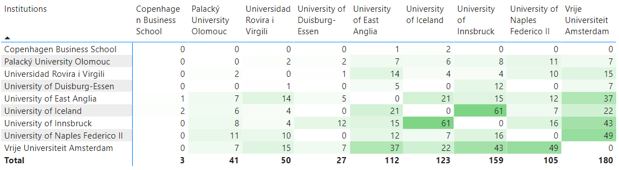

Domain 2 | DIGITAL SOCIETY & GLOBAL CITIZENSHIP
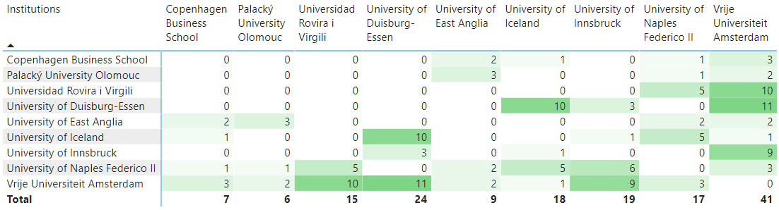

Domain 3 | HEALTH AND WELLBEING
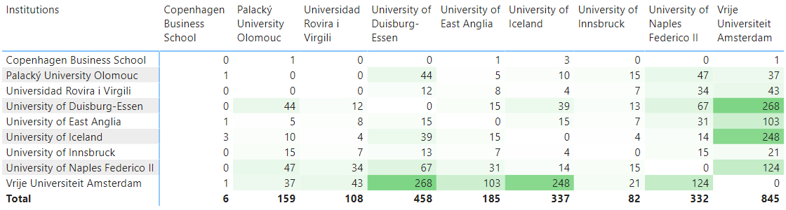

Domain 4 | CULTURE: DIVERSITY & IDENTITY
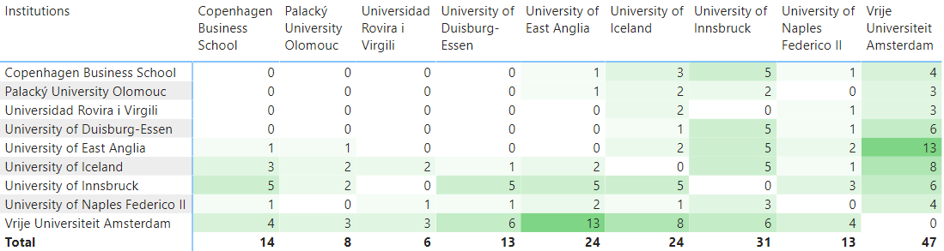

It’s important to take into account that:
- There are publications that may not be in any domain.
- There are publications that may be in more than one domain.
- Publications are resulting not only from H2020 projects.

3.7 Map of co-publications within Aurora
DATA INFORMATION
data | All publication types in all subject areas from 2016 to 2021
source | SciVal® database, Elsevier B.V., http://www.scival.com (downloaded on june-2022)
download date | June 2022
data processing | Own graphics created with SciVal data.

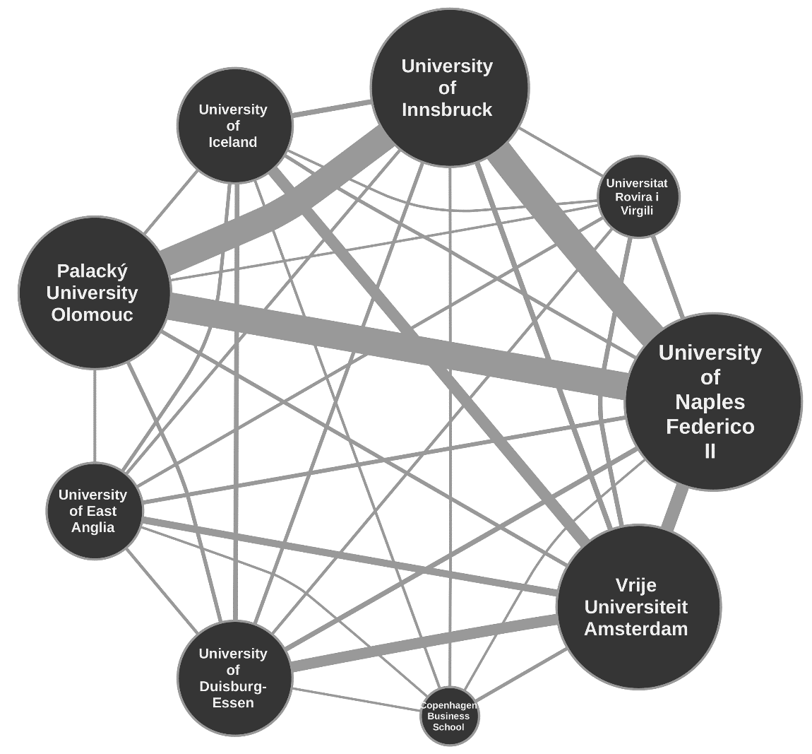
Fig 18 - Map of co-publications within Aurora

3.8 Maps of collaborations based on publications within Aurora by SDGs
DATA INFORMATION
data | All publication types in all subject areas from 2016 to 2021
source | SciVal® database, Elsevier B.V., http://www.scival.com (downloaded on june-2022)
download date | June 2022
data processing | Graphics provided by SciVal.
See this information in Annex 6.

3.9 Aurora collaborations with the other alliances based on co-publications

Aurora has collaborated with 483 collaborating groups in worldwide, 37 of them are European Universities Alliances.
DATA INFORMATION
data | All publication types in all subject areas from 2016 to 2021
source | SciVal® database, Elsevier B.V., http://www.scival.com (downloaded on june-2022)
download date | June 2022
data processing | Own graphics created with SciVal data.

AURORA AND COLLABORATION WITH 37 EUROPEAN UNIVERSITIES ALLIANCES

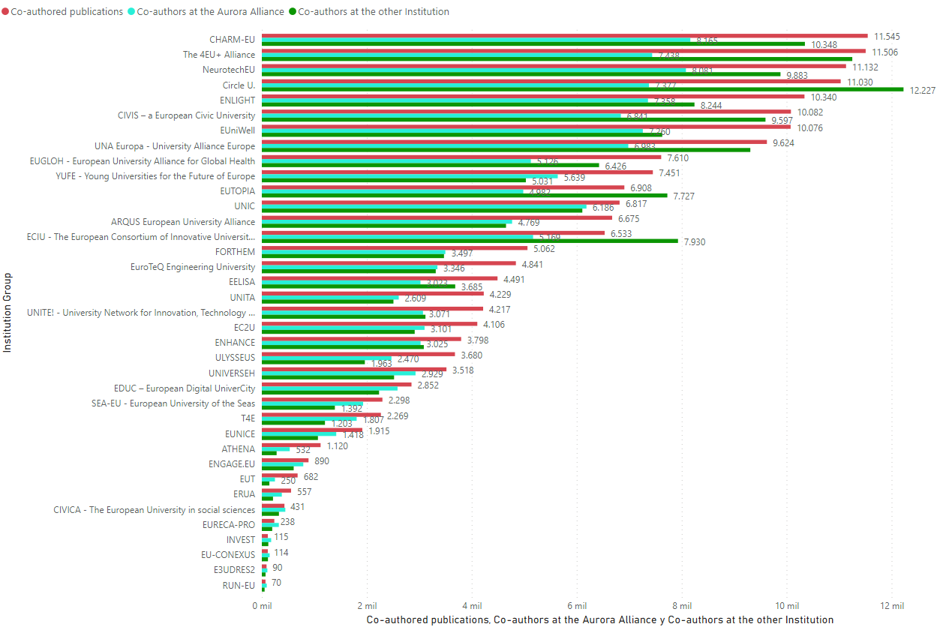
Fig 19 – Number of co-publications and authors with other alliances
The alliances taken into account in figure 19 are based on the R&I component (funding of alliances by the SwafS programme in H2020, minus EU4ART as explained previously). See more information in Annex 7.

3.10 Details of the top 17 collaborating European Universities Alliances

DATA INFORMATION
data | All publication types in all subject areas from 2016 to 2021
source | SciVal® database, Elsevier B.V., http://www.scival.com (downloaded on june-2022)
download date | June 2022
data processing | Graphics provided by SciVal.

See the information in Annex 8.

3.11 AURORA SDG Analysis

DATA INFORMATION
data | All publication types by SDGs from 1996 to 2022
source | SciVal® database, Elsevier B.V., http://www.scival.com (downloaded on june-2022)
download date | June 2022
data processing | Graphics provided by https://bit.ly/aurora-sdg-dashboard-v4

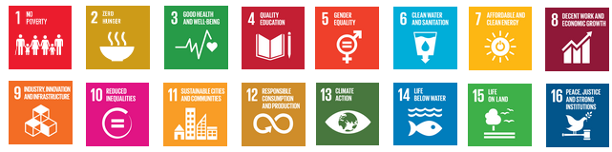

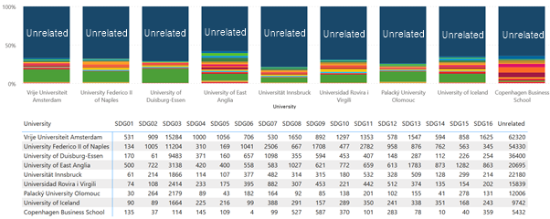
Fig 20 – Number of publications by SDGs

See more information in Annex 9.

AURORA COLLABORATIONS
DATA INFORMATION
data | All publication types by SDGs from 1996 to 2022
source | SciVal® database, Elsevier B.V., http://www.scival.com (downloaded on june-2022)
download date | June 2022
data processing | Graphics provided by https://bit.ly/aurora-sdg-dashboard-v4

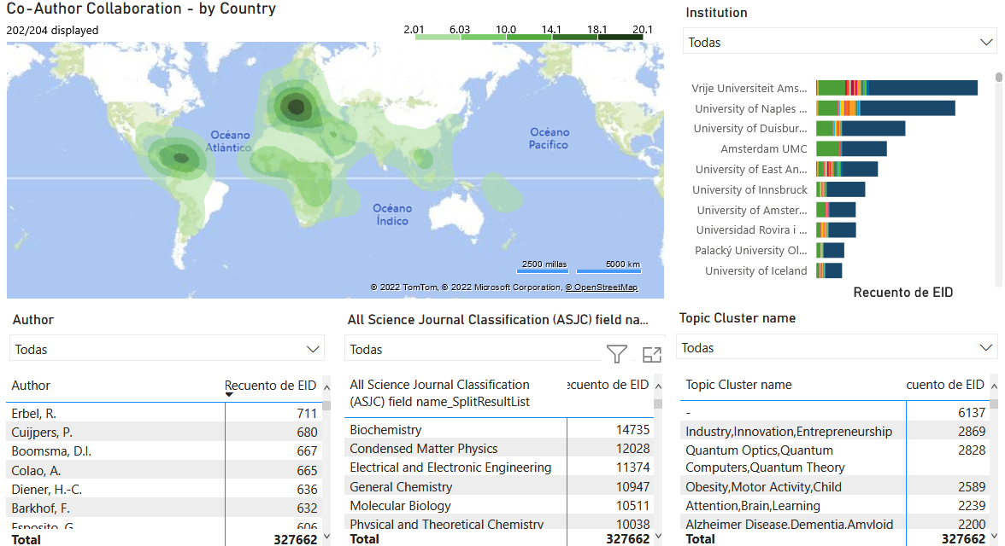
Fig 21 – Heat map and top authors, fields and topic cluster in Aurora collaborations

See more information in Annex 10.

3.12 The European Universities Alliances in the world

Results: Map of the world’s universities by scientific production and impact. 2015-19 (annual average)
DATA INFORMATION
data | Map of the world’s universities by scientific production and impact
source | SciVal® database, Elsevier B.V., http://www.scival.com (downloaded on june-2022)
download date | June 2022
data processing | Own graphics created with SciVal data.

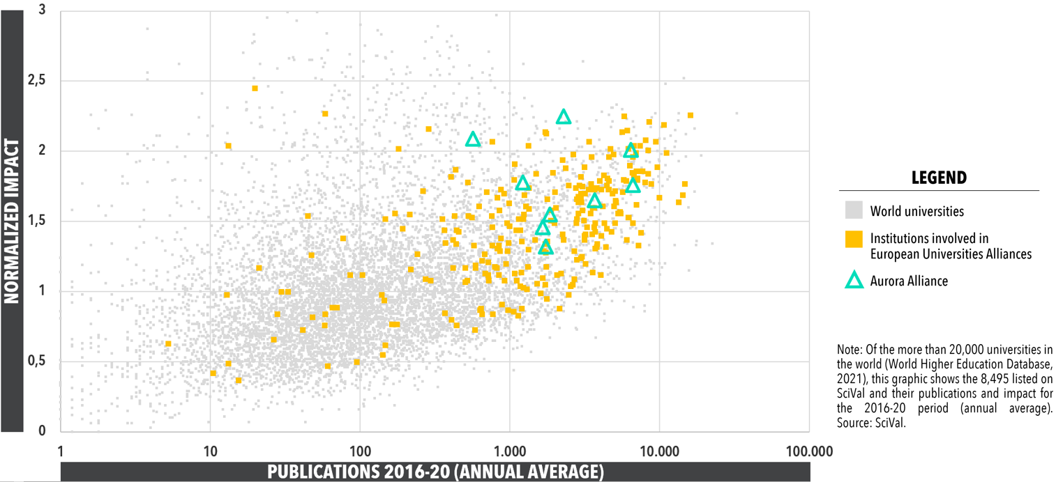
Fig 22 - Map of the world’s universities by scientific production and impact. 2015-19 (annual average)

Visibility: Global position of the Aurora universities in world university rankings
DATA INFORMATION
data | Global position of the Aurora universities in world university rankings
source | ARWU, THE, QS rankings
download date | June 2022
data processing | Table provided by URV Research and Innovation 2020 Report

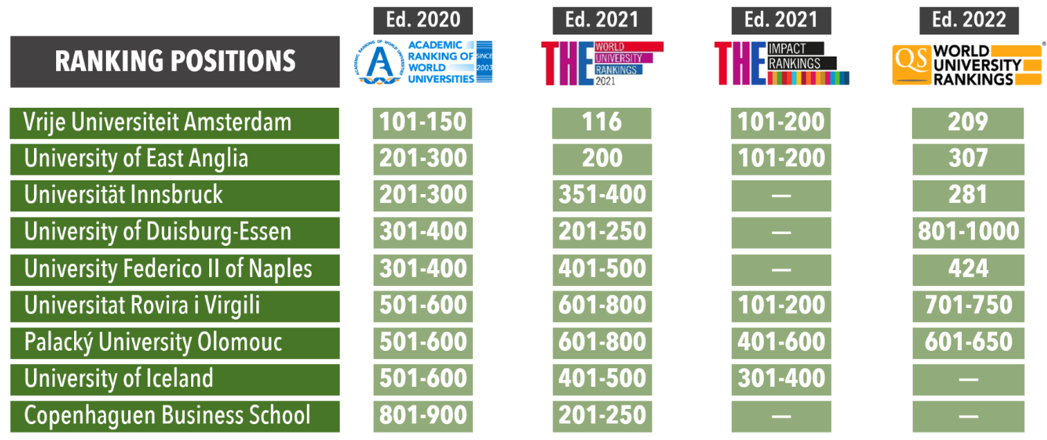
Fig 23 - Global position of the Aurora universities in world university rankings

4. Conclusions
AURORA KEY INDICATORS

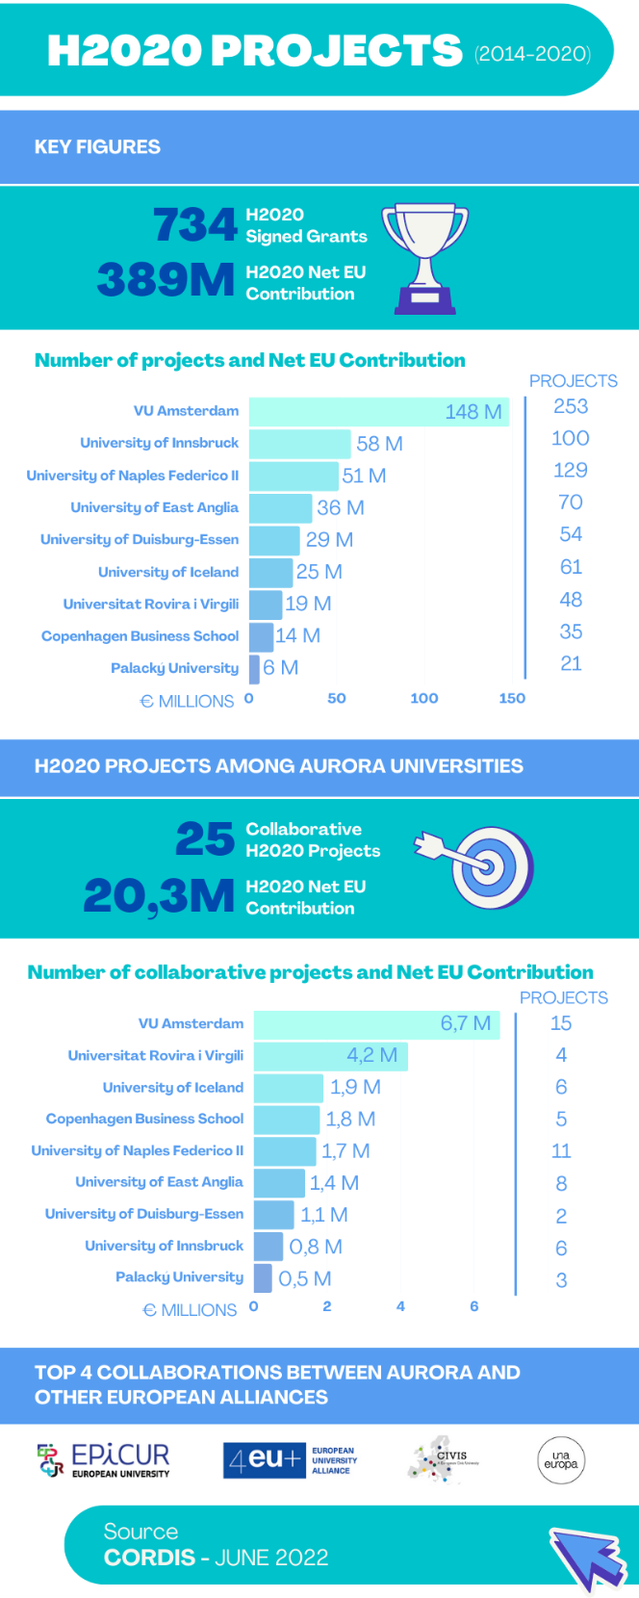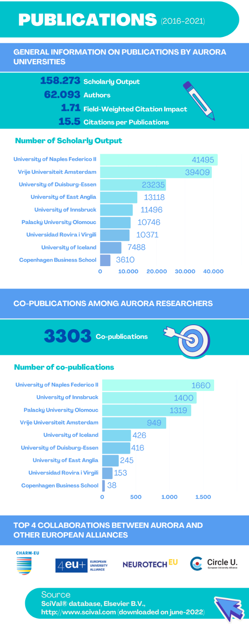

After carrying out this study and analyzing the data obtained, the questions raised are answered.
1 How do Aurora universities perform in European funding?
AURORA H2020 PROJECTS (2014-2020)
Aurora with 734 H2020 Signed Grants and €389 M H2020 Net EU Contribution is good at natural sciences and social sciences. ERC and MSCA are the best programmes with 68% of the H2020 total funding.
VU Amsterdam is the best university obtaining H2020 funding: €148M in 253 projects. It is far ahead of the other universities (more than double). University of Innsbruck (€58M and 100 projects) and University of Naples Federico II (€51M and 129 projects) are second and third place.
Who is the best in each Pillar?
Pillar 1 - VU Amsterdam (ERC (€73M) and MSCA (€23.4M))
Pillar 2 - University of Duisburg-Essen (€4.1M in ICT)
Pillar 3 - VU Amsterdam (€16.4M in Health)
Others - University of Innsbruck (€1.96M in EURATOM)
Normalising the data by academic staff, VU Amsterdam is also the best at obtaining H2020 funding with 72,130 € by academic staff. Although VU Amsterdam ranks second with 2,427 teaching and research staff (in full-time equivalents) in absolute data after the University of Duisburg-Essen with 3,393 teaching and research staff.

2 How do Aurora universities perform in scientific publications?
AURORA PUBLICATIONS (2016-2021)
Aurora has 158.273 publications, with 62,093 authors. Remember Aurora has over 15,000 Academic Staff FTE. Medicine (20.6%) is the subject area with more publications. Followed by biochemistry, genetics and molecular biology (8.5%), social sciences (6.5%) and engineering (6.3%).
If the publications among the universities of Aurora are compared, University of Naples Federico II is the one that publishes the most (41,494 publications), even normalising by research staff. Followed by VU Amsterdam (39,436 publications).
3 What collaborations are there within Aurora?
AURORA COLLABORATIVE H2020 PROJECTS (2014-2020)
There are 25 collaborative projects among Aurora Universities (projects involving more than one Aurora University) funded by the H2020 programme. Most collaborations are in domain 3 “Health and wellbeing” (10 projects) followed by domain 1 “Sustainability and climate change” (9 projects). In domain 2 “Digital society & global citizenship”, there are 4 projects and finally in domain 4 “Culture: diversity & identity “, there are 2.

VU Amsterdam is the one that has collaborated the most with 15 projects obtaining €6.7M. Its collaborations are with all Aurora Universities except with University of Duisburg-Essen. Several collaborations are also between VU Amsterdam and University of Naples Federico II and VU Amsterdam with University of East Anglia (four projects in both).
Usually two Aurora universities collaborated in H2020 projects (except in three times being 3 members and in AURORA RI with all of them).

AURORA CO-PUBLICATIONS (2016-2021)
There have been 3,303 co-publications among Aurora Universities. University of Naples Federico II and Palacký University have most co-publications (618) followed by University of Naples Federico II and University of Innsbruck (610).
A breakdown of collaborations by domain and the highest number of collaborations:
1 | Sustainability and climate change – 800 co-publications. University of Naples Federico II and VU Amsterdam have 49 co-publications.
2 | Digital society & global citizenship – 156 co-publications. VU Amsterdam and University of Duisburg-Essen have 11 co-publications.
3 | Health and wellbeing – 2,512 co-publications. VU Amsterdam and University of Duisburg-Essen have 268 co-publications.
4 | Culture: diversity & identity – 180 co-publications. VU Amsterdam and University of East Anglia have 13 co-publications.
Total | 3.648 co-publications by domains.
It’s important to take into account that:
- There are publications that may not be in any domain.
- There are publications that may be in more than one domain.
- There are co-publications that may not derive from projects.

European Universities Alliances
4 What collaborations are there with Aurora?
COLLABORATIONS IN H2020 PROJECTS (2014-2020)
There are 33 alliances collaborating with Aurora in H2020 projects. Pillar I “Excellent Science” has more collaborations, followed by Pillar III “Societal Challenges”.

COLLABORATIONS IN PUBLICATIONS (2016-2021)
In the period from 2016 to 2021, Aurora has co-published with 37 alliances. There have been more collaborations with CHARM-EU, 4EU+ Alliance, NeurotechEU and Circle U.

CHARM-EU (lead: University of Barcelona, Spain) and Aurora have been collaborating in 11,545 publications with 8,166 Aurora co-authors and 10,348 CHARM-EU co-authors in Medicine, Physics and Astronomy and Biochemistry, Genetics and Molecular Biology.
4EU+ Alliance (lead: Charles University, Czech Republic) and Aurora have been collaborating in 11,506 publications with 7,436 Aurora co-authors and 11,250 4EU+ Alliance co-authors in Medicine, Physics and Astronomy and Biochemistry, Genetics and Molecular Biology.

NeurotechEU (lead: Radboud University, The Netherland) and Aurora have been collaborating in 11,137 publications with 8.091 Aurora co-authors and 9,883 NeurotechEU co-authors in Medicine, Physics and Astronomy and Biochemistry, Genetics and Molecular Biology.
Circle U. (lead: Aarhus University, Denmark) and Aurora have been collaborating in 11,022 publications with 7,372 Aurora co-authors and 12,220 Circle U. co-authors in Medicine, Physics and Astronomy and Biochemistry, Genetics and Molecular Biology.
In 34 SwafS alliances of 37, the areas where Aurora universities collaborate more are always Medicine, Physics and Astronomy and Biochemistry, Genetics and Molecular Biology in the same order.

Final considerations:
SciVal is based on Scopus as a data source. SciVal oversimplifies interpretation of the data: for example, educational sciences are underrepresented in Scopus and the engineering sciences are included very heterogeneously (with strong fluctuations even within a subject area). In addition, publication media is also often a problem while the humanities are generally hardly included. The statements obtained with the data are correspondingly error-prone. Hence, Scopus is an incomplete database but for pragmatic purposes we chose to continue using this database and the SciVal model.
The data presented in this report provide an overview of the period 2016-2021. This can be regarded as a starting point for continued future measurements of collaborations between Aurora universities, and between Aurora universities and other EUAs. This may reflect the effect of this Erasmus+ funded initiative on collaboration between European universities.

5. Annexes

ANNEX 1 - COMPARISON AMONG Aurora UNIVERSITIES

DATA INFORMATION
data | Aurora universities H2020 projects
source | cordis.europa.eu
download date | June 2022
data processing | Own graphics created with downloaded data from CORDIS

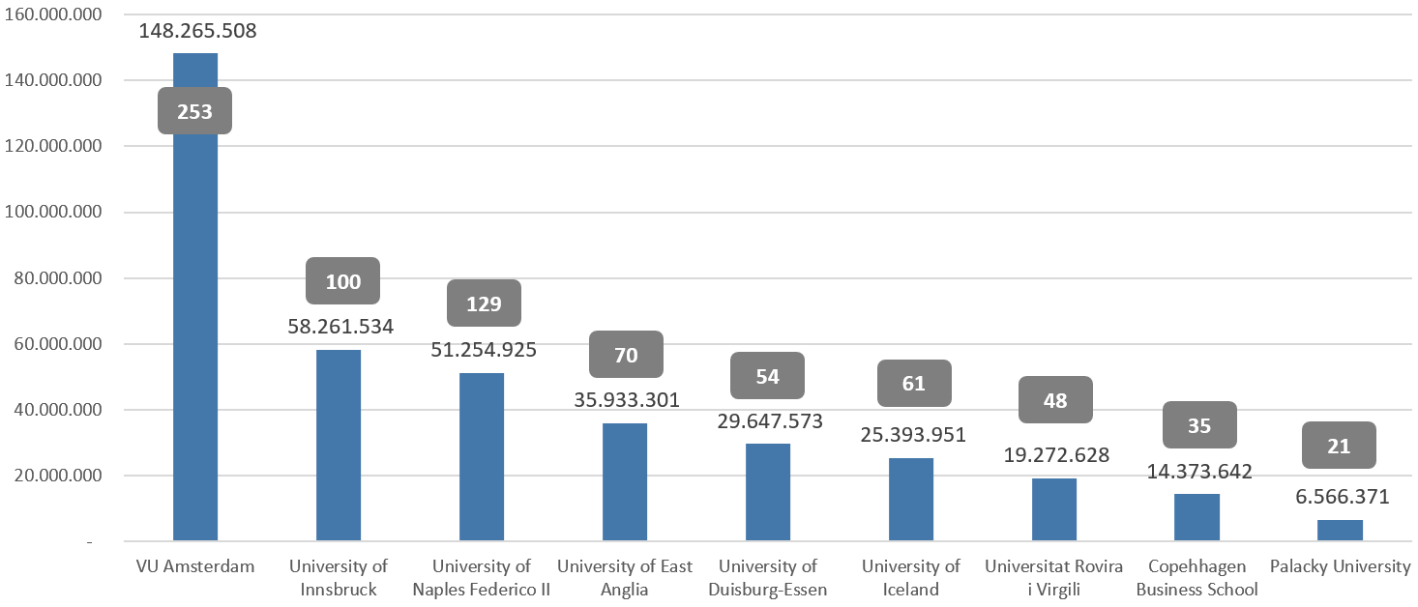
Fig 24 – Comparison of H2020 projects among Aurora universities
Figure 12 shows the number of H2020 project participations per alliance beneficiary and the related H2020 budget. VU Amsterdam had the most participations and largest total budget. Followed by University of Innsbruck and University of Naples. Both VU Amsterdam and University of Innsbruck got about 580,000 euro per project – for the other Aurora Alliance universities this was less.

PILLAR I
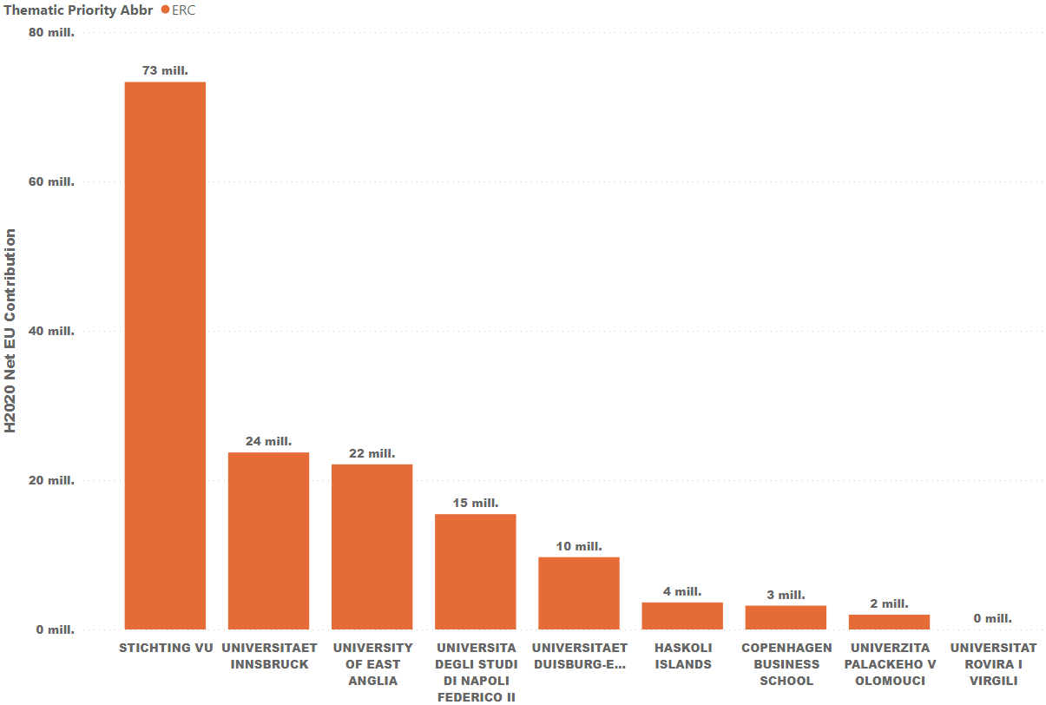
Fig 25 – Comparison ERC projects among Aurora universities in H2020
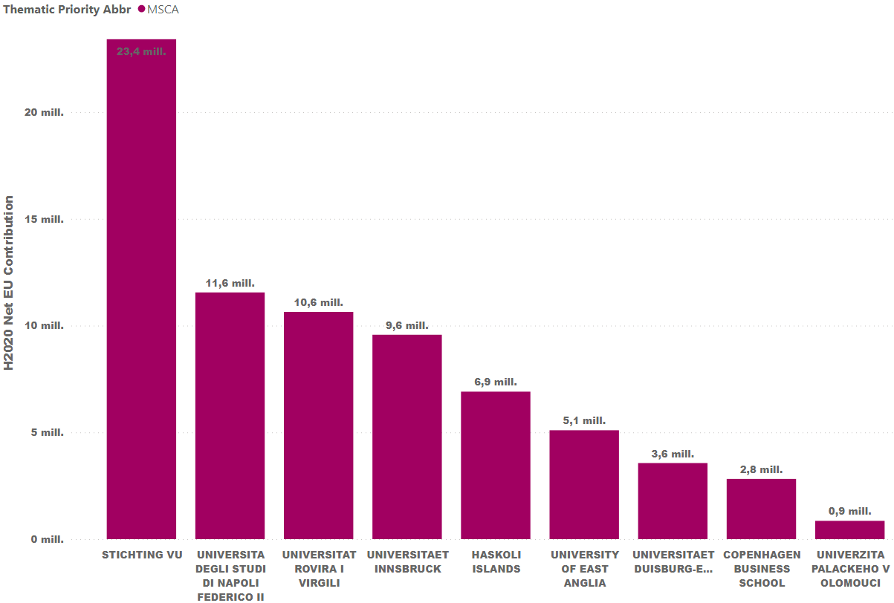
Fig 26 – Comparison MSCA projects among Aurora universities in H2020

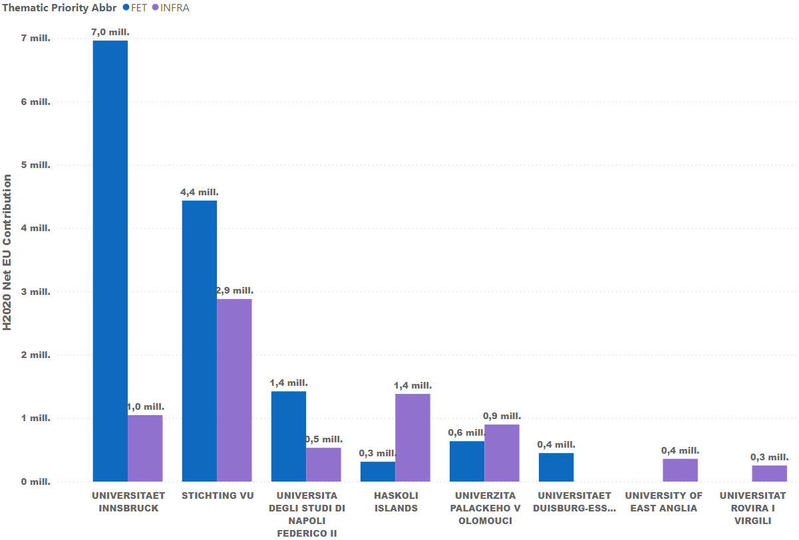
Fig 27 - Comparison FET and INFRA projects among Aurora universities in H2020
Figures 13 to 15 show that the strength of the universities is in different actions in Pillar 1. In H2020 University of Innsbruck was strong in innovative research while VU Amsterdam was strongest in ERC and MSCA projects.

PILLAR II
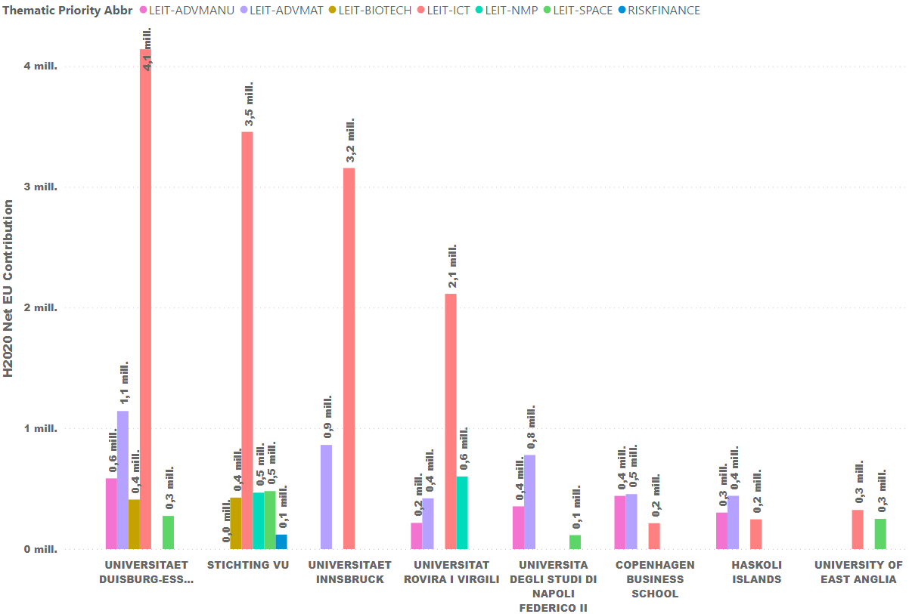
Fig 28 - Comparison Pillar II projects among Aurora universities in H2020
Figure 16 points out that the different universities do not have the same research emphasis. While University of Duisburg-Essen, VU Amsterdam, University of Innsbruck and University Rovira I Virgili have a strong emphasis on digital sciences in Pillar 2 funding schemes. Though, total budgets are quite small.

PILLAR III
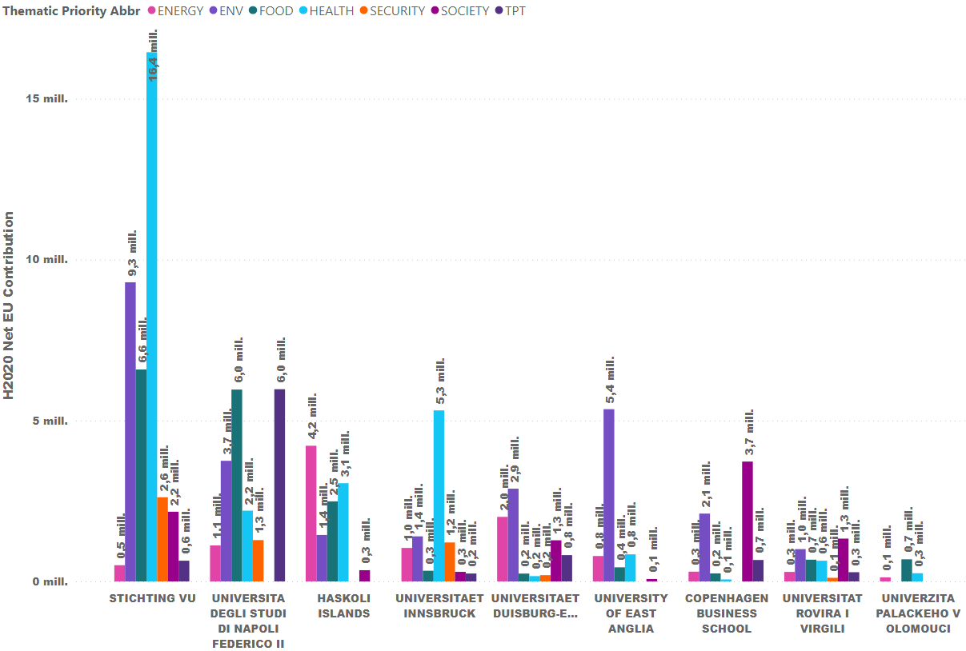
Fig 29 - Comparison Pillar III projects among Aurora universities in H2020
Figure 17 shows a strong health-related research component at VU Amsterdam and University of Innsbruck, while energy-related H2020 projects prevail at the University of Iceland, food-related research at University of Naples, environmental H2020 studies at the University of East Anglia, and both environmental and societal H2020 studies at Copenhagen Business School.

OTHERS
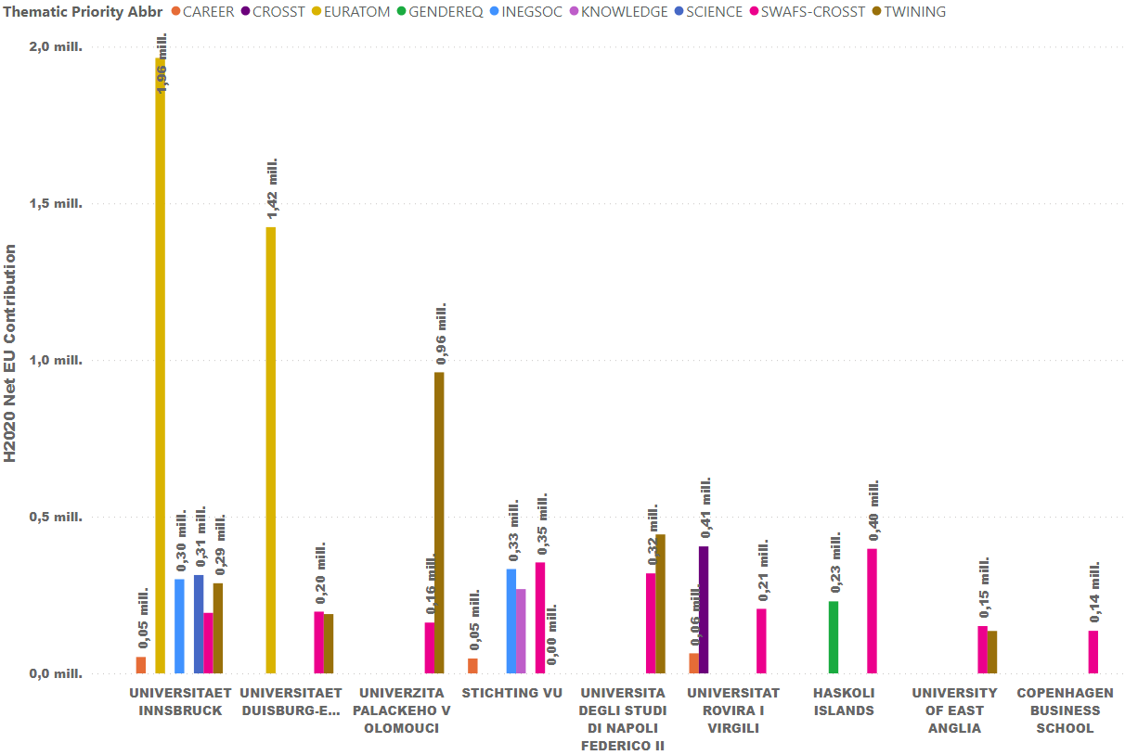
Fig 30 - Comparison other projects among Aurora universities in H2020
ANNEX 2 - General information of each AURORA universities H2020 Projects

DATA INFORMATION
data | AURORA universities H2020 projects
source | cordis.europa.eu
download date | June 2022
data processing | Data from the 9 AURORA universities.  Graphics provided by CORDIS dashboard.

Copenhagen Business School – PIC: 998706666

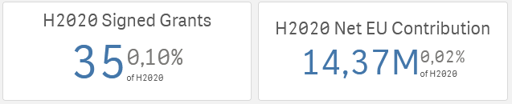

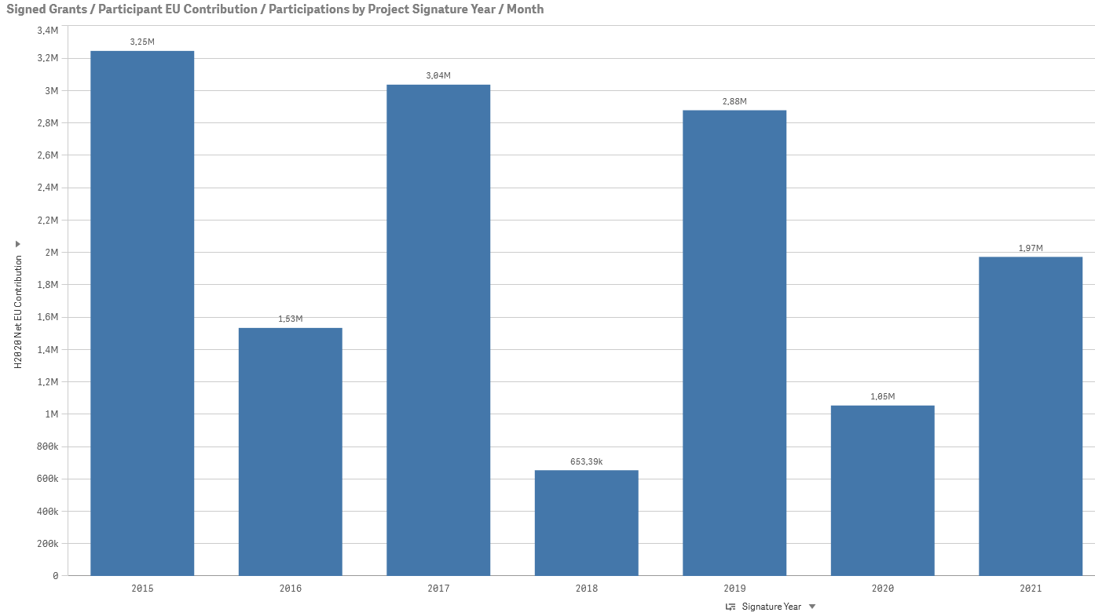
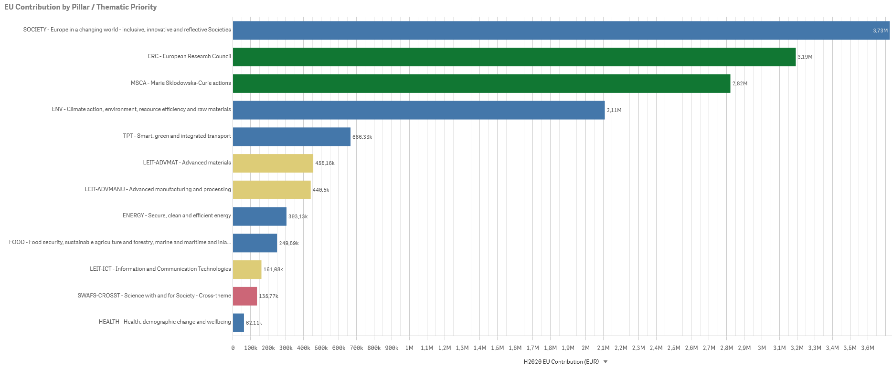
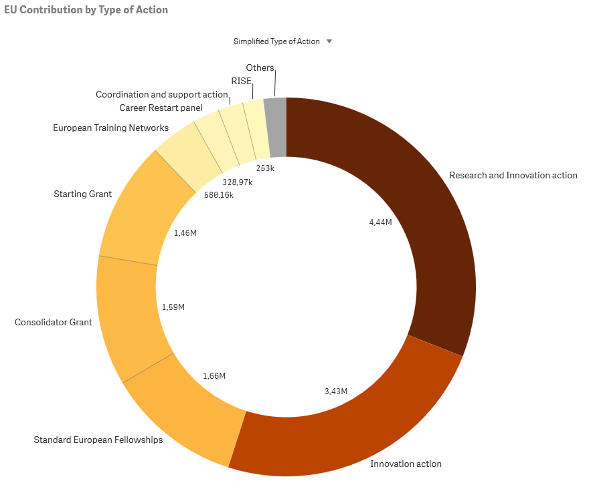

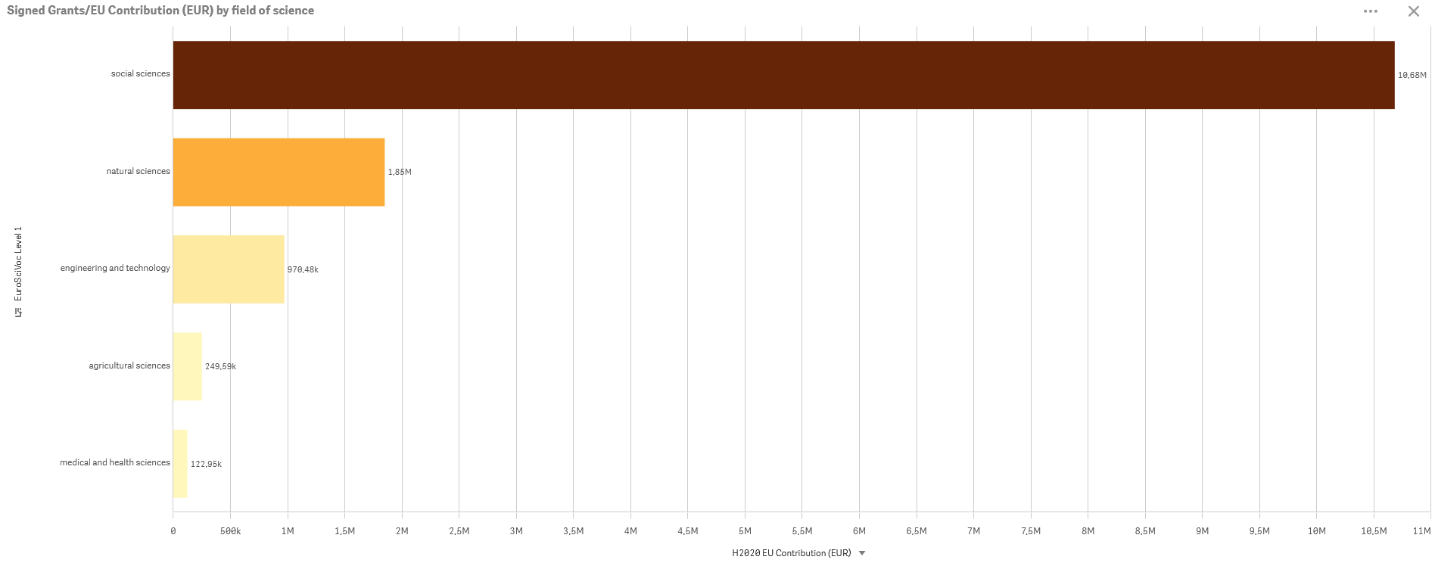
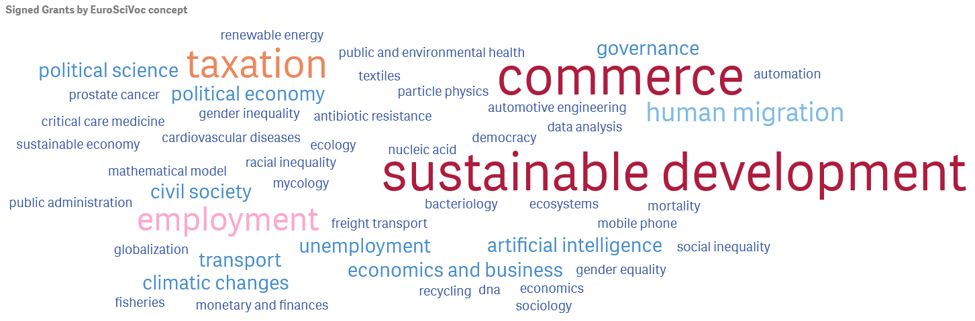
Palacký University Olomouc – PIC: 999649506
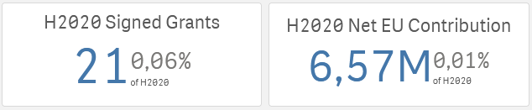

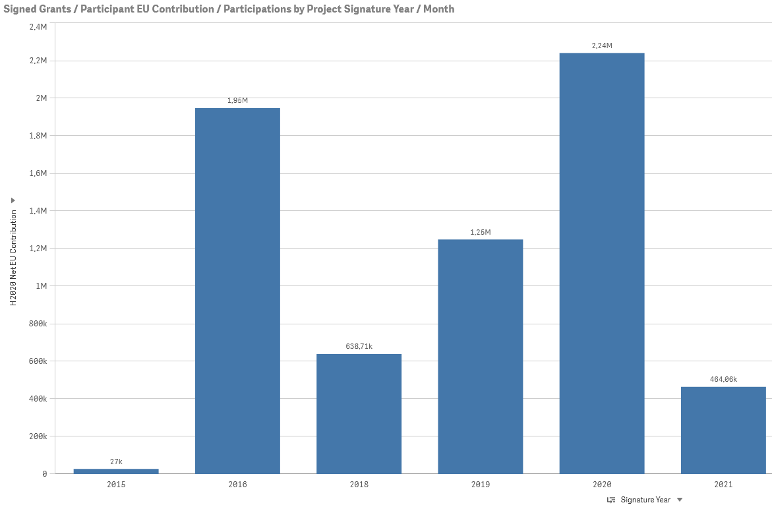
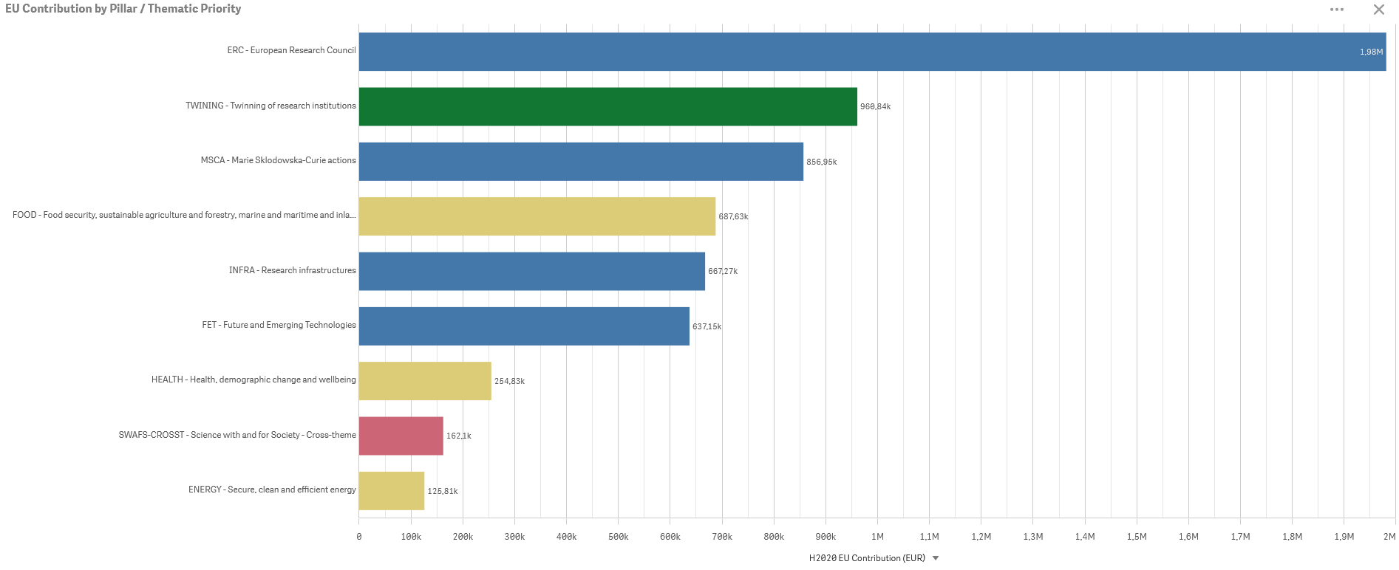

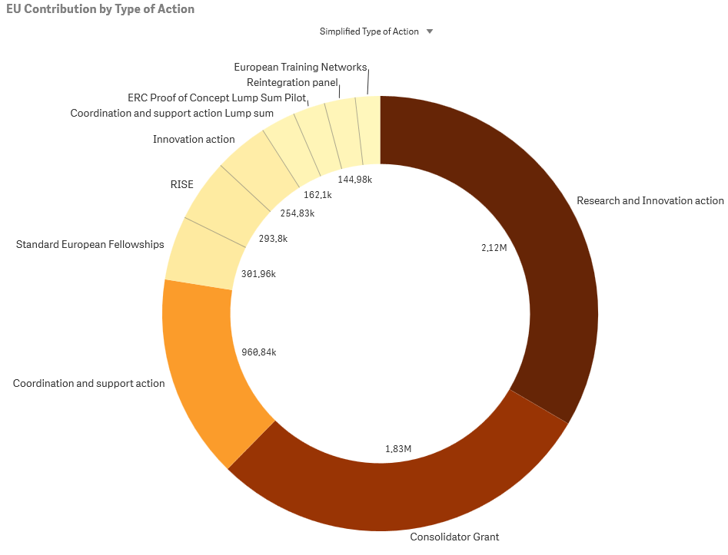

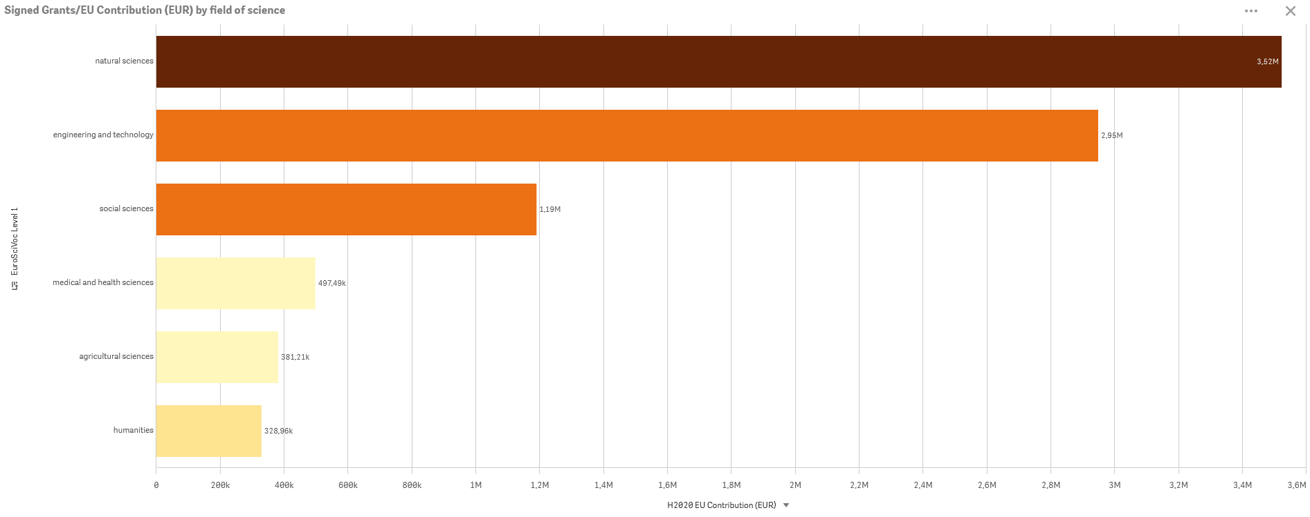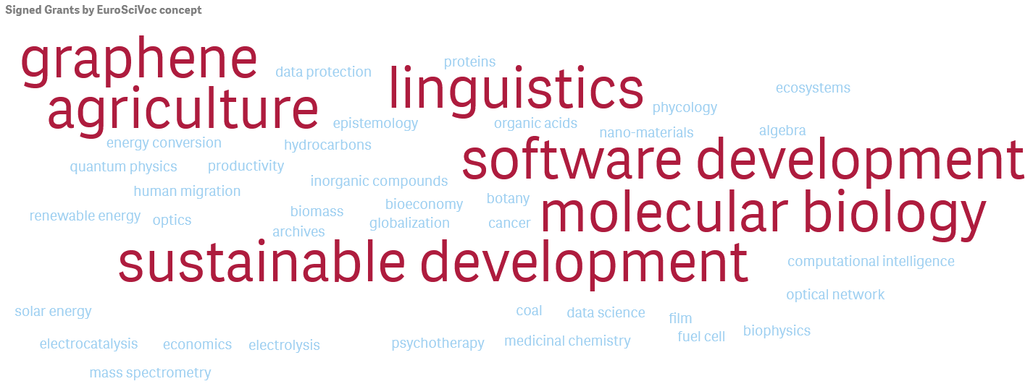

Universidad Rovira i Virgili – PIC: 999880560
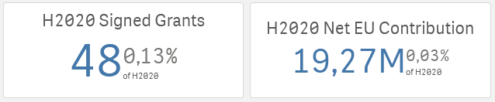

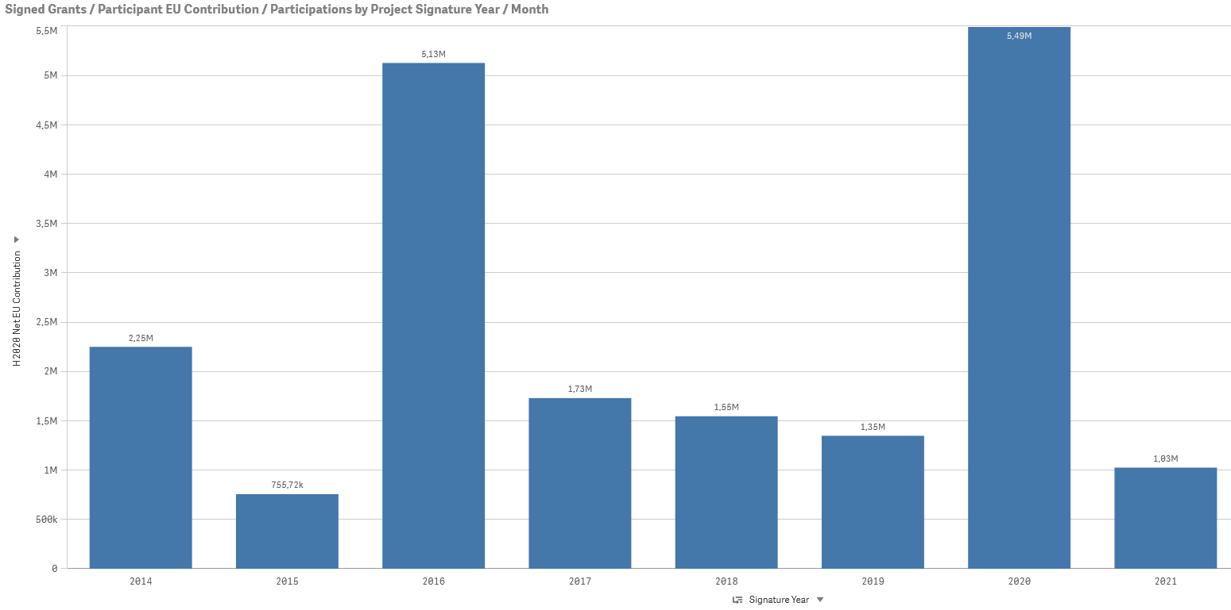
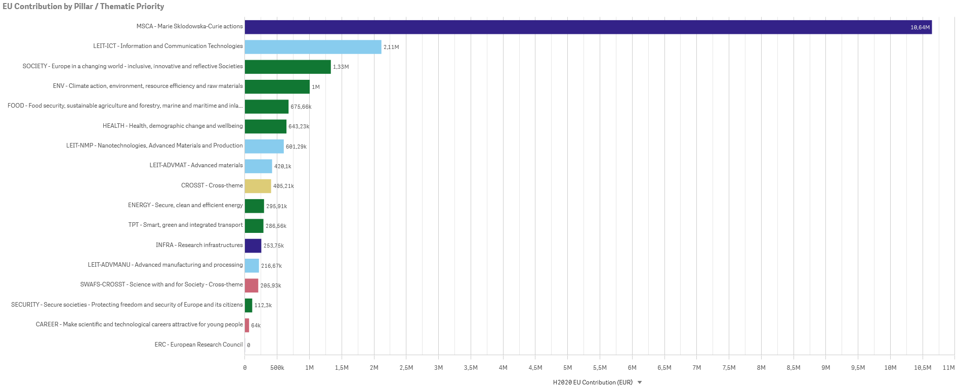
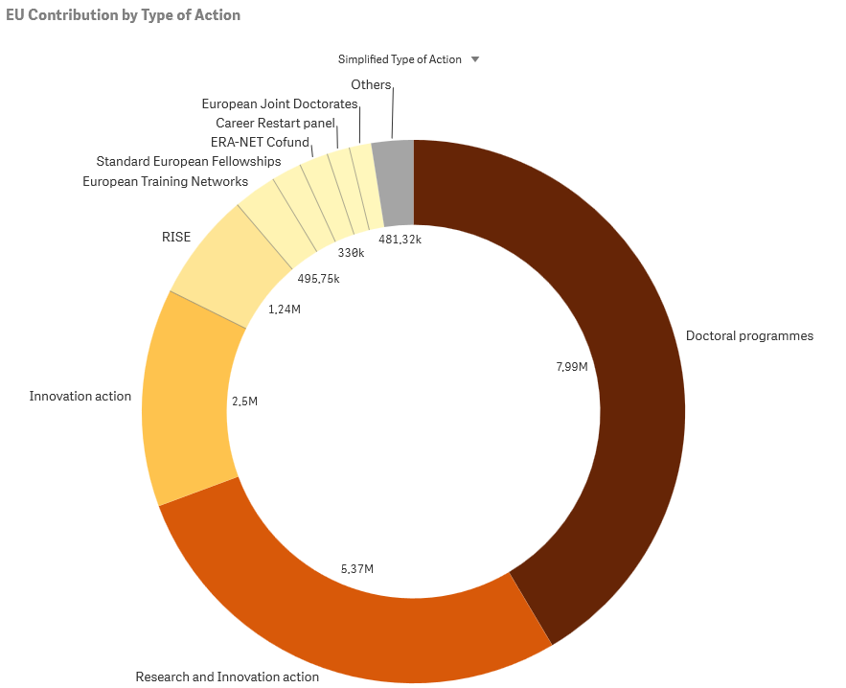

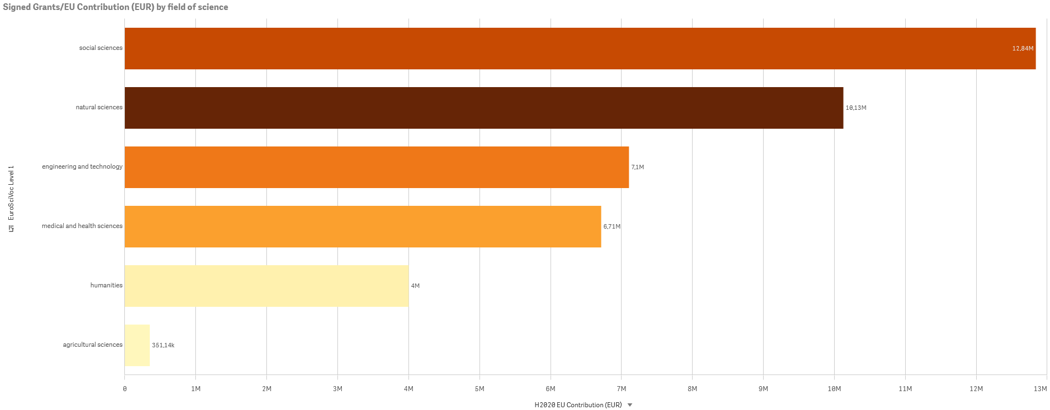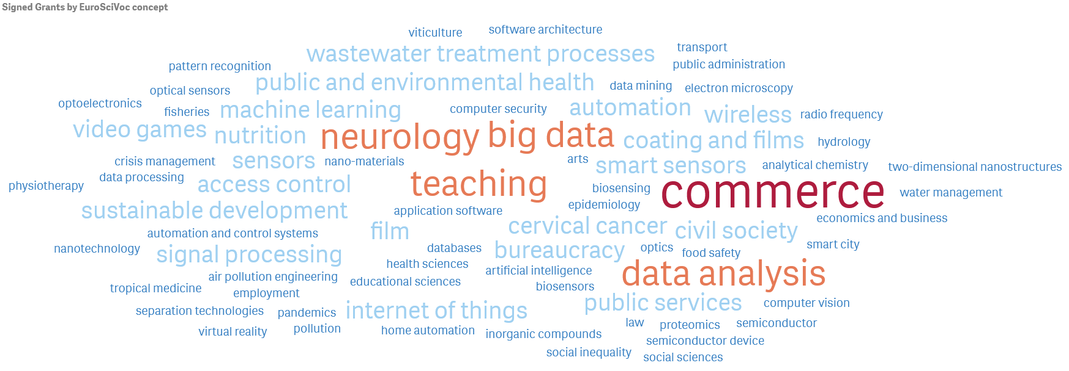
University of Duisburg-Essen – PIC: 999843312
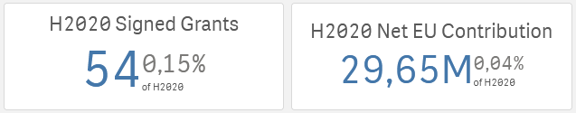

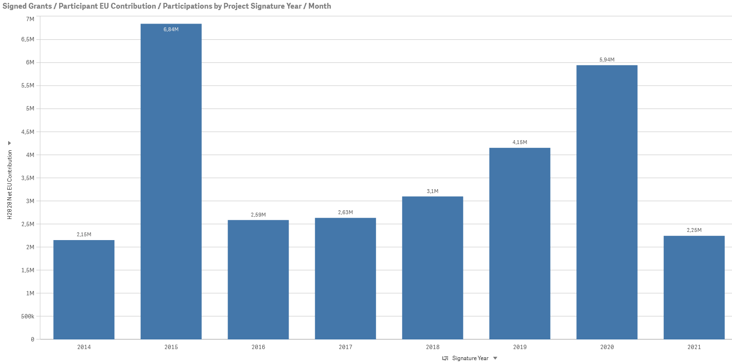

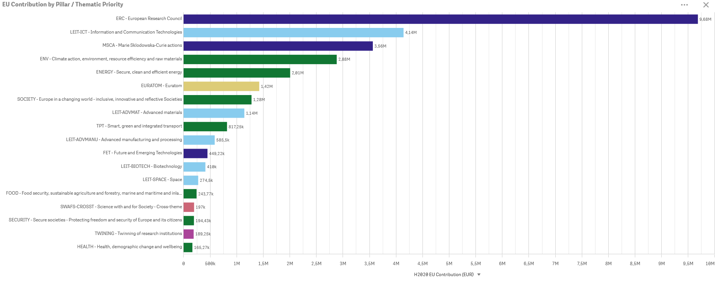
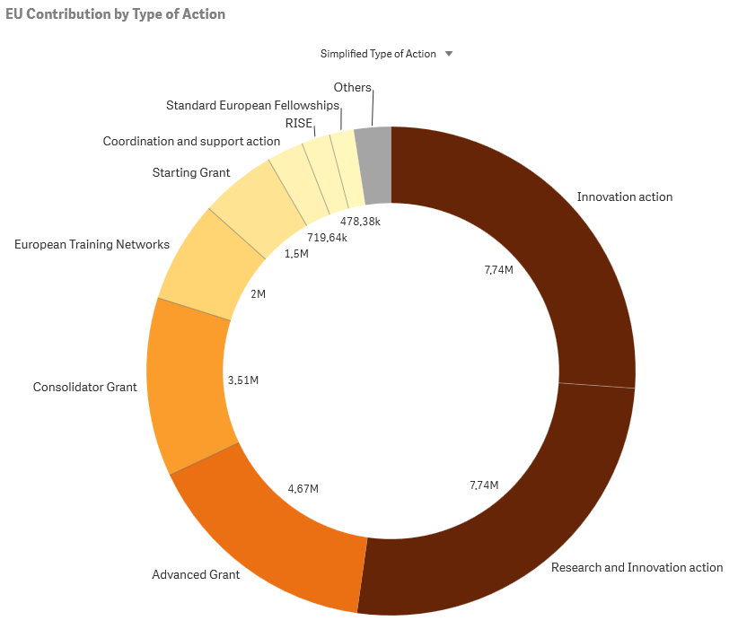

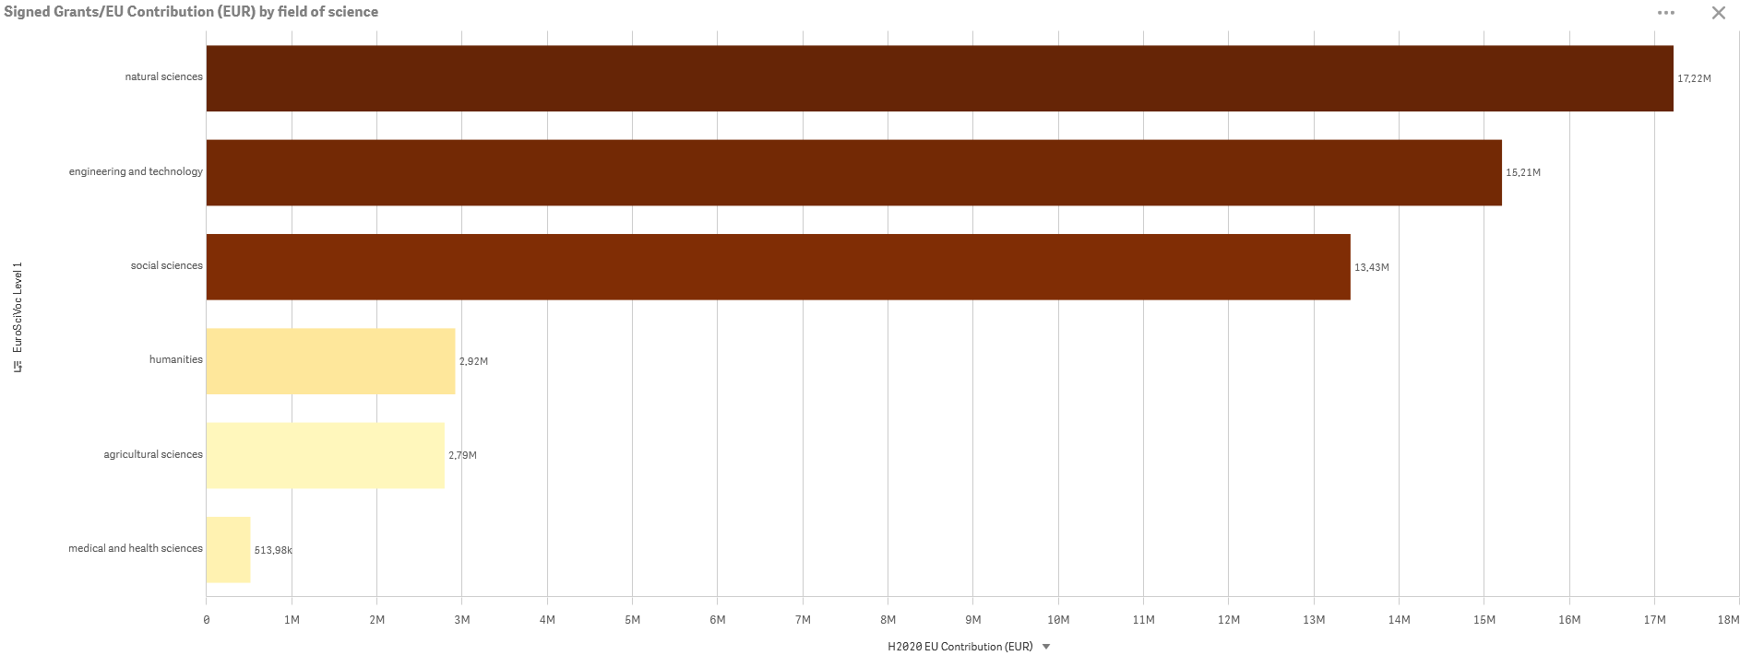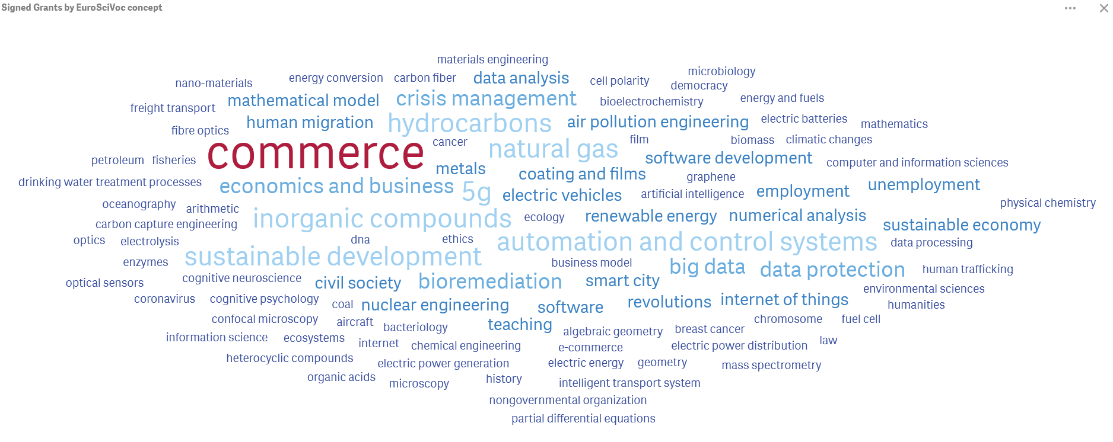
University of East Anglia – PIC: 999985611
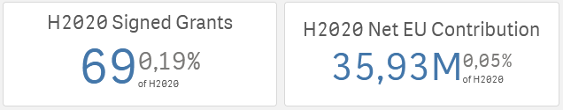

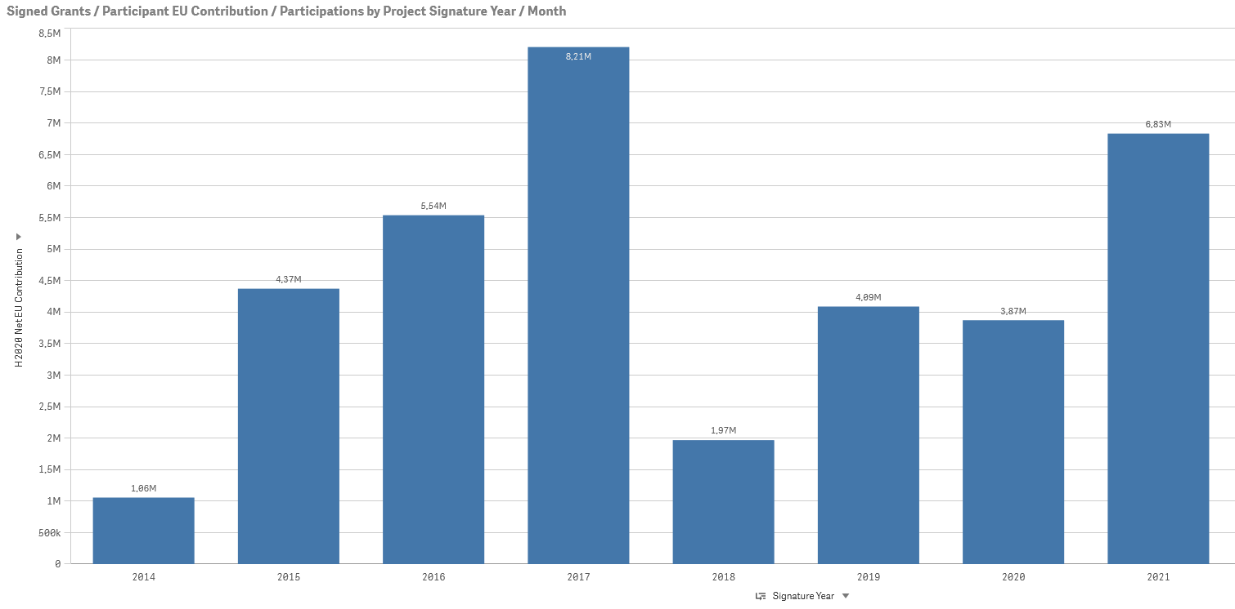
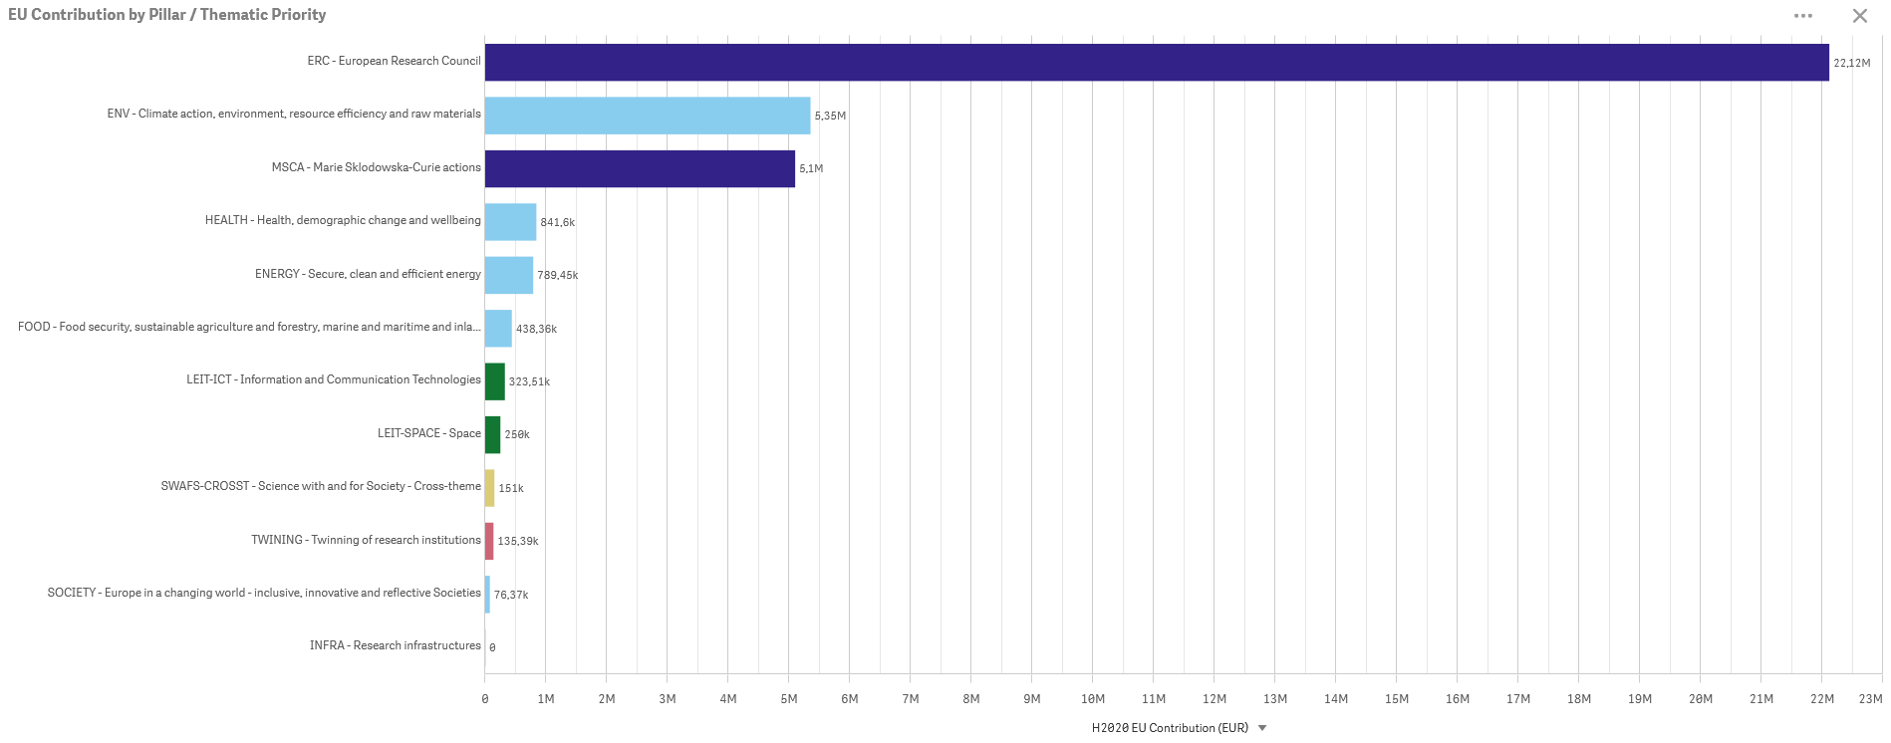
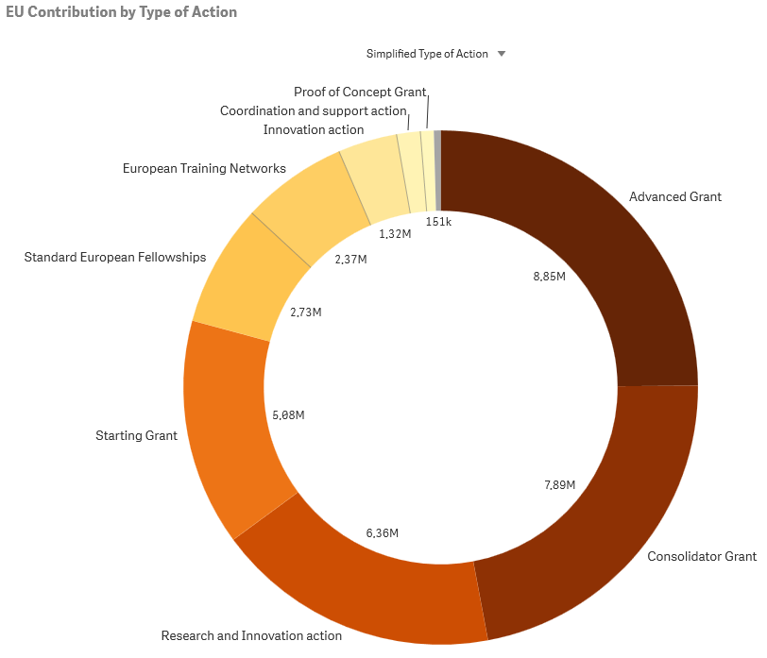
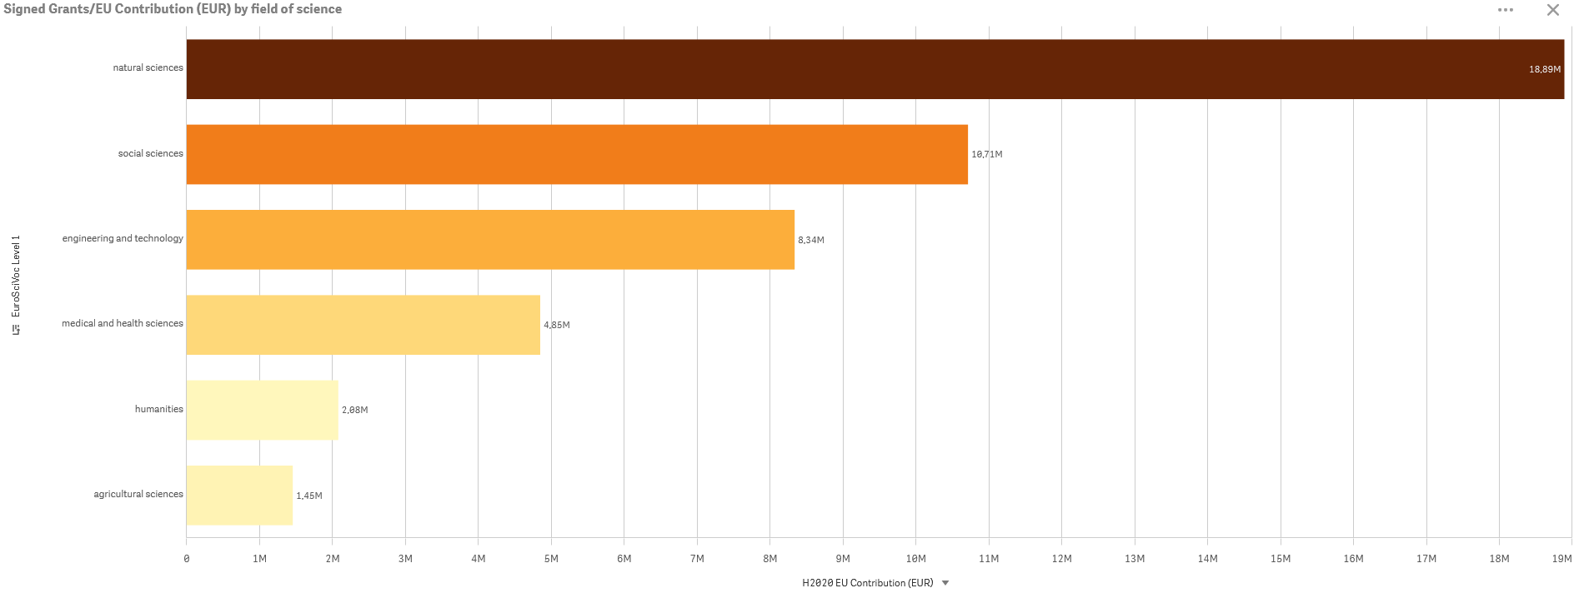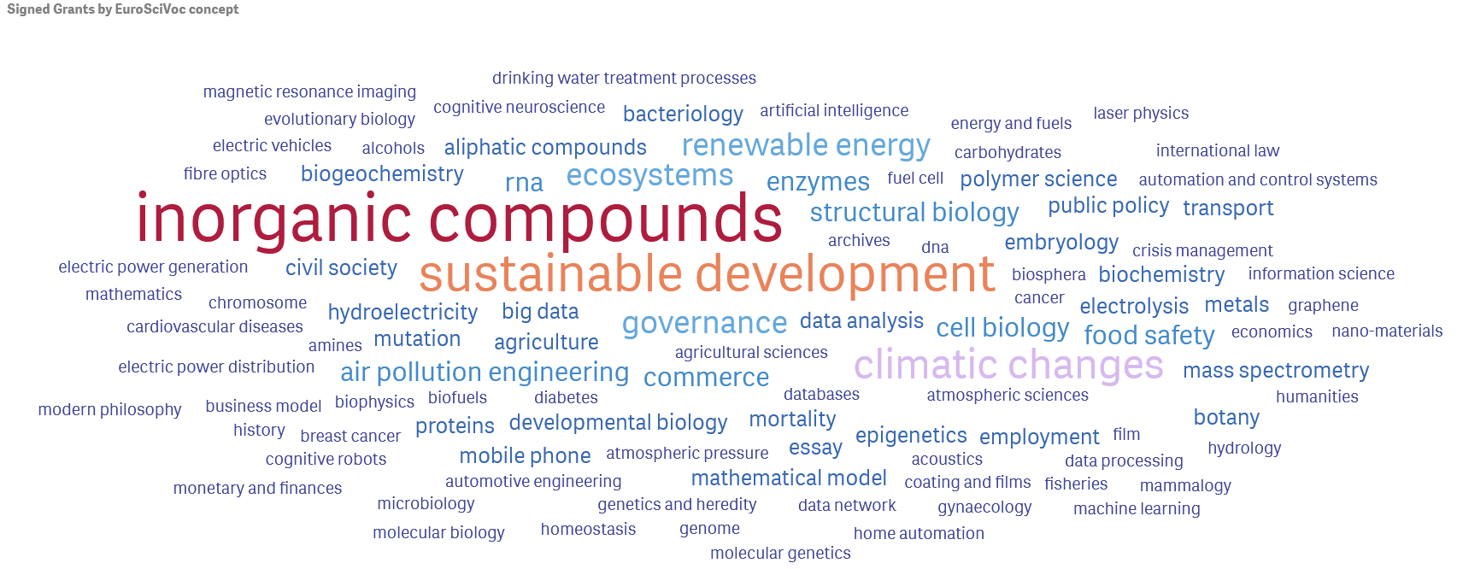
University of Iceland – PIC: 999884246
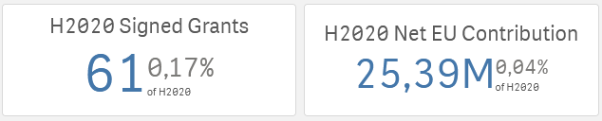
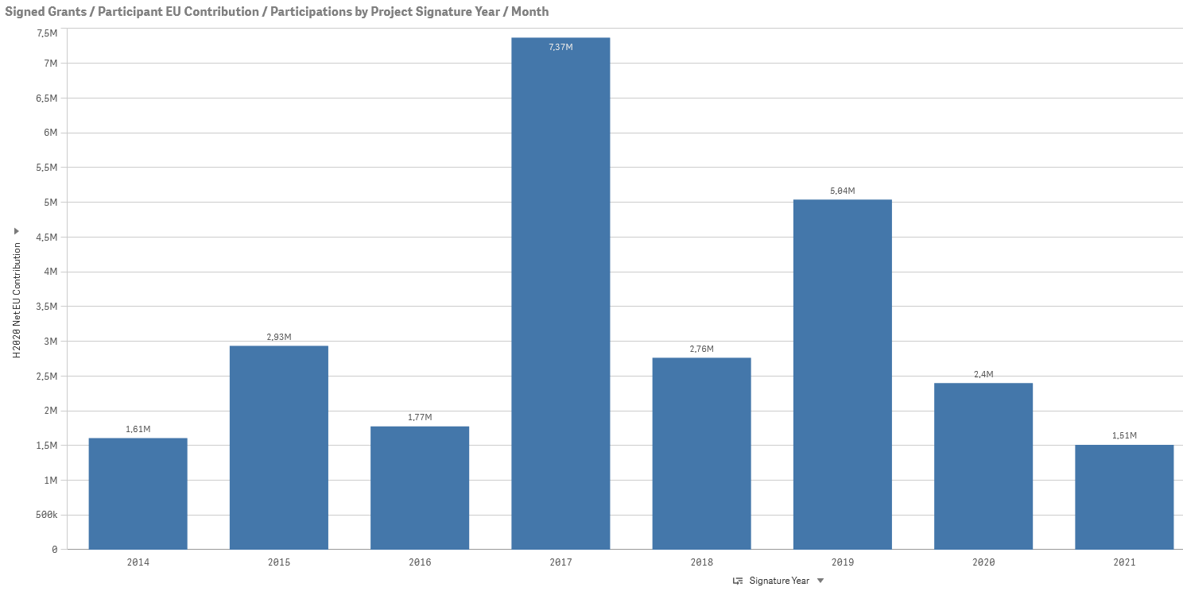
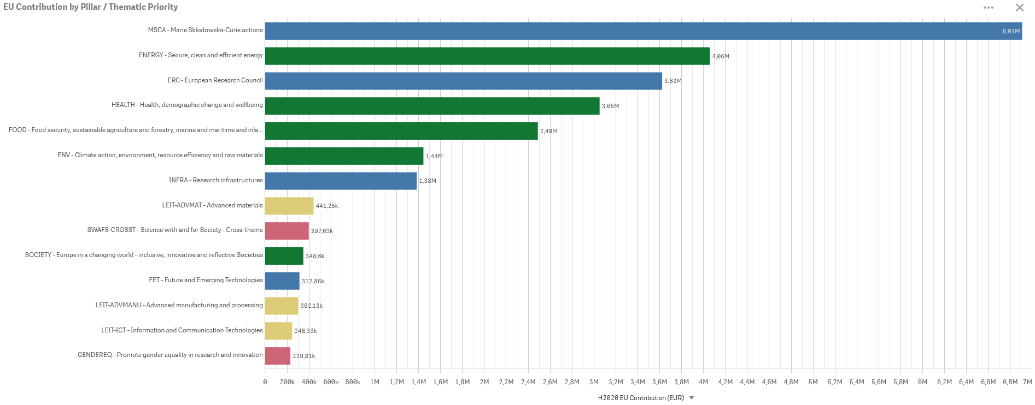
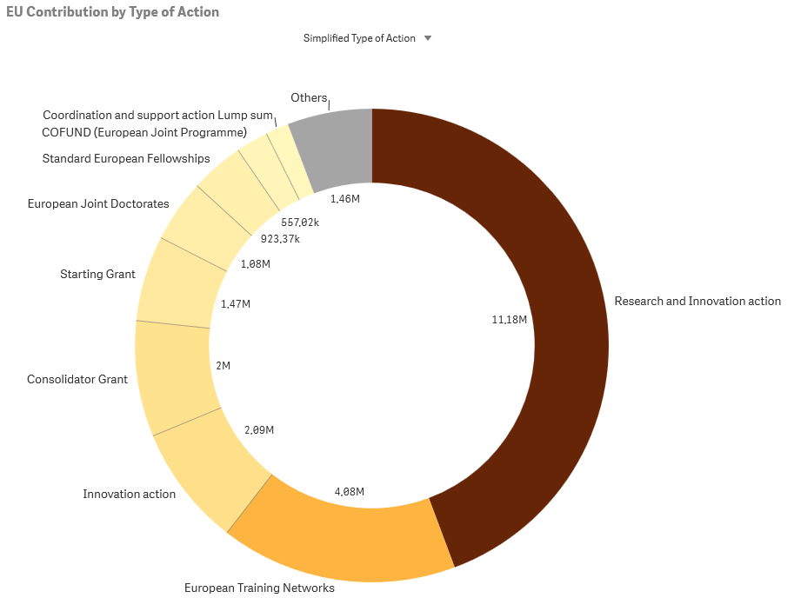
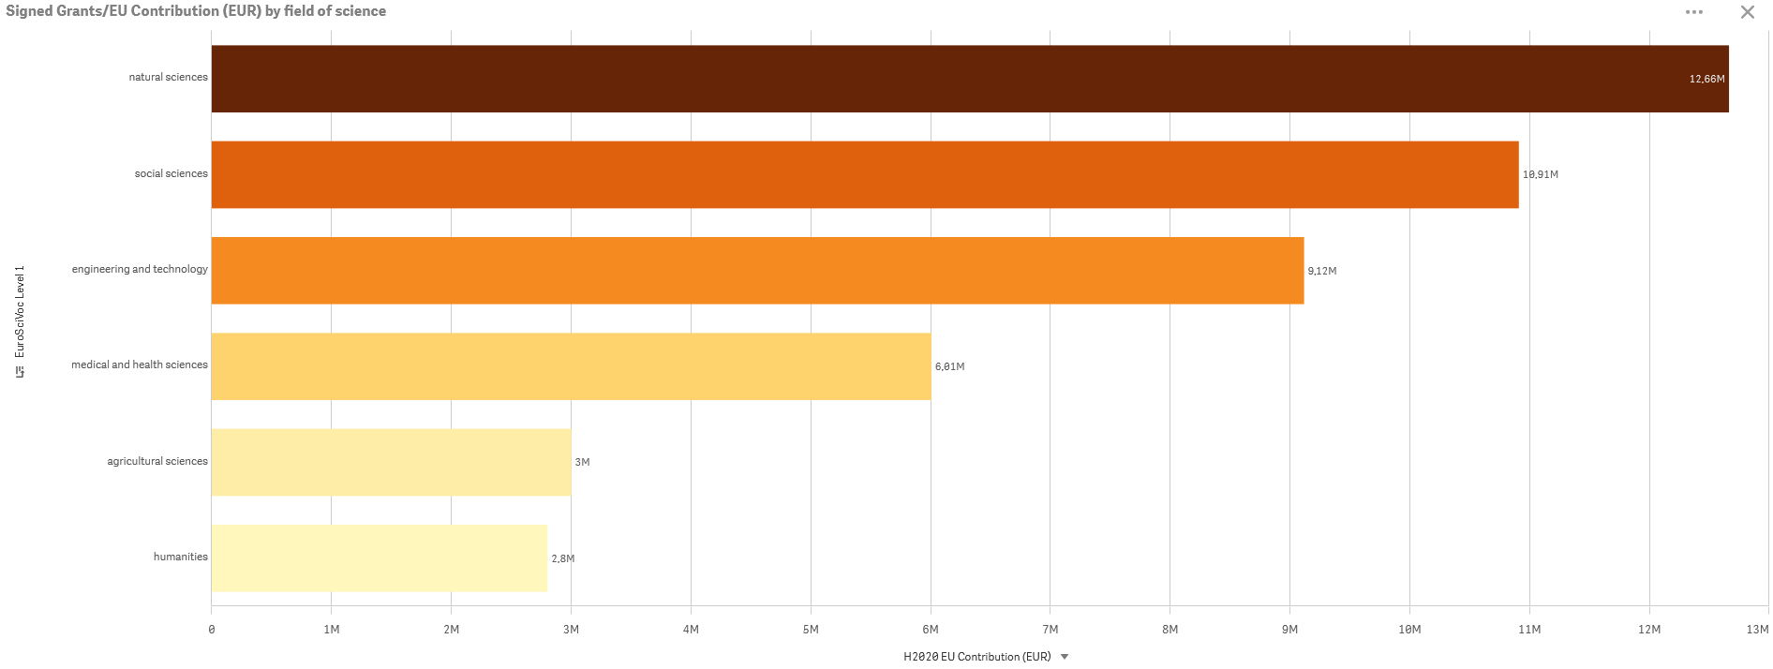
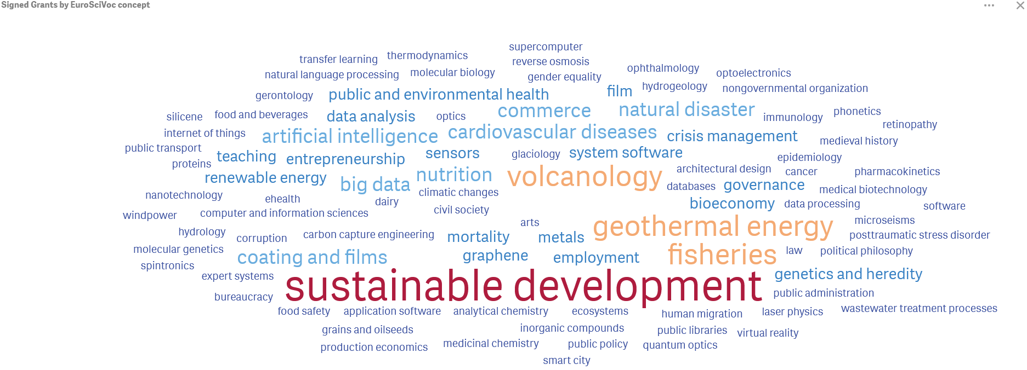
University of Innsbruck – PIC: 999869114
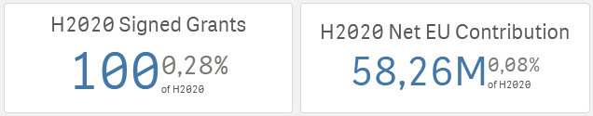
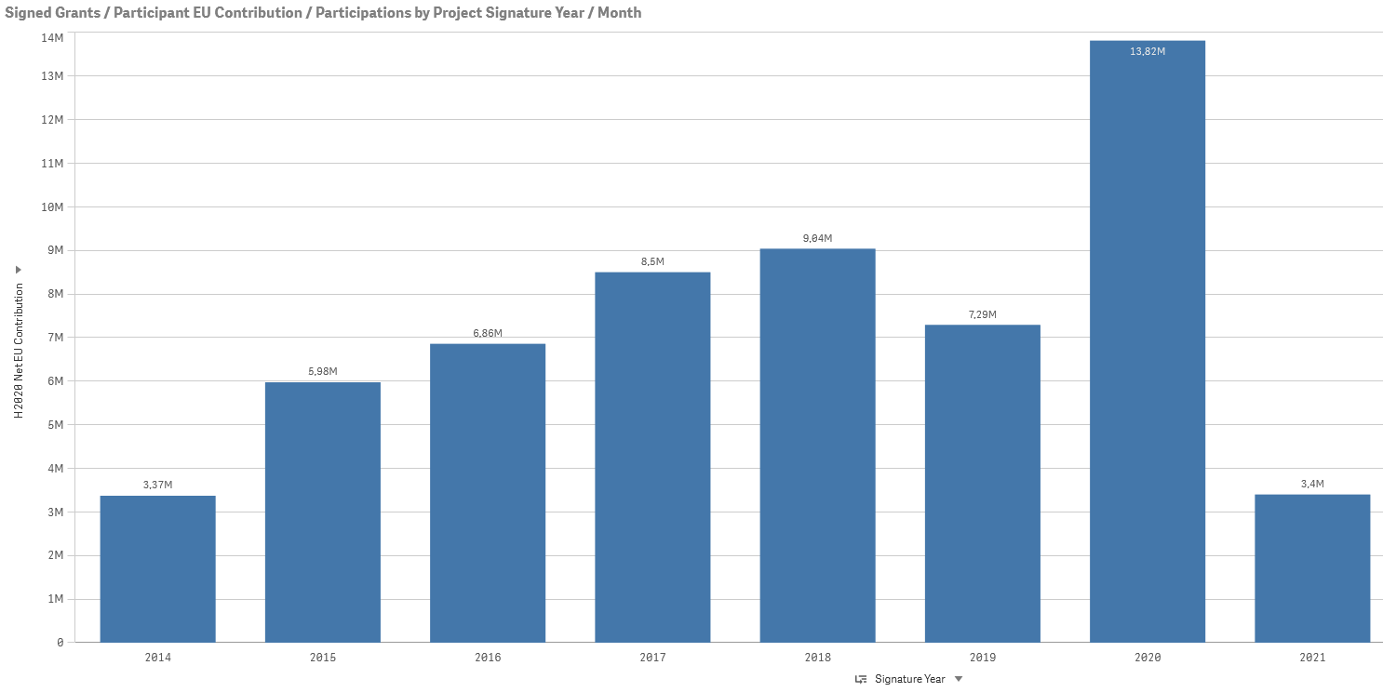
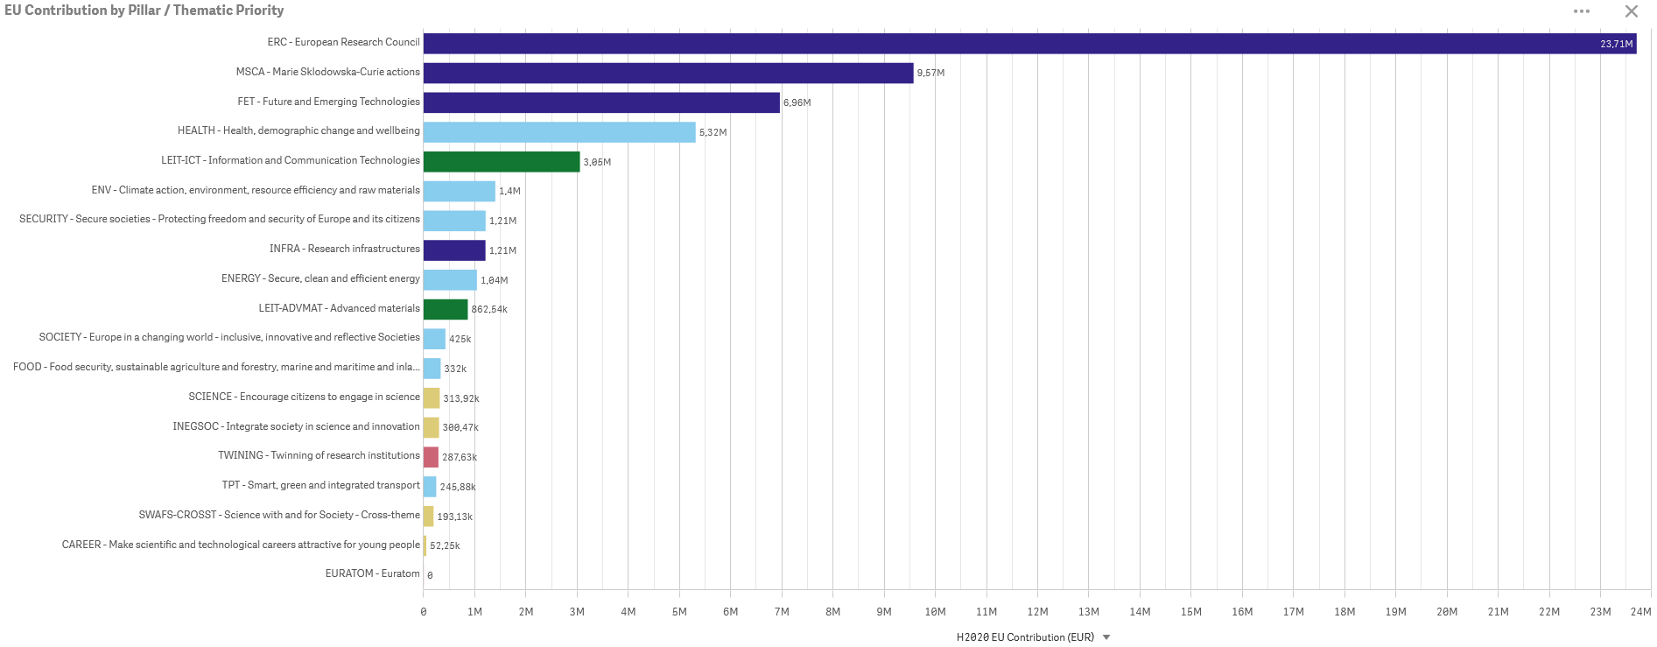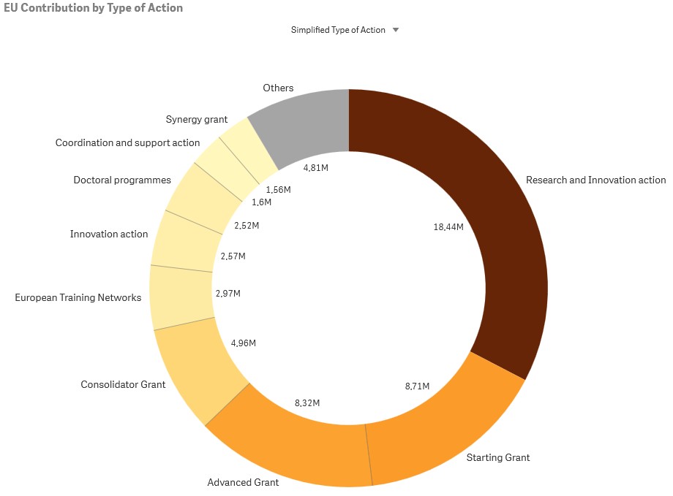

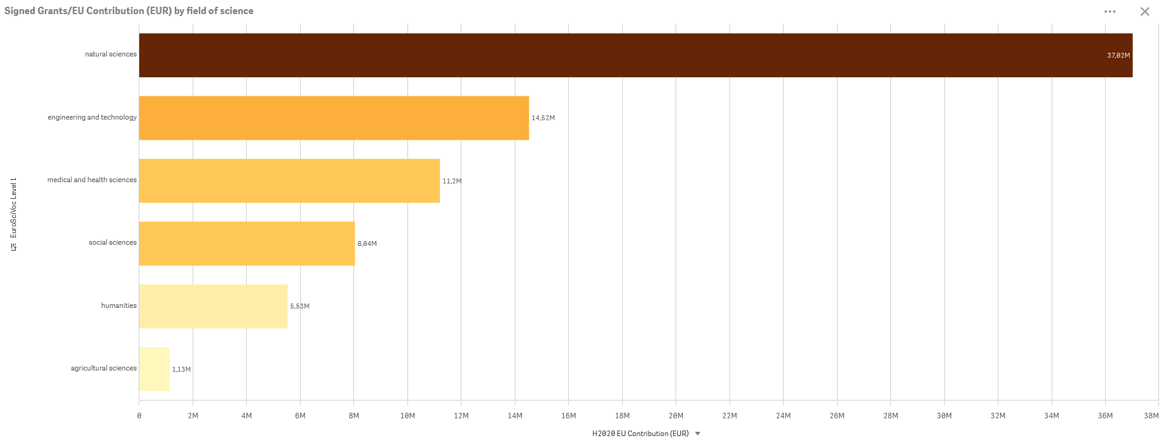
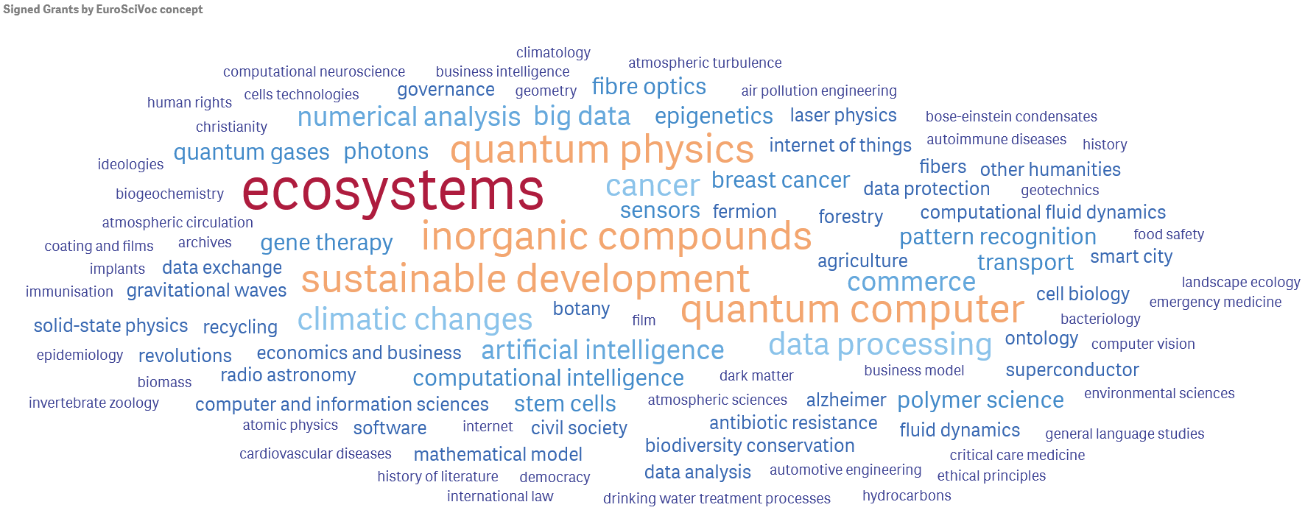
University of Naples Federico II – PIC: 999976590
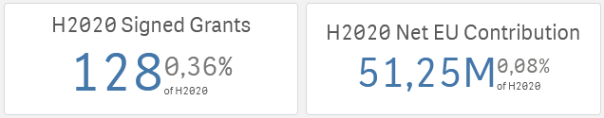
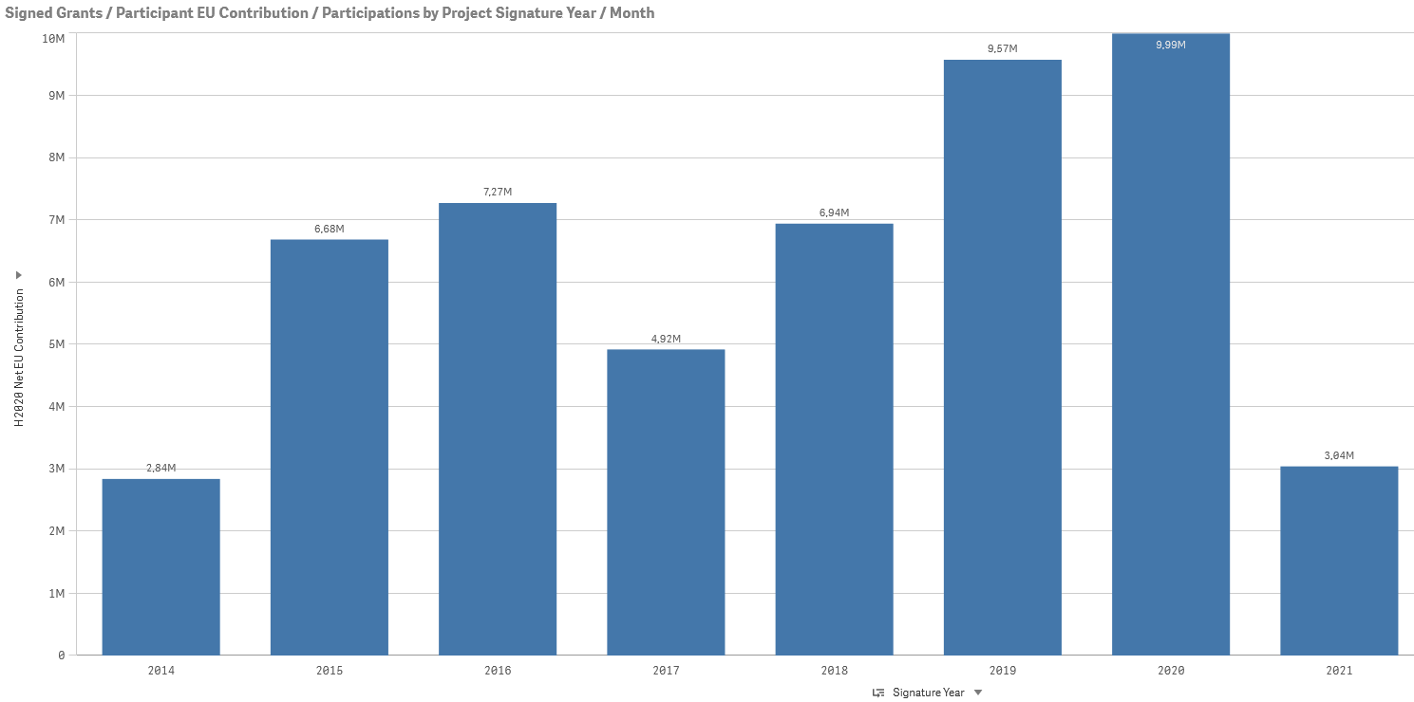
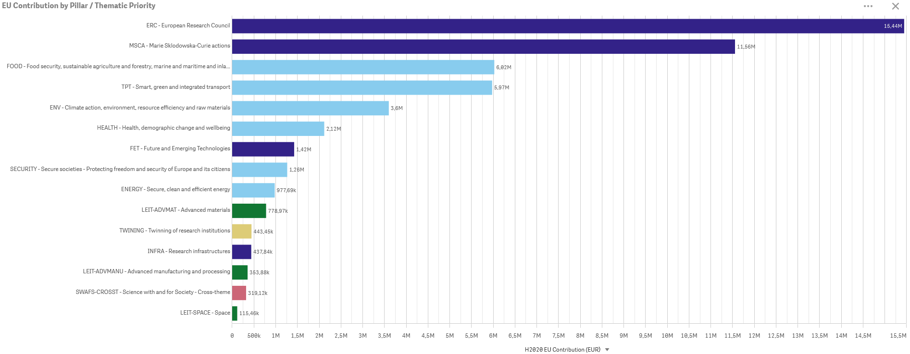
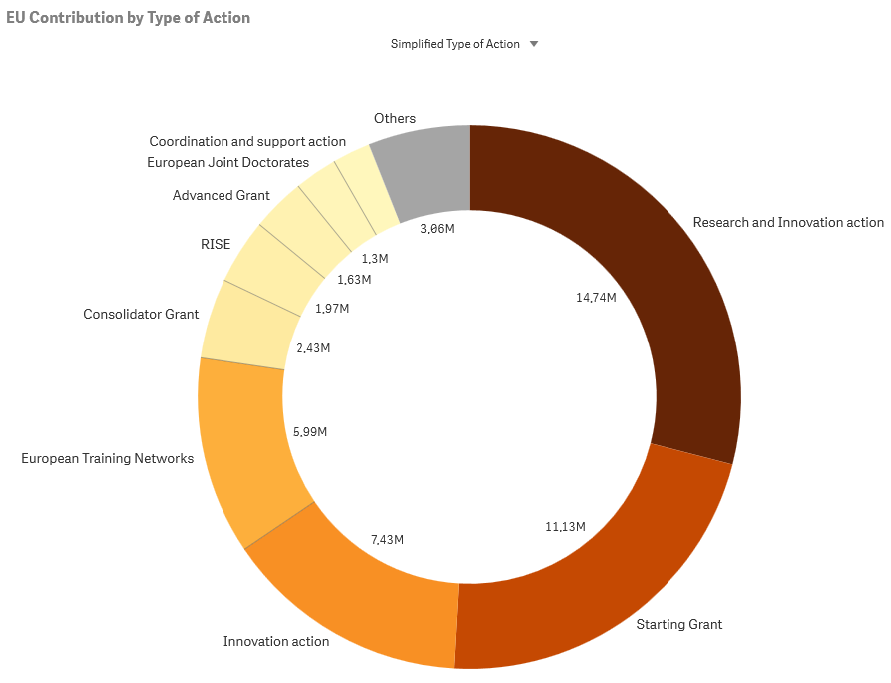
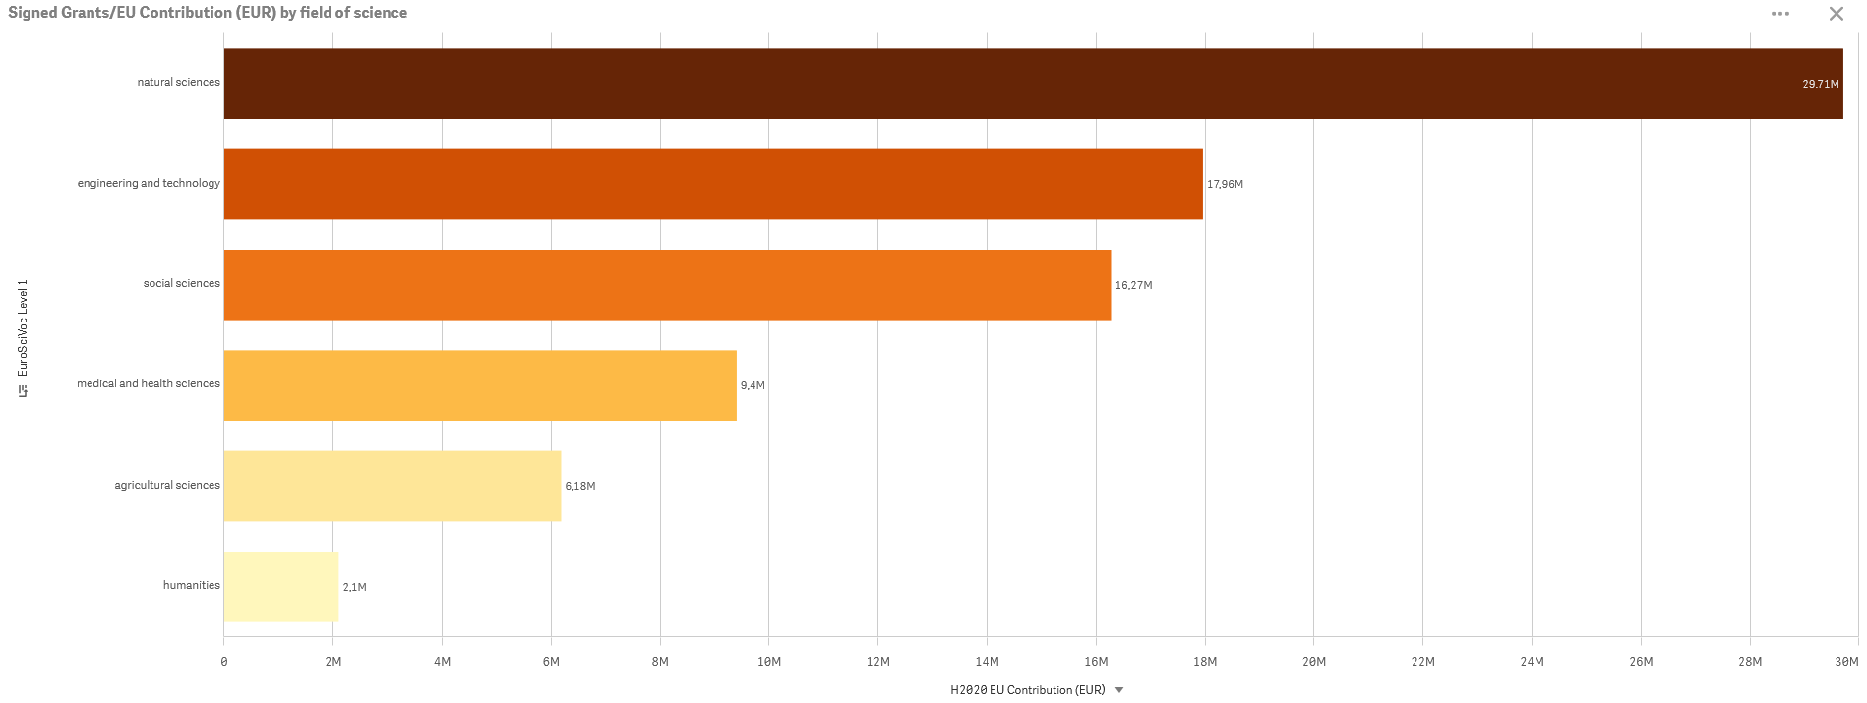
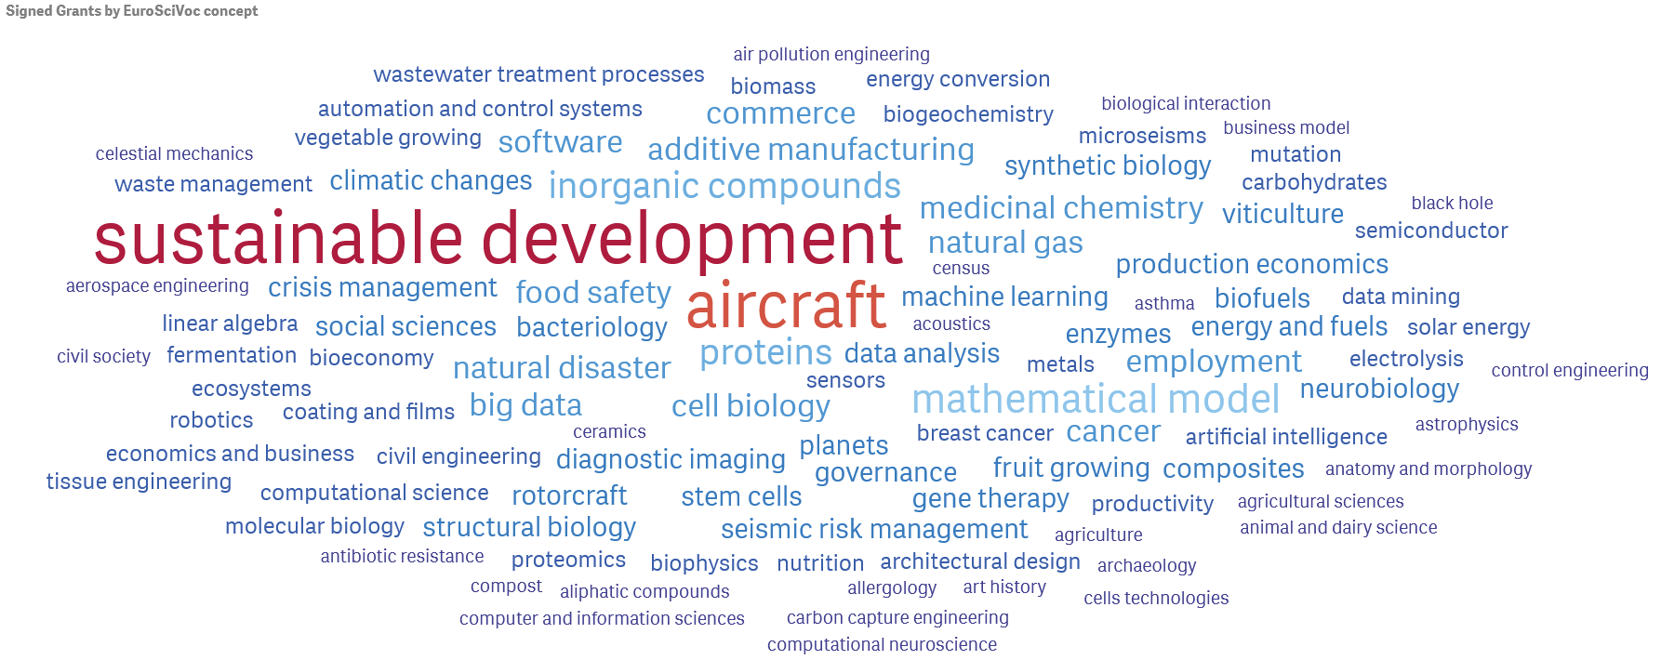
Vrije Universiteit Amsterdam – PIC: 954530344
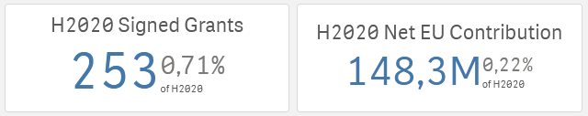
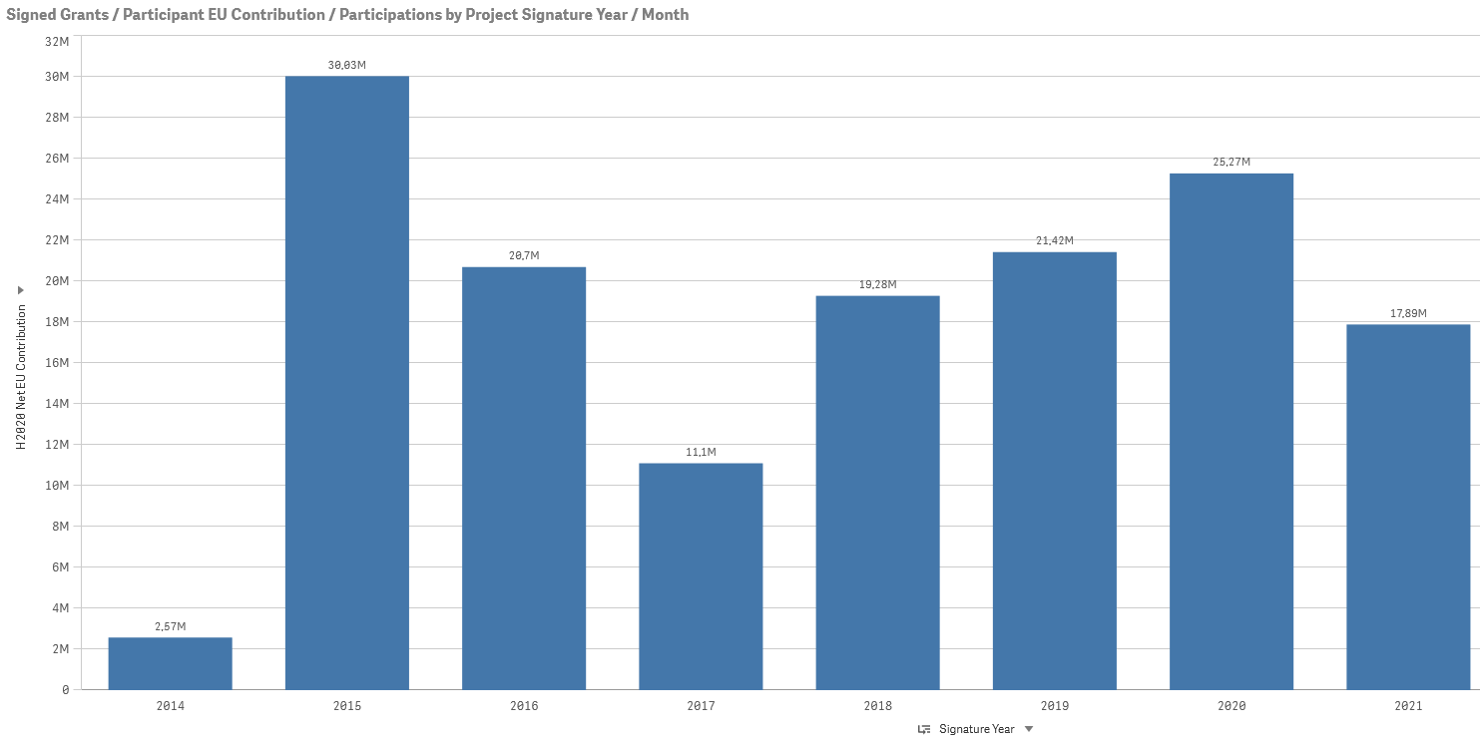
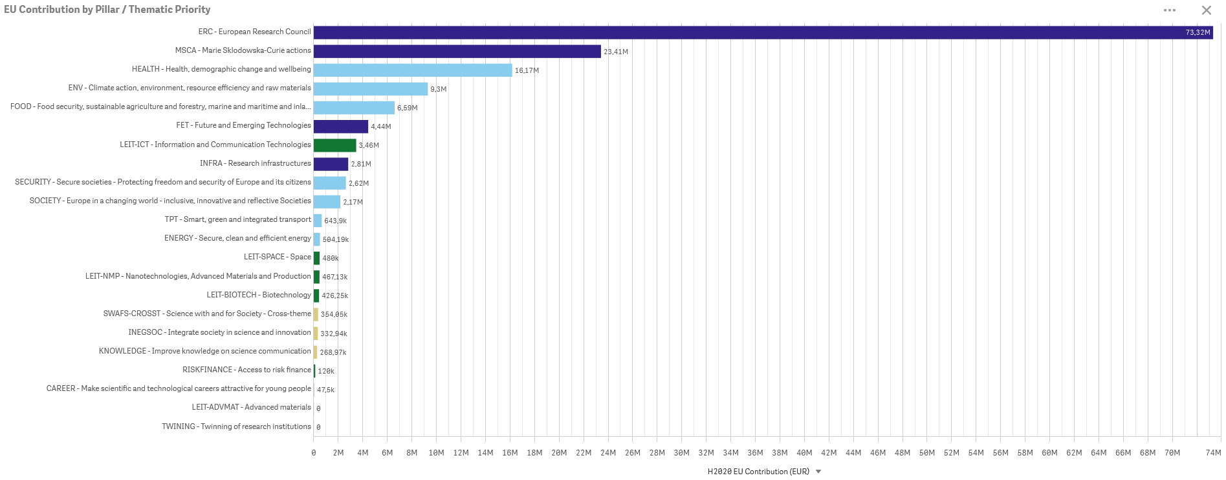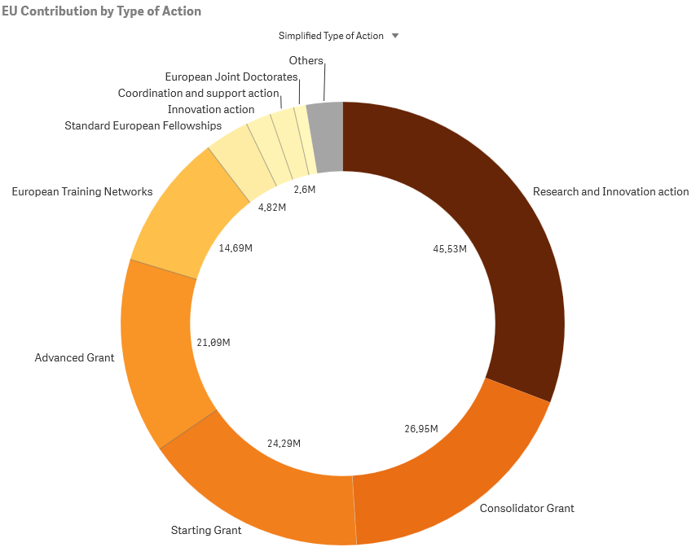
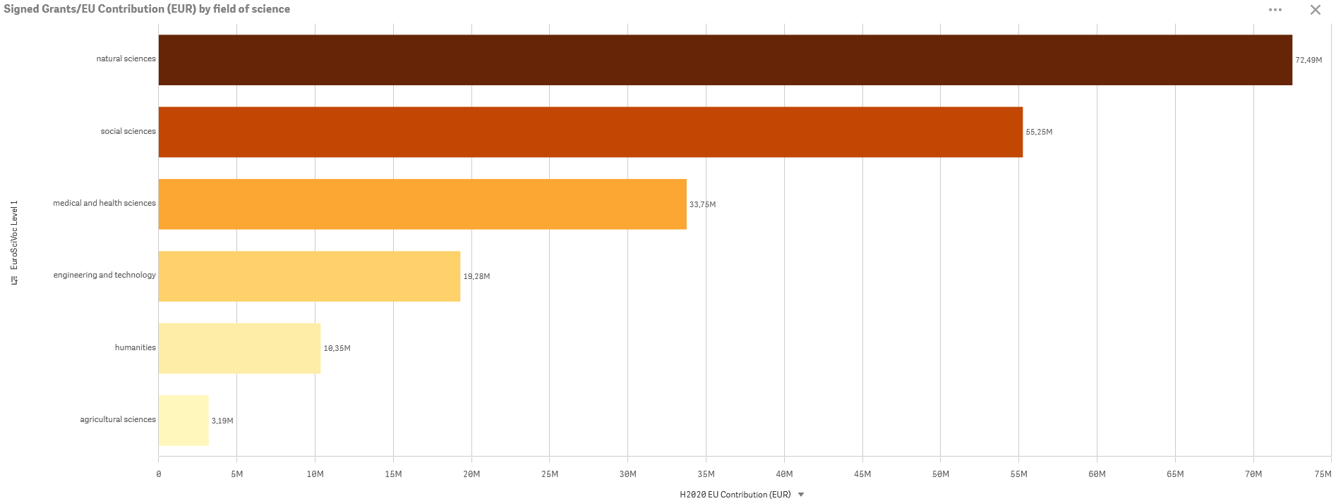
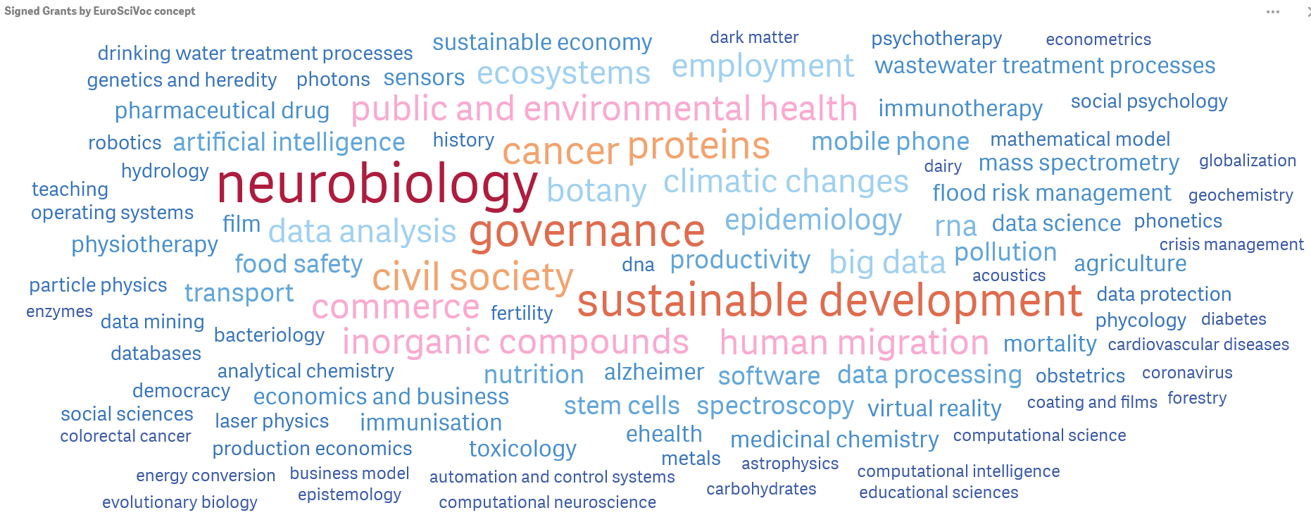

ANNEX 3 – Comparation among Aurora Universities publications

DATA INFORMATION
data | All publication types in all subject areas from 2016 to 2021
source | SciVal® database, Elsevier B.V., http://www.scival.com (downloaded on june-2022)
download date | June 2022
data processing | Graphics provided by SciVal.

SCHOLARLY OUTPUT BY PUBLICATION YEAR
DATA INFORMATION
data | All publication types in all subject areas from 2016 to 2021
source | SciVal® database, Elsevier B.V., http://www.scival.com (downloaded on june-2022)
download date | June 2022
data processing | Graphics provided by SciVal.

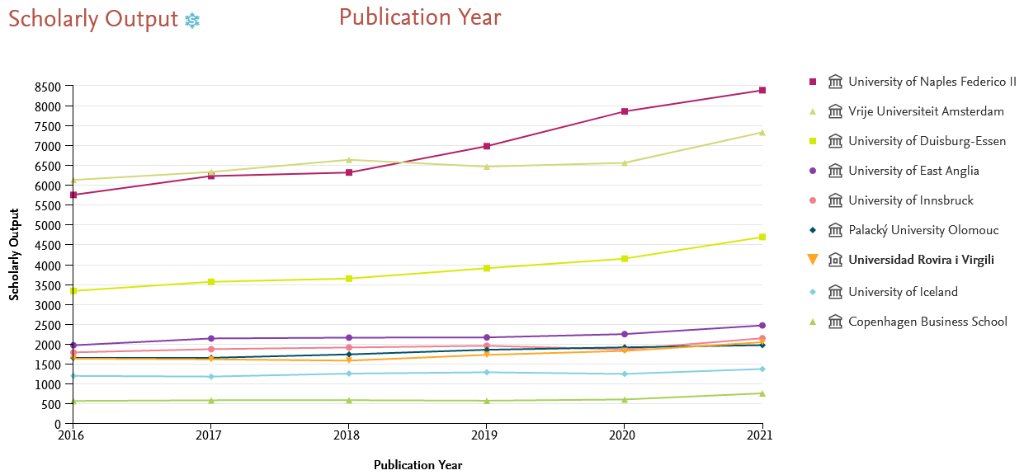
Fig 31 – Number of Scholarly Output of each Aurora University

SCHOLARLY OUTPUT BY PUBLICATION YEAR RELATIVE BY RESEARCH STAFF (IN FULL-TIME EQUIVALENTS)
DATA INFORMATION
data | All publication types in all subject areas from 2016 to 2021
source | QS 2022 - SciVal® database, Elsevier B.V., http://www.scival.com (downloaded on june-2022)
download date | June 2022
data processing | Own graphics created with SciVal data.  Data on teaching and research staff (in full-time equivalents) are obtained from QS World University Rankings (2022 edition), except for the University of Iceland and the Copenhaguen Business School which are obtained from institutional websites.
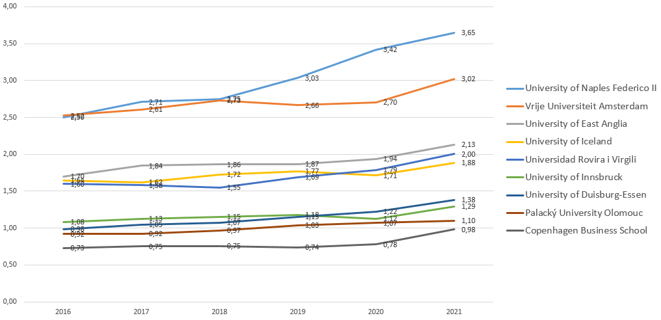
Fig 32 – Scholarly output relative by research staff

ACADEMIC – CORPORATE COLLABORATION BY PUBLICATION YEAR
DATA INFORMATION
data | All publication types in all subject areas from 2016 to 2021
source | SciVal® database, Elsevier B.V., http://www.scival.com (downloaded on june-2022)
download date | June 2022
data processing | Graphics provided by SciVal.

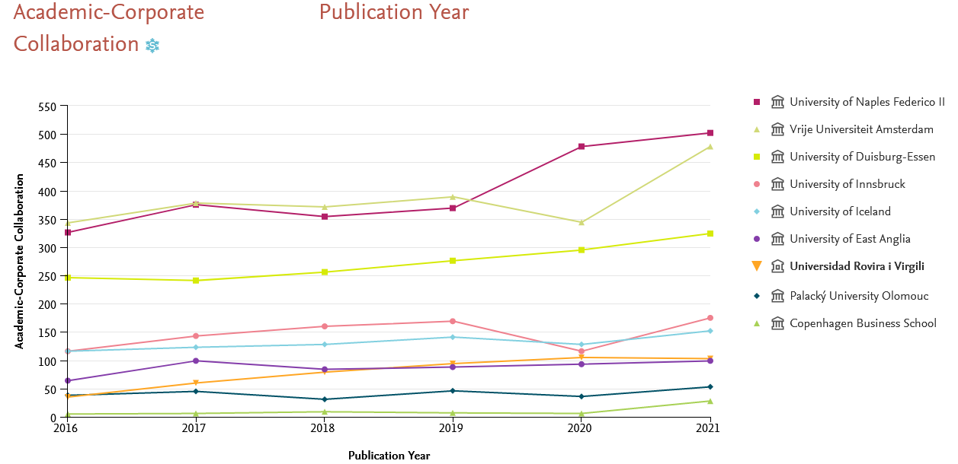
Fig 33 - Number of publications with corporates

ANNEX 4 – Comparation among Aurora Universities publicacions by clusters

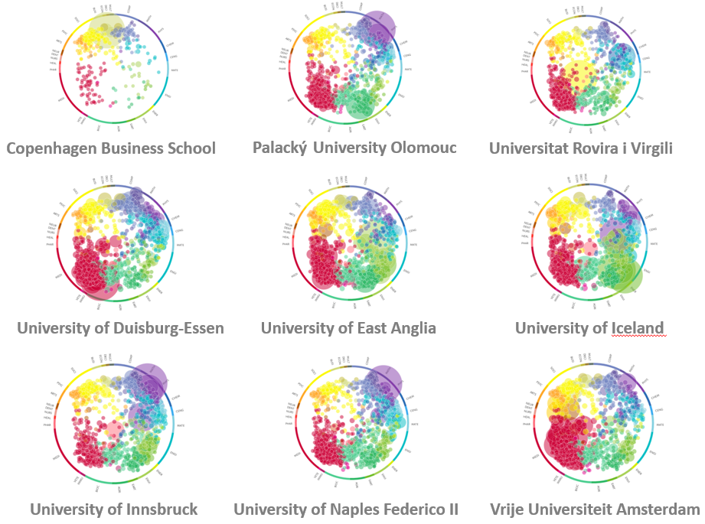
Fig 34 – Aurora Universities publications by topic clusters

ANNEX 5 - General information of each AURORA university publications

DATA INFORMATION
data | All publication types in all subject areas from 2016 to 2021
source | SciVal® database, Elsevier B.V., http://www.scival.com (downloaded on june-2022)
download date | June 2022
data processing | Graphics provided by SciVal.

Brief summary of Aurora Universities highlights:

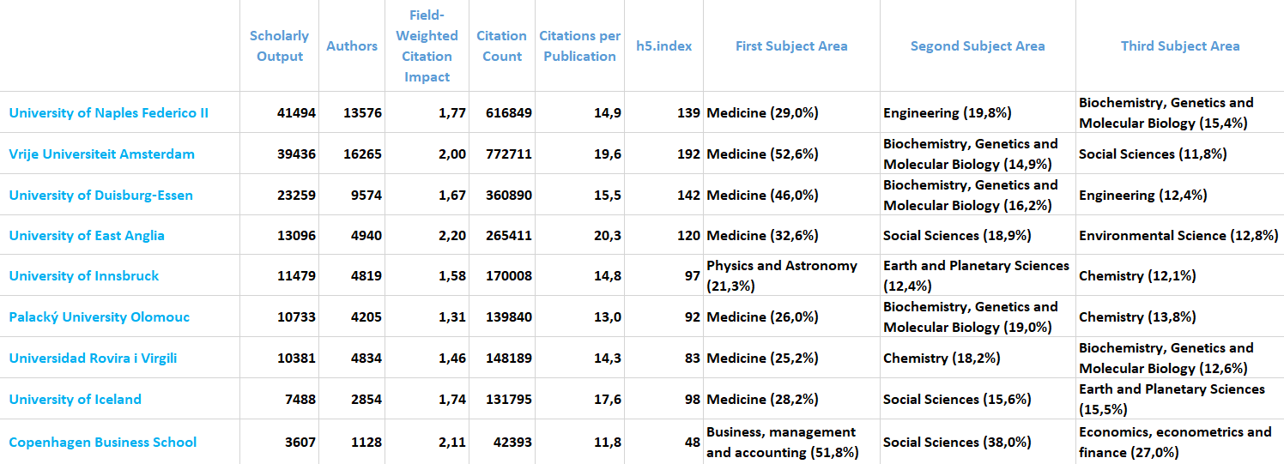

Copenhagen Business School

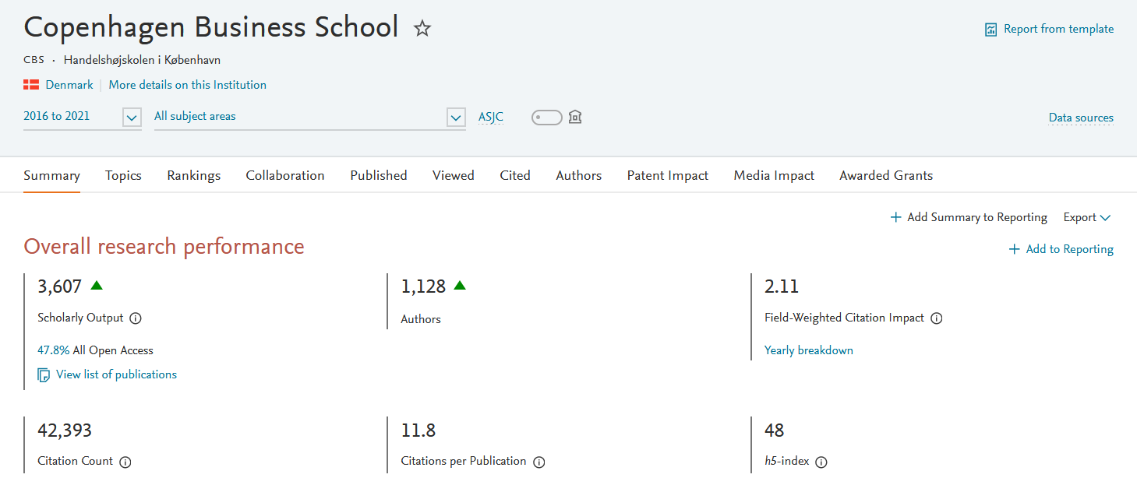
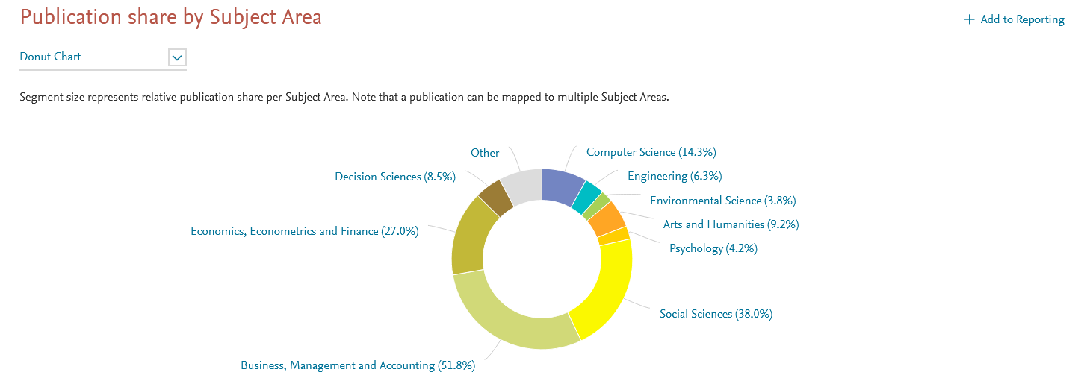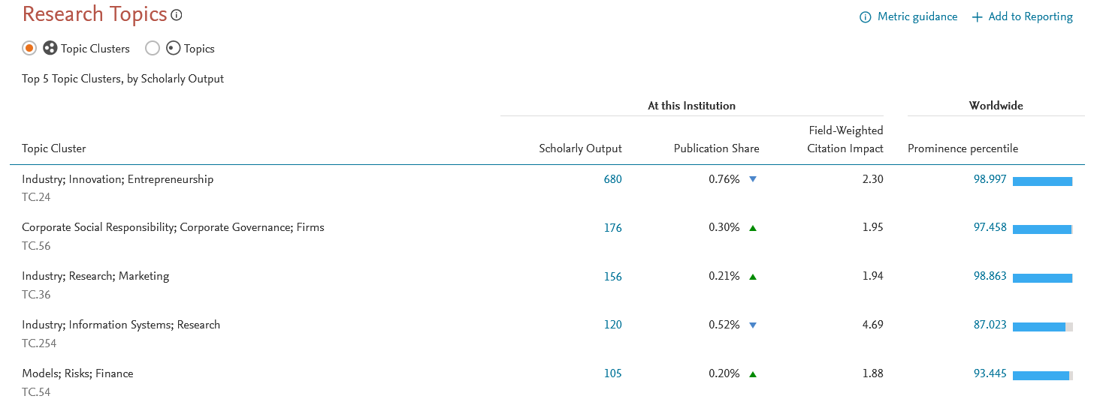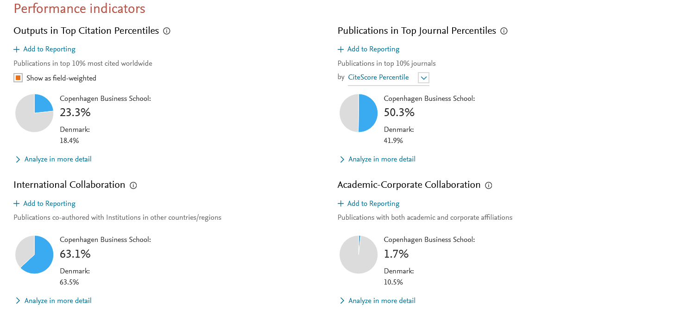

Palacký University Olomouc

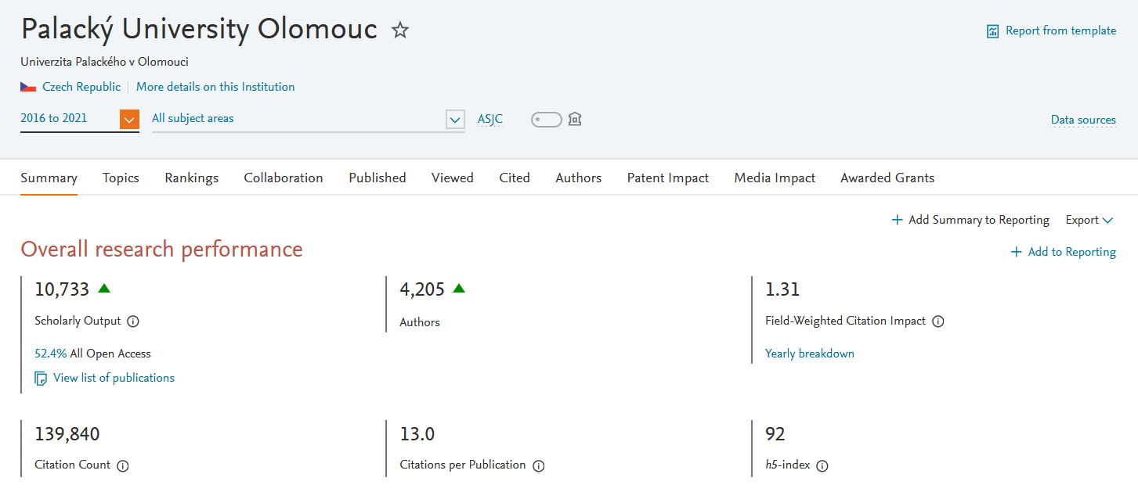
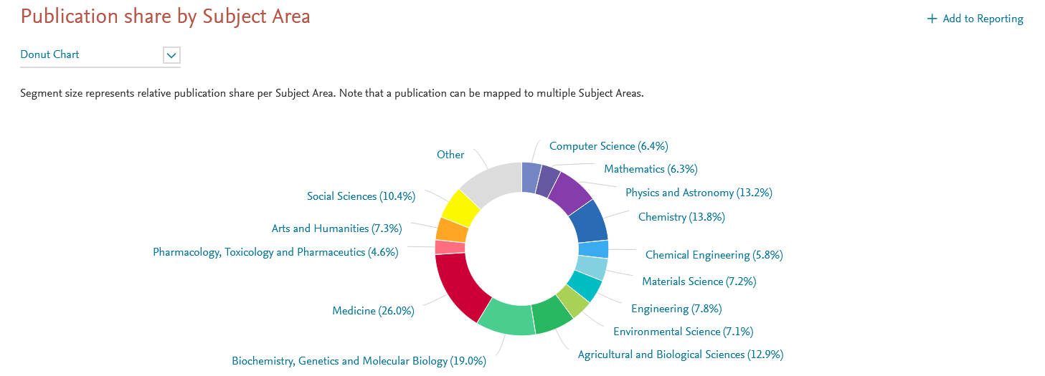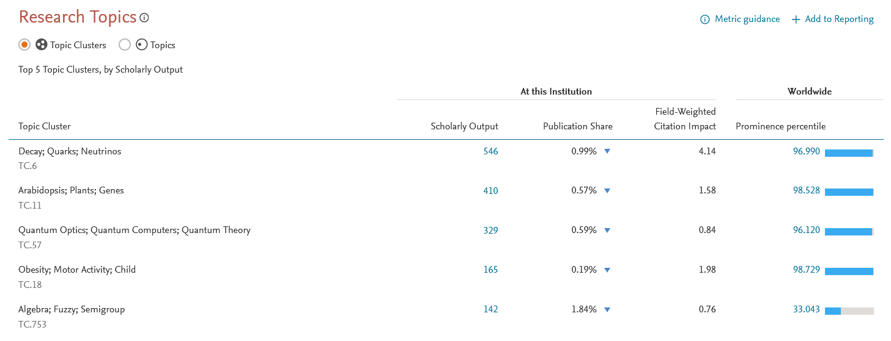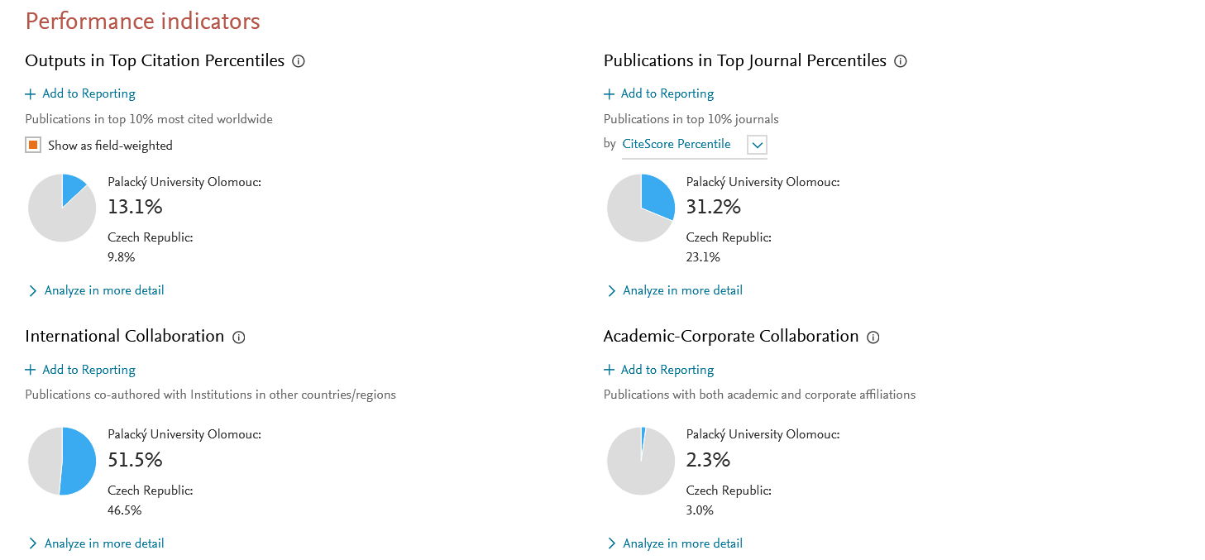

Universidad Rovira i Virgili

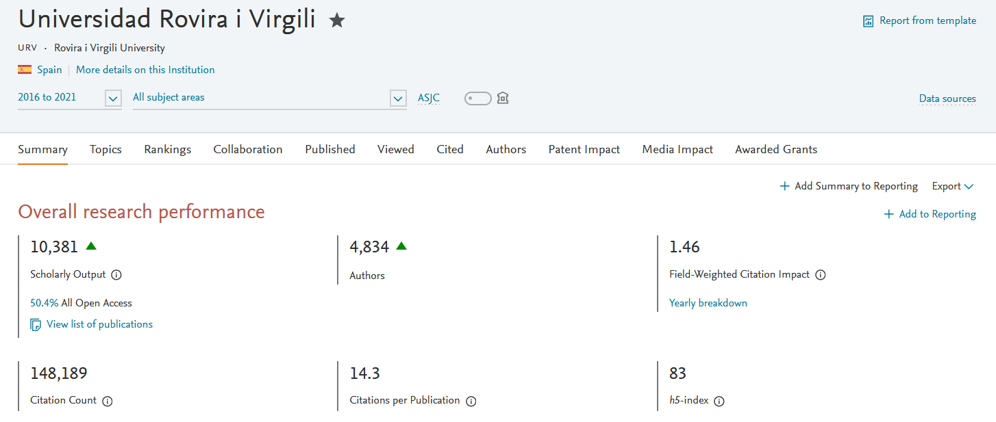
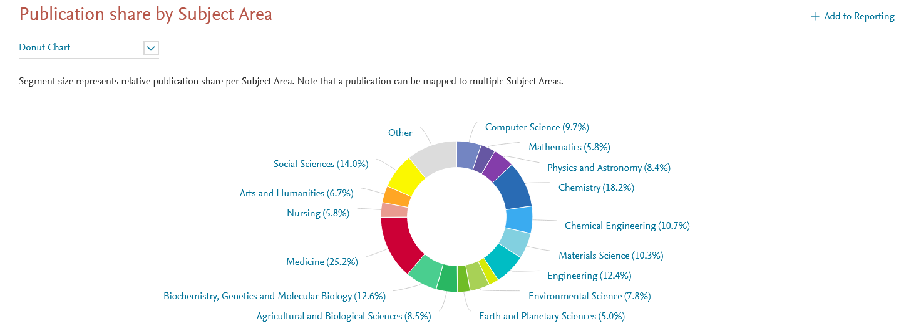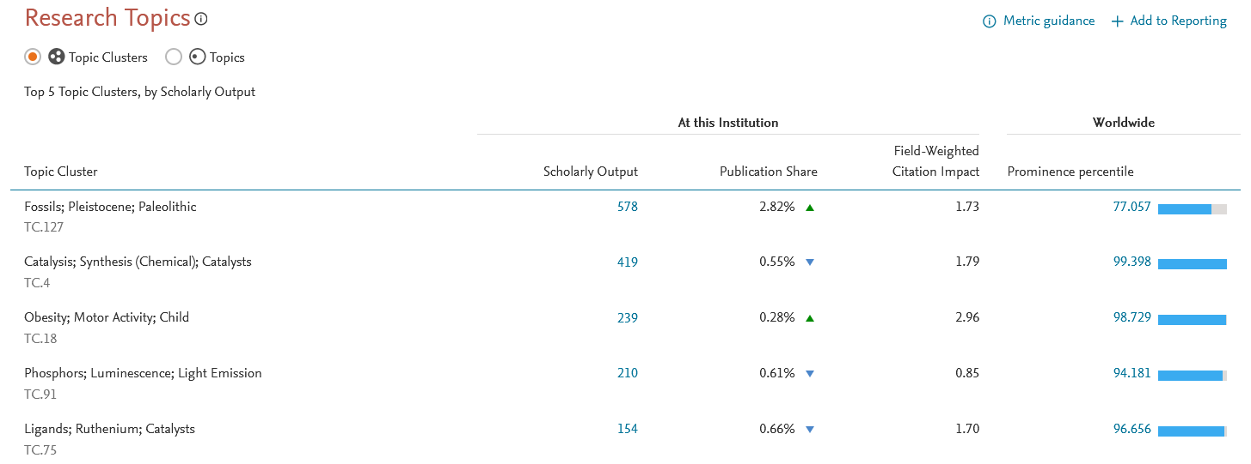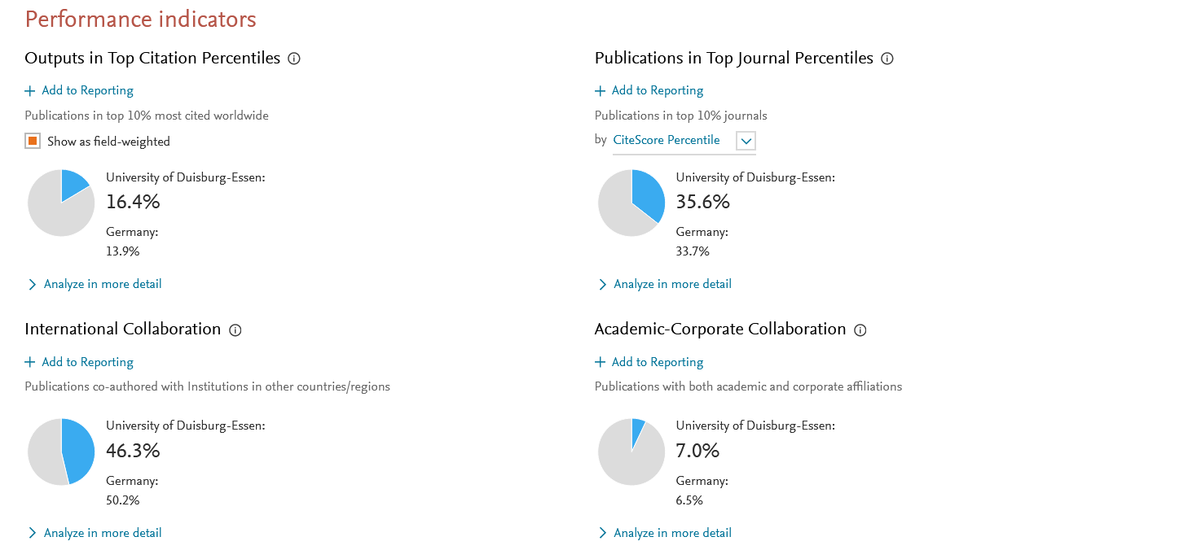

University of Duisburg-Essen

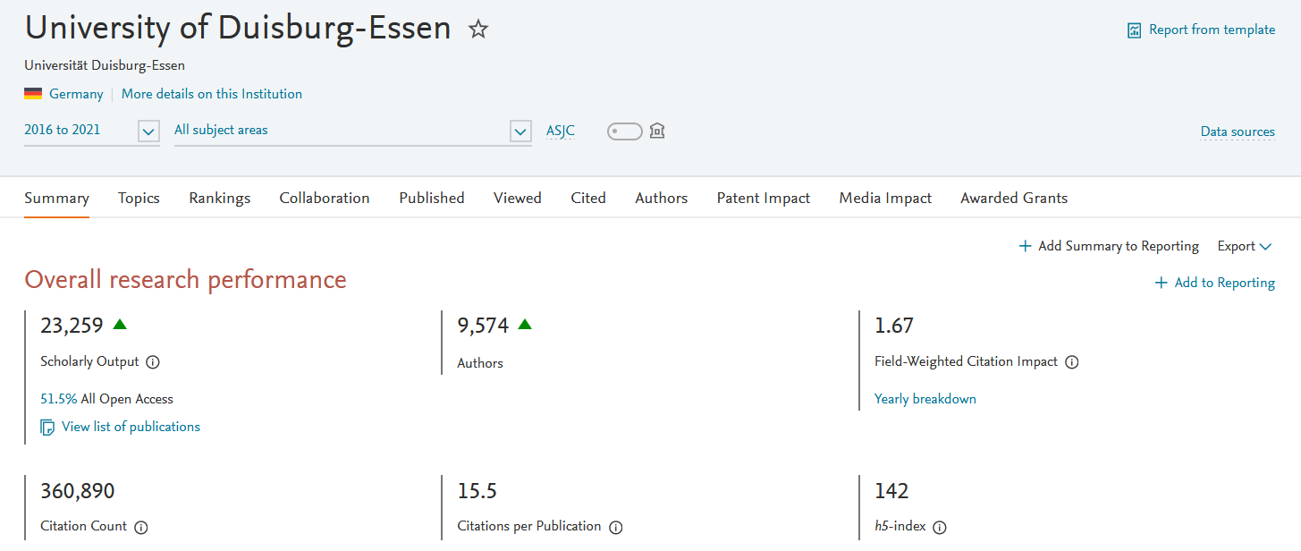
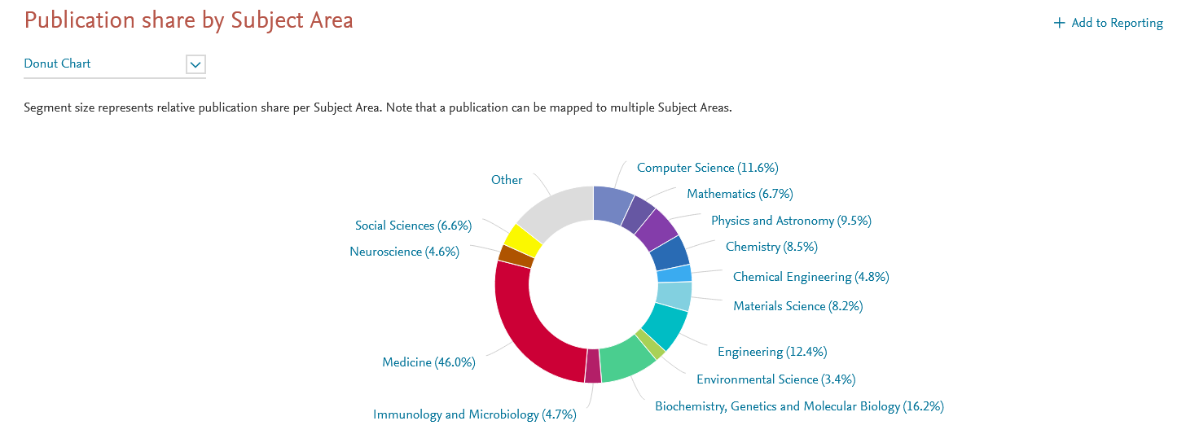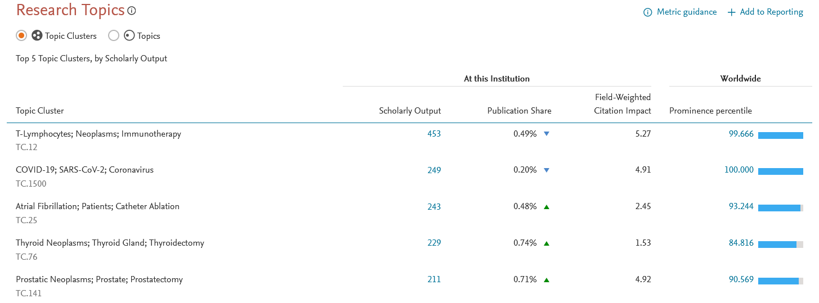
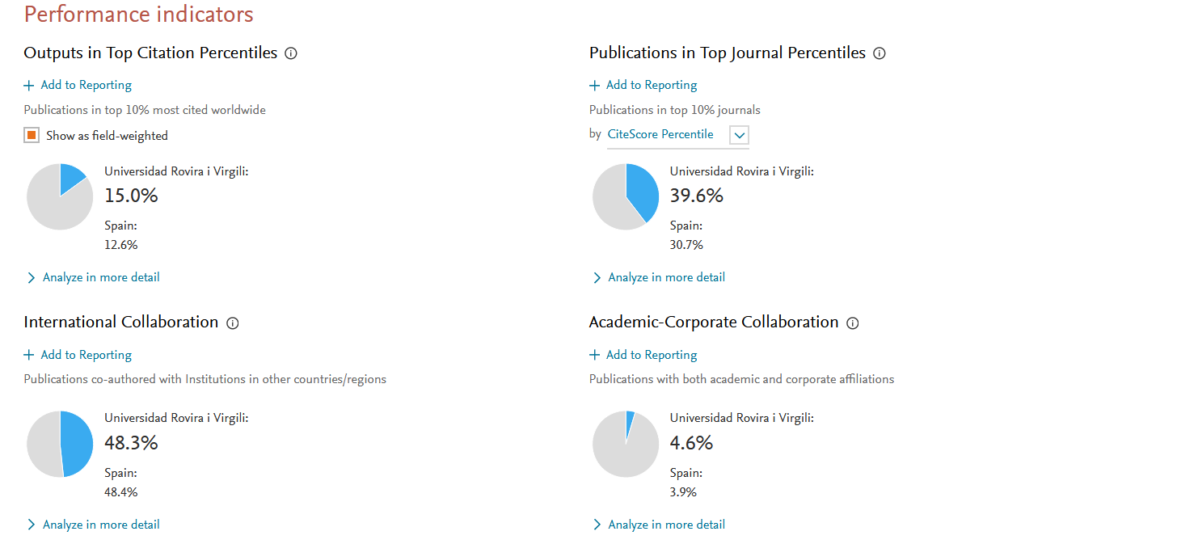

University of East Anglia

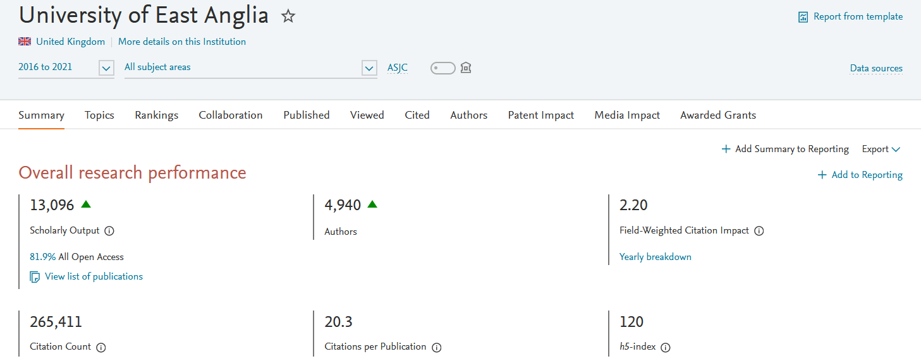
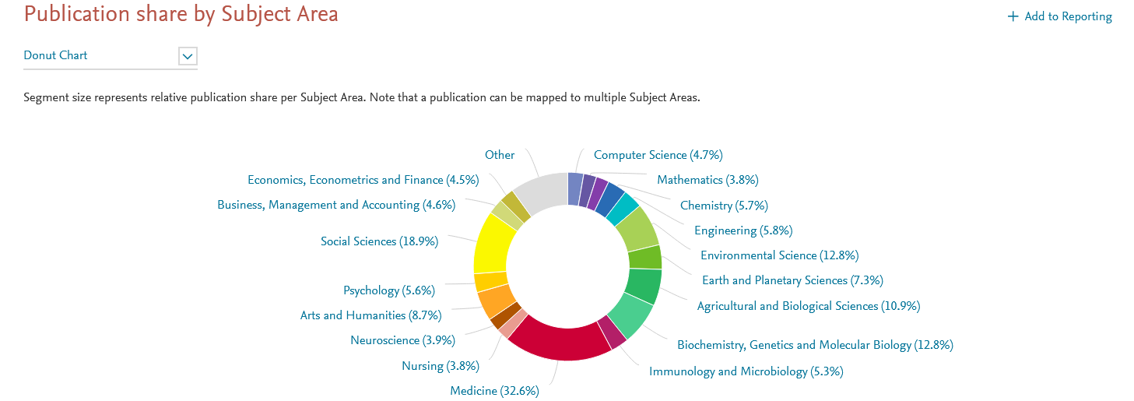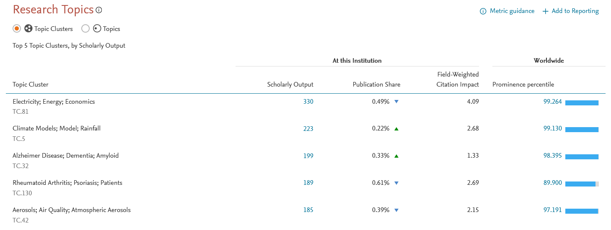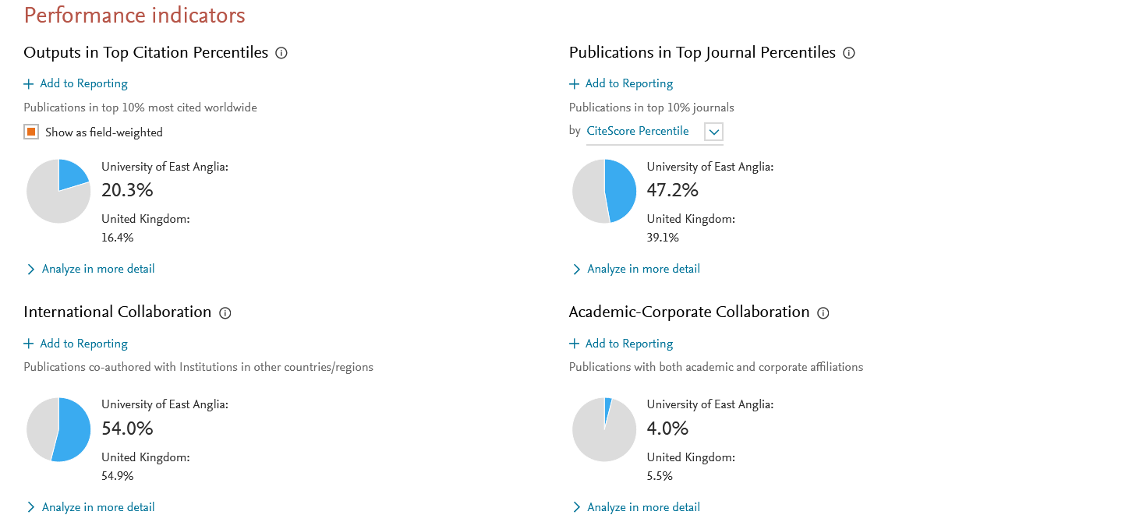

University of Iceland

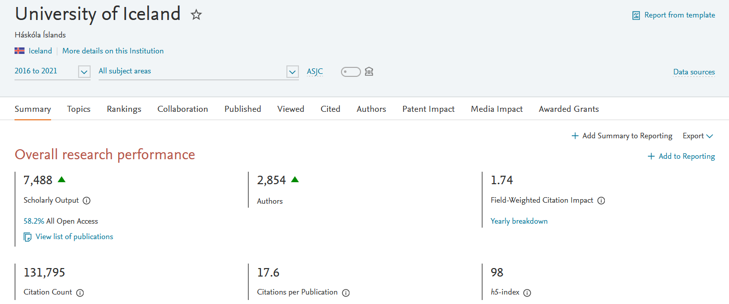
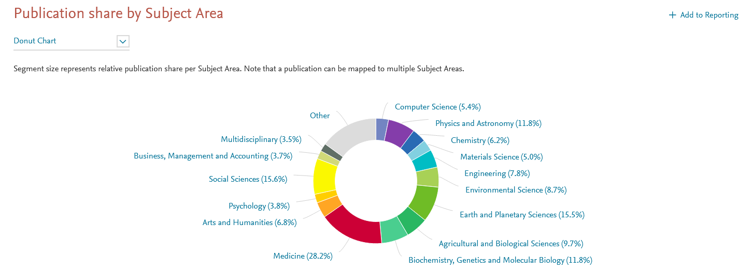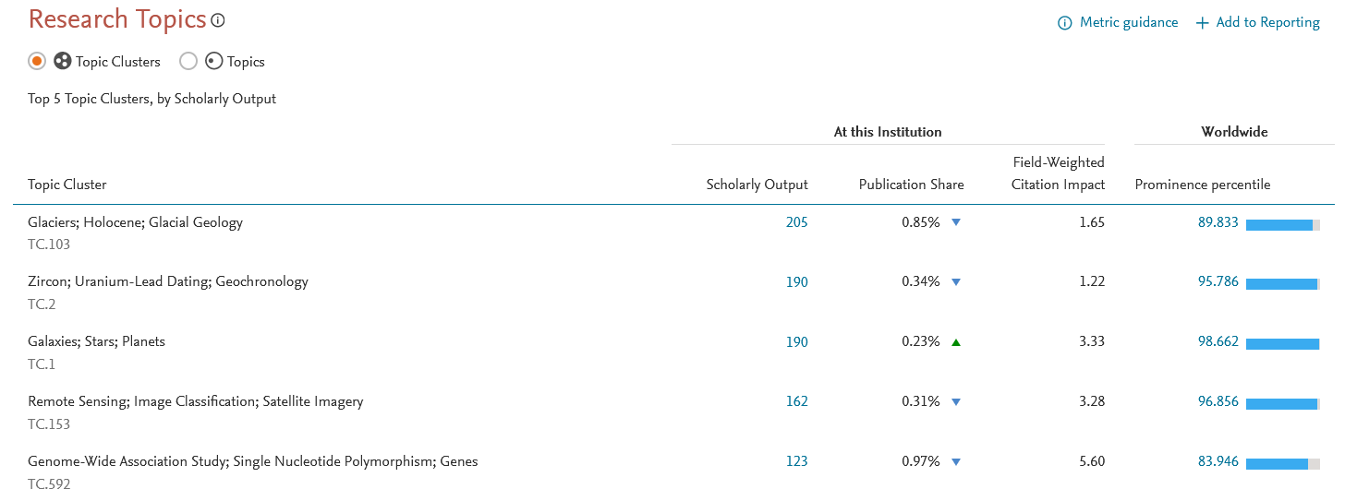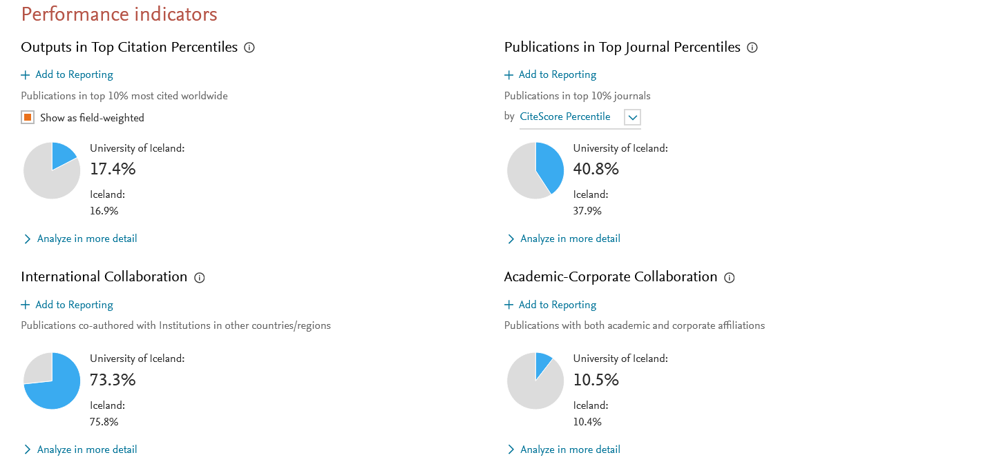

University of Innsbruck
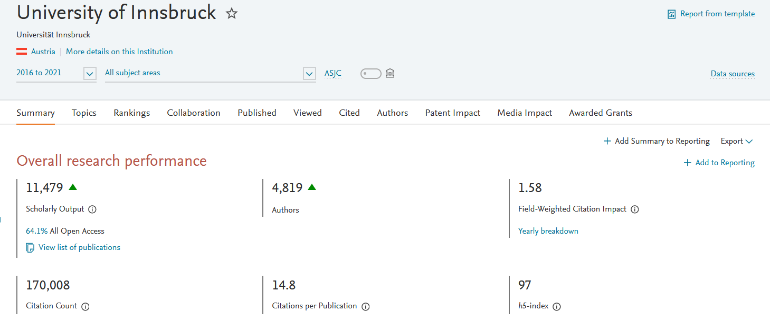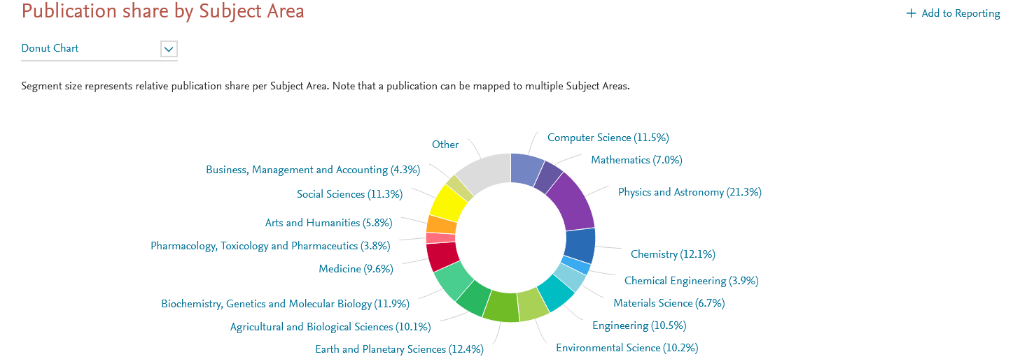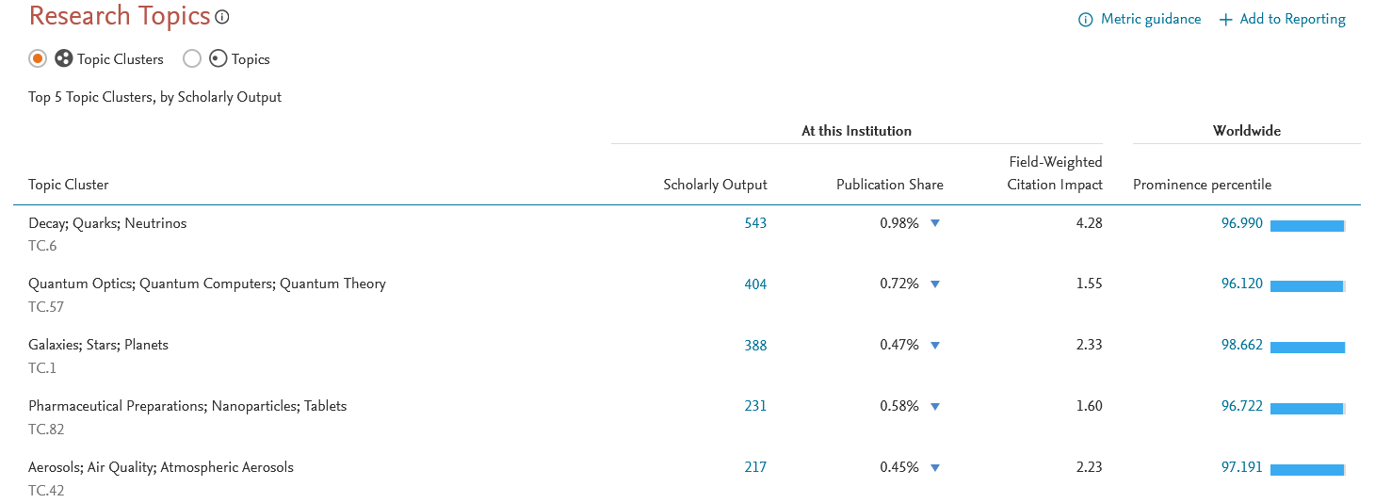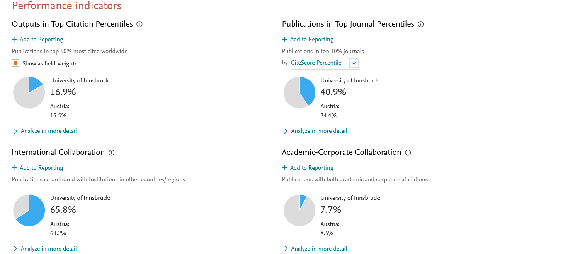

University of Naples Federico II
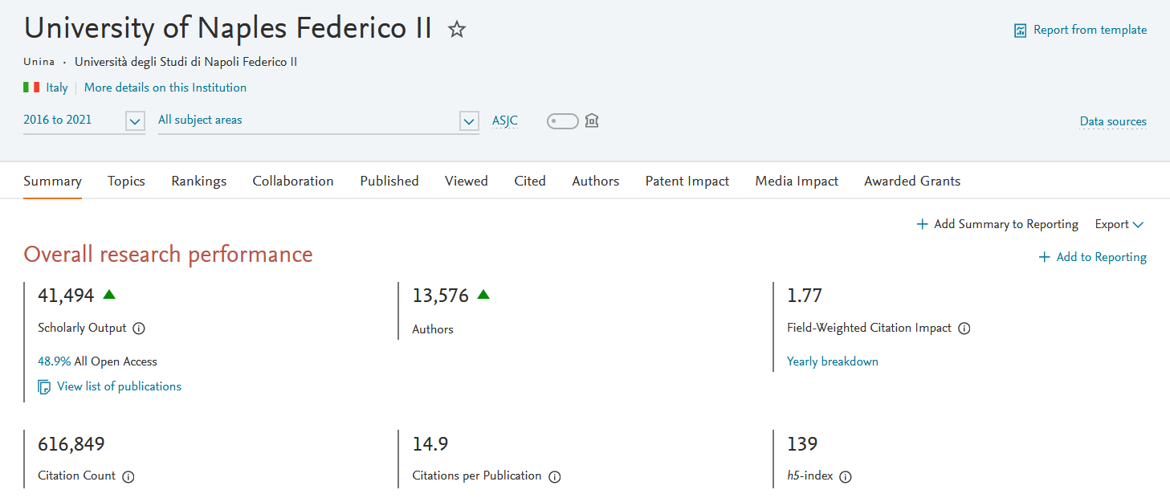
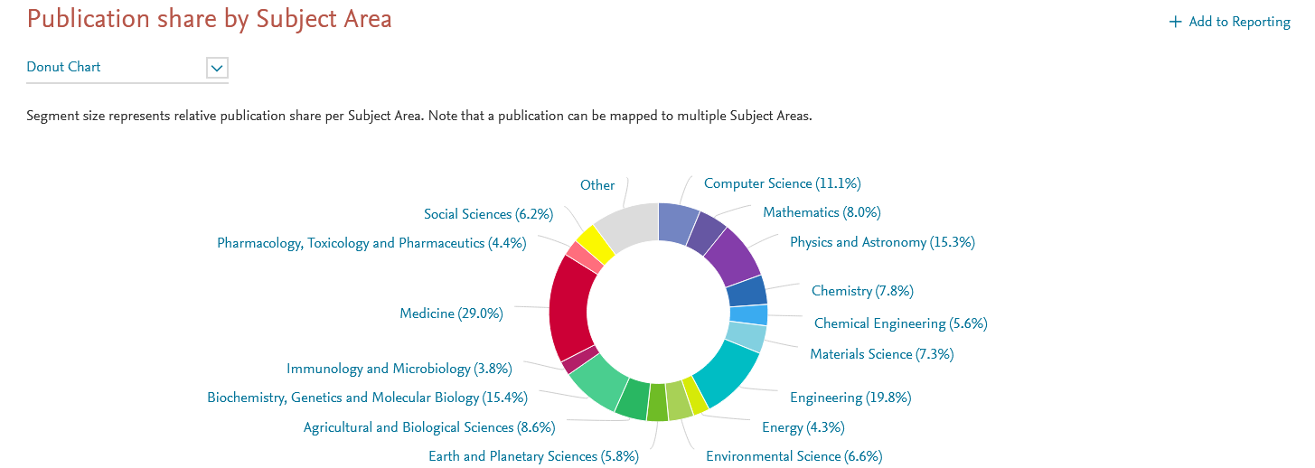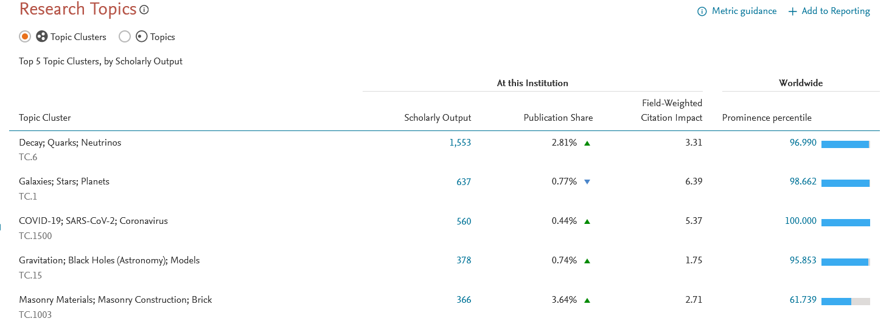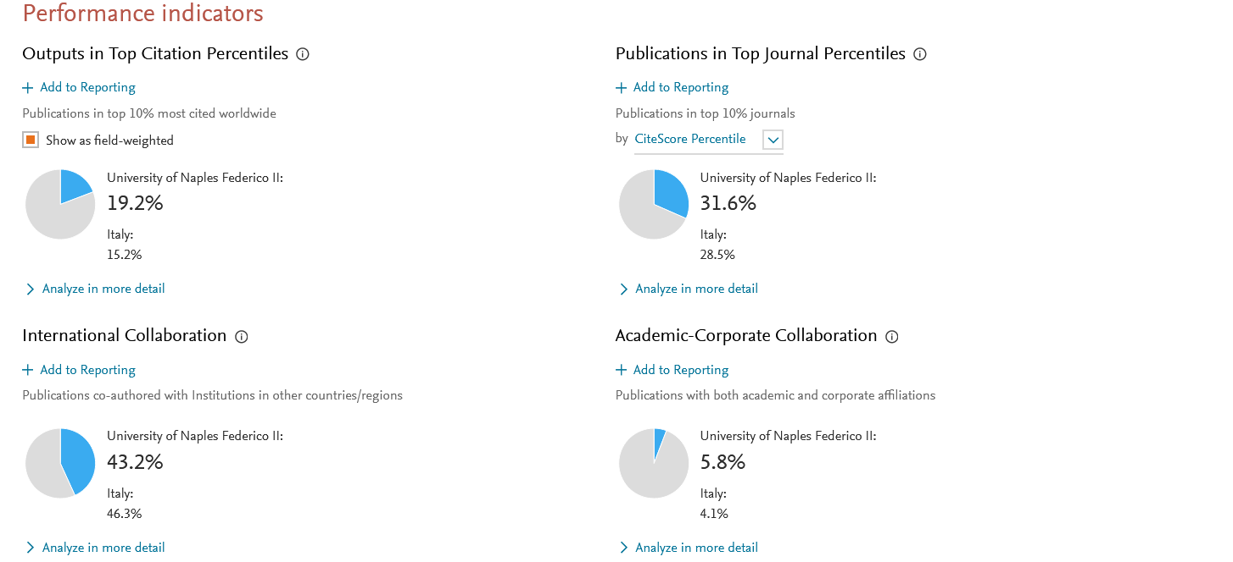

Vrije Universiteit Amsterdam

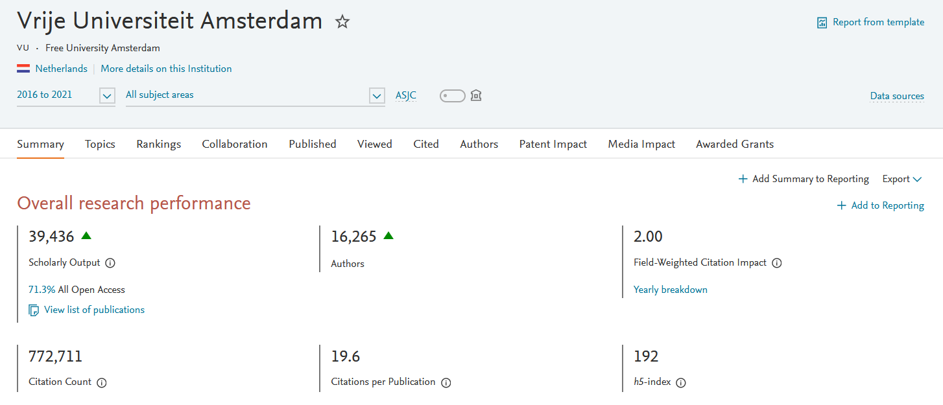
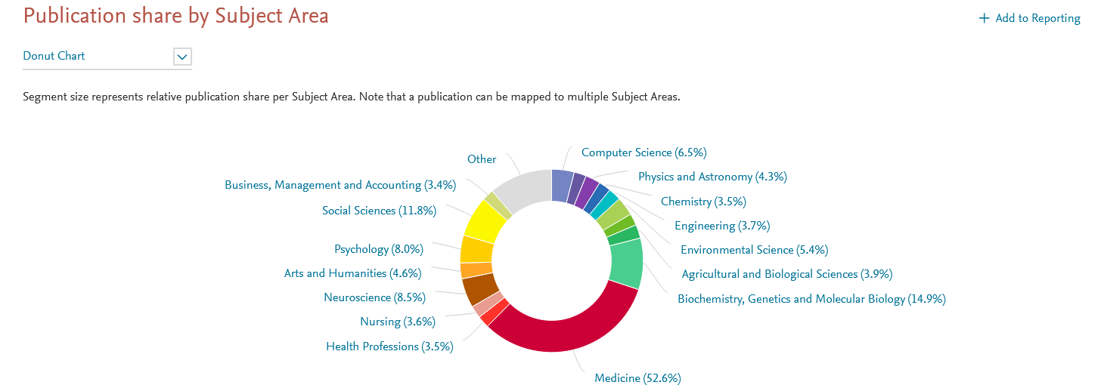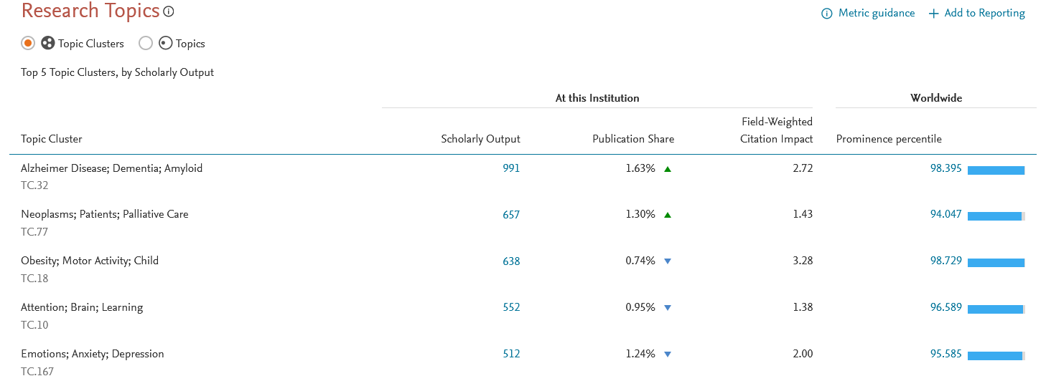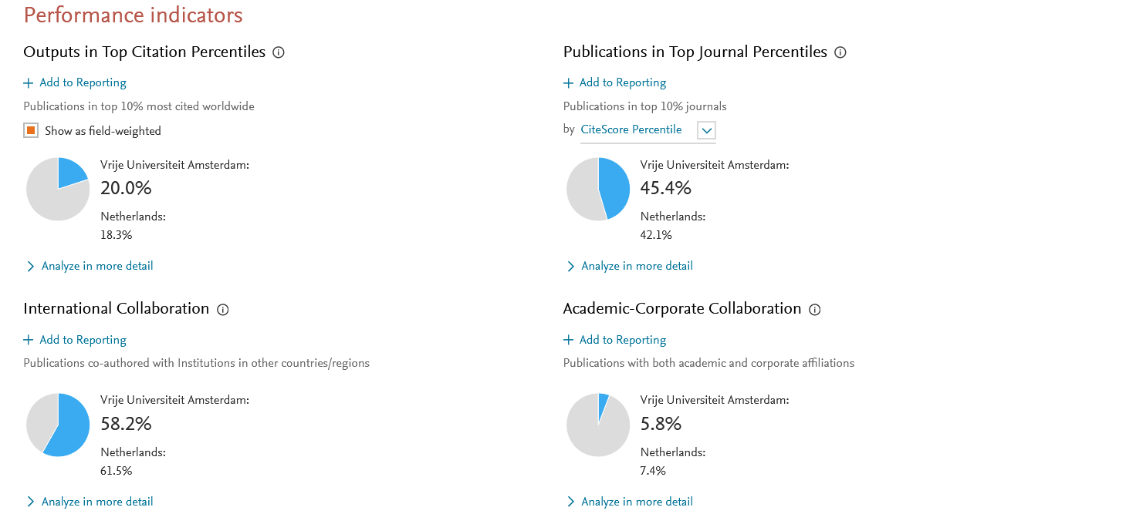

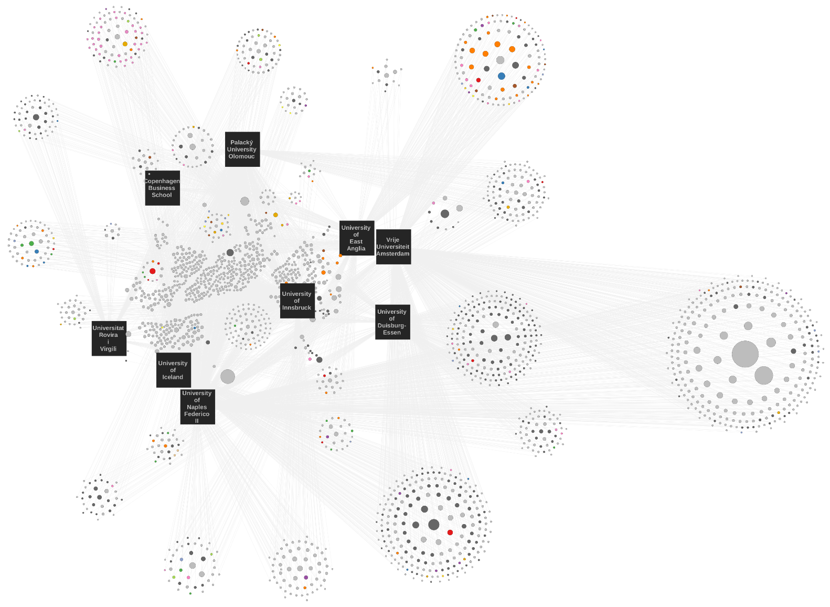
ANNEX 6 - Map of collaborations in publications within Aurora by SDGs
Fig 35 – Map of collaborations in publications within Aurora
DATA INFORMATION
data | All publication types by SDGs from 2016 to 2021
source | SciVal® database, Elsevier B.V., http://www.scival.com (downloaded on june-2022)
download date | June 2022
data processing | Own graphics created with SciVal data.

Collaborations within Aurora
- Each point is a publication.
- The colors are by SDGs.
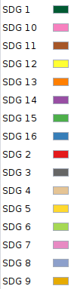

Map of collaborations within Aurora by SDGs
DATA INFORMATION
data | All publication types by SDGs from 2016 to 2021
source | SciVal® database, Elsevier B.V., http://www.scival.com (downloaded on june-2022)
download date | June 2022
data processing | Own graphics created with SciVal data.

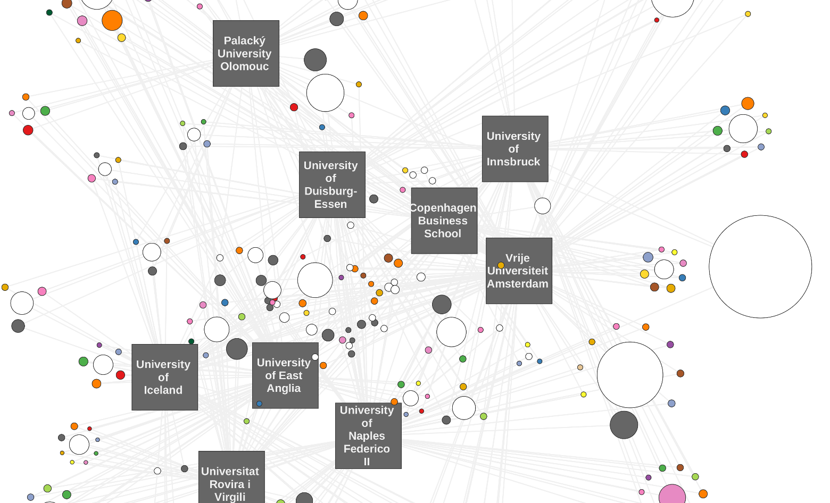
Fig 36 - Map of collaborations within Aurora by groups of publications
Collaborations within Aurora
- Each point is a group of publication.
- The colors are by SDGs.

Map of collaborations within Aurora by SDGs
DATA INFORMATION
data | All publication types by SDGs from 2016 to 2021
source | SciVal® database, Elsevier B.V., http://www.scival.com (downloaded on june-2022)
download date | June 2022
data processing | Own graphics created with SciVal data.
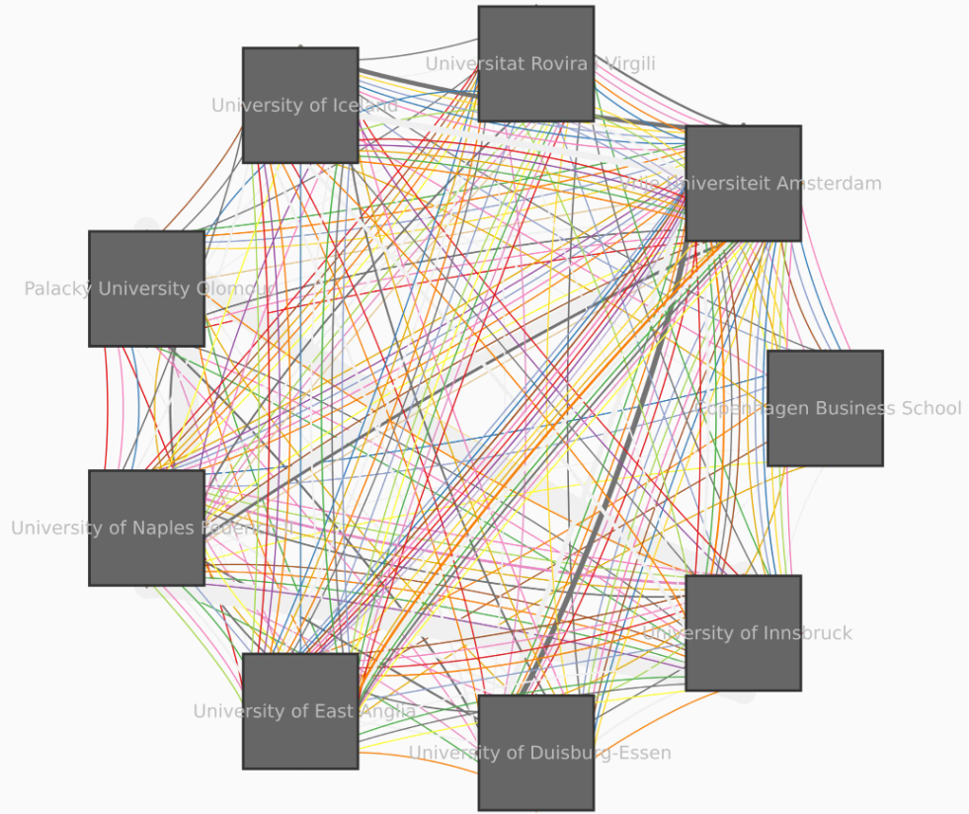

Fig 37 - Map of collaborations within Aurora by SDGs

ANNEX 7 - Aurora collaborations with the other alliances

DATA INFORMATION
data | All publication types in all subject areas from 2016 to 2021
source | SciVal® database, Elsevier B.V., http://www.scival.com (downloaded on june-2022)
download date | June 2022
data processing | Own graphics created with SciVal data.

37 EUROPEAN UNIVERSITIES ALLIANCES COLLABORATION BY AURORA

Fig 38 – Number of co-publications and authors with other alliances

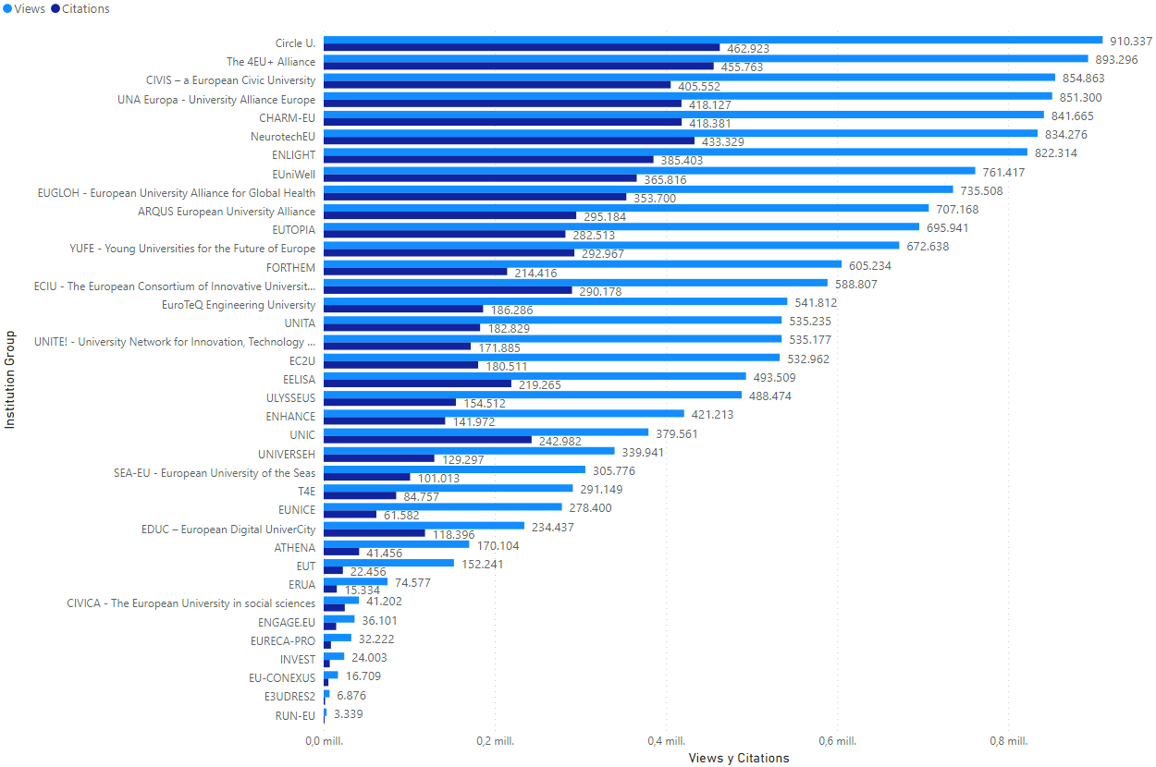
Fig 39 – Number of views and citations in co-publications with other alliances
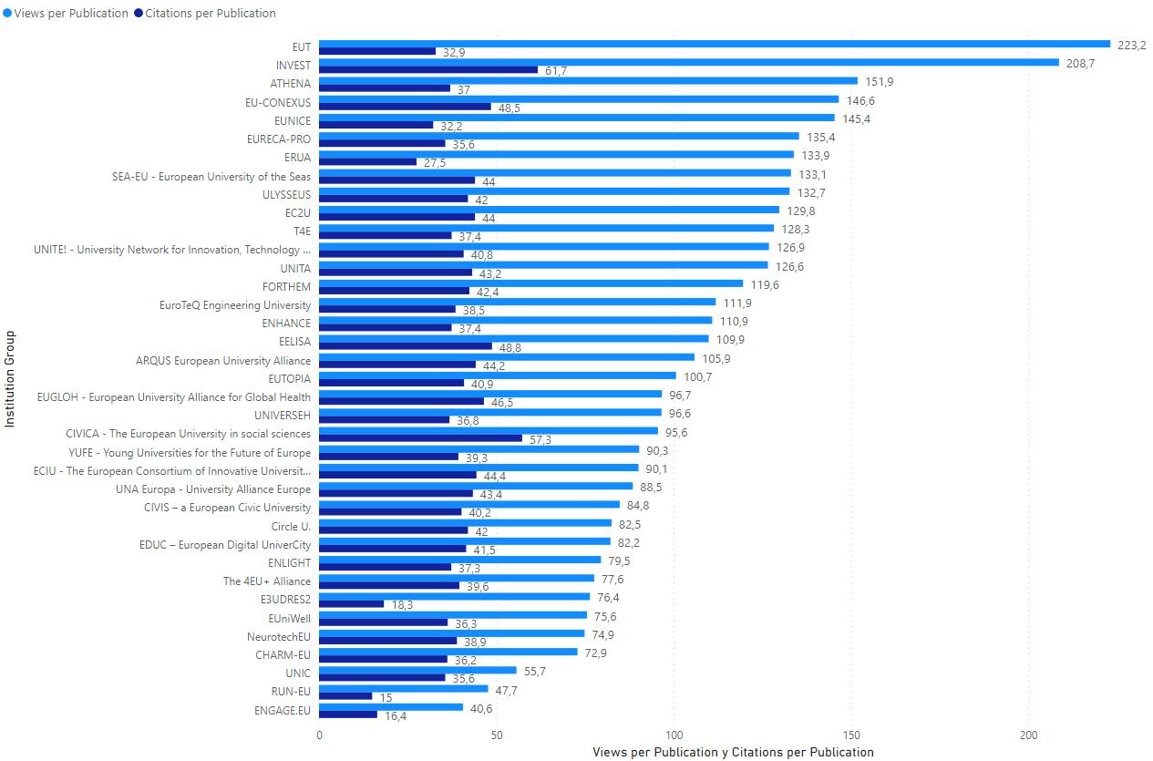
Fig 40 – Number of views and citations per publication in co-publications with other alliances
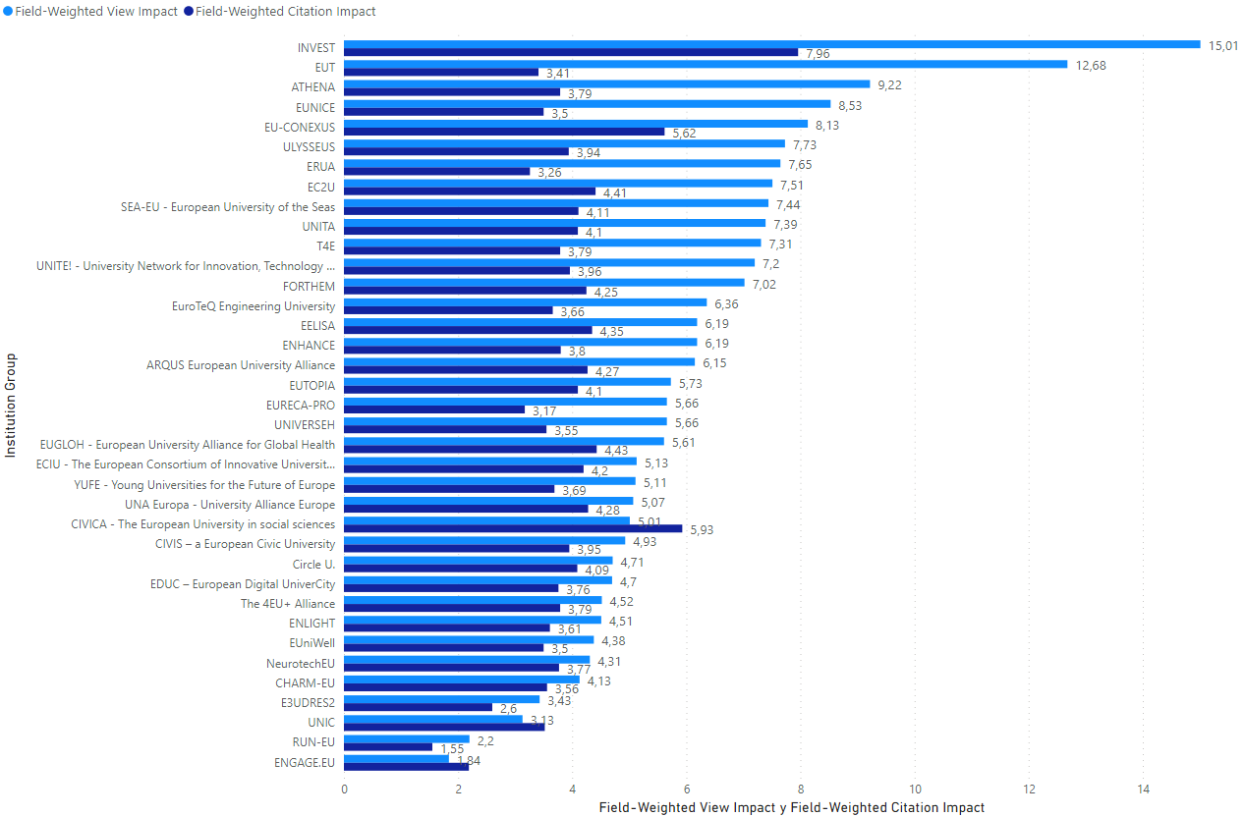
Fig 41 – Number of Field-Weighted View Impact and Field-Weighted Citation Impact in co-publications with other alliances

ANNEX 8. Details of the top 17 collaborating European Universities Alliances

DATA INFORMATION
data | All publication types in all subject areas from 2016 to 2021
source | SciVal® database, Elsevier B.V., http://www.scival.com (downloaded on june-2022)
download date | June 2022
data processing | Graphics provided by SciVal.
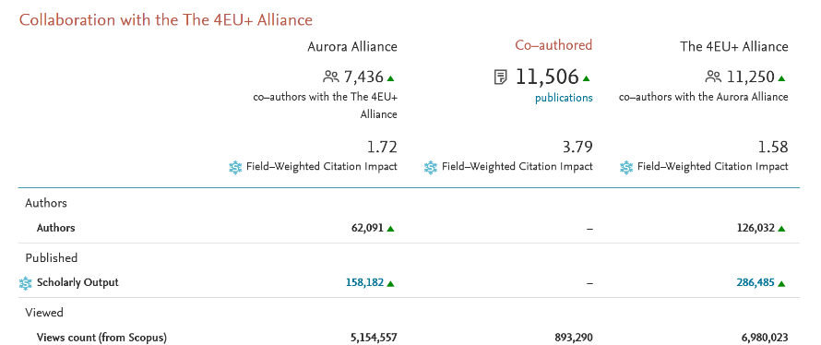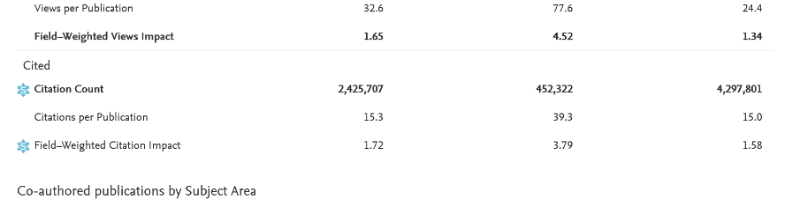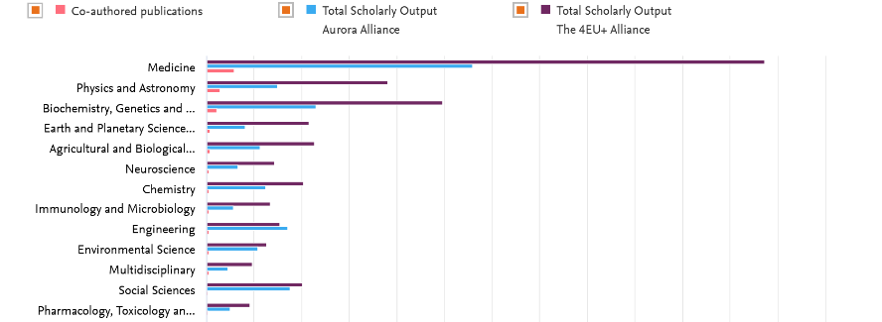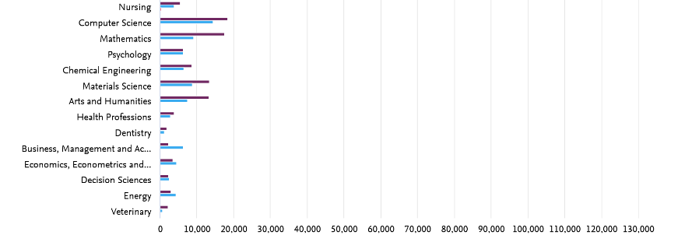
Fig 42 – Details of the collaboration between Aurora and 4EU+ Alliance
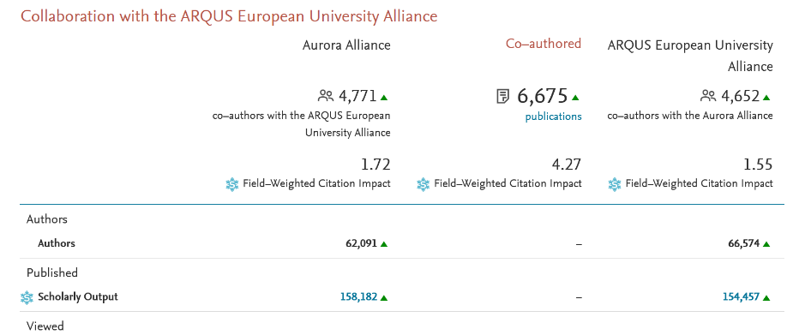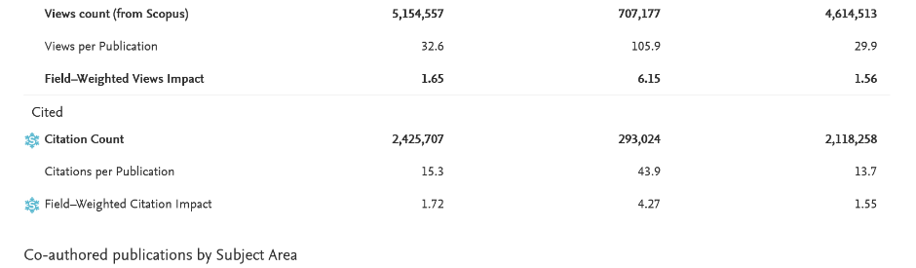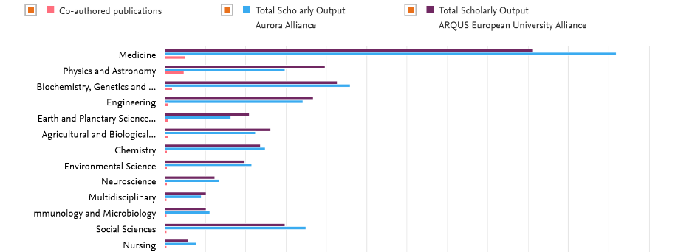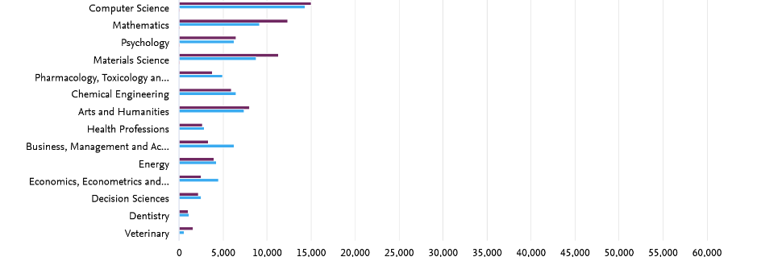
Fig 43 – Details of the collaboration between Aurora and ARQUS European University Alliance
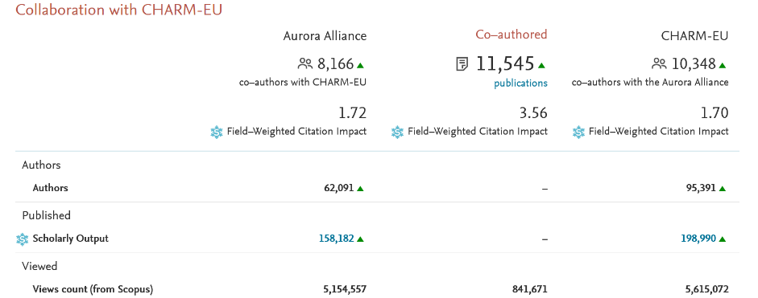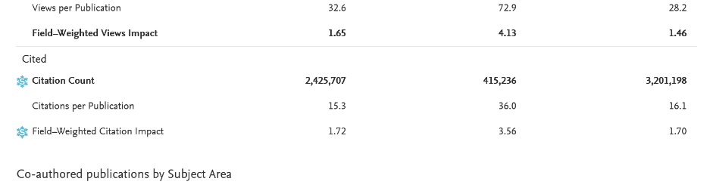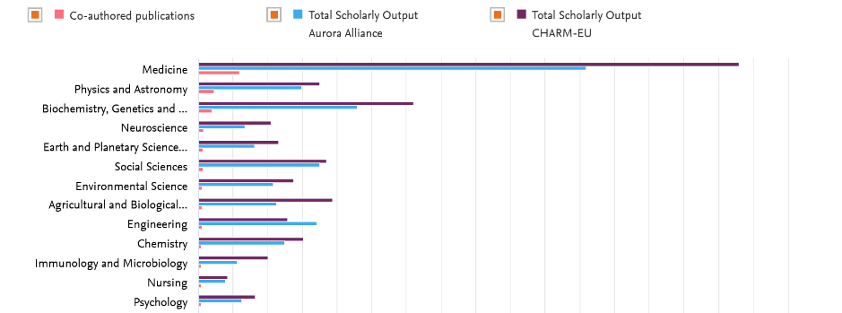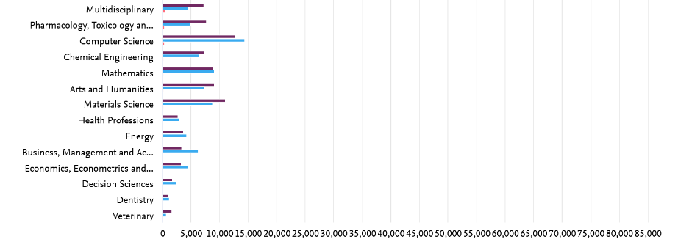
Fig 44 – Details of the collaboration between Aurora and CHARM-EU
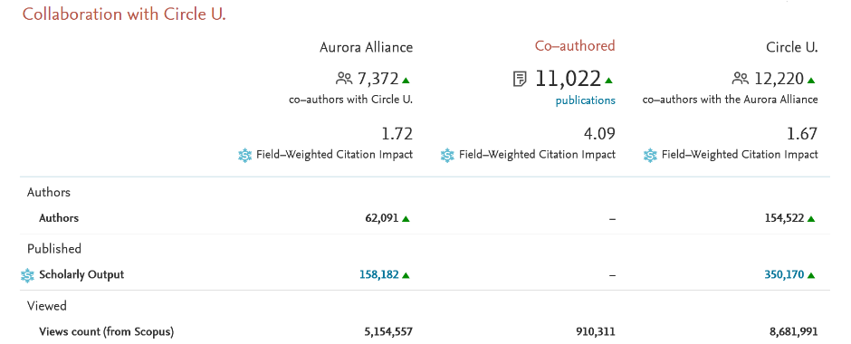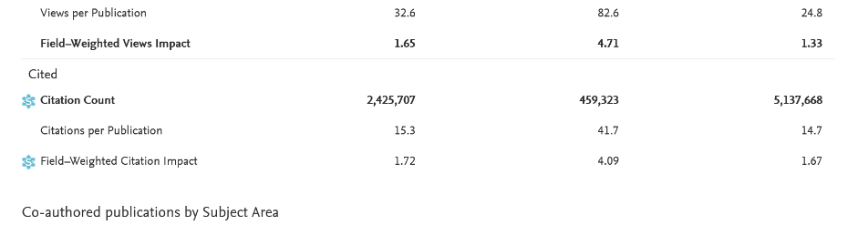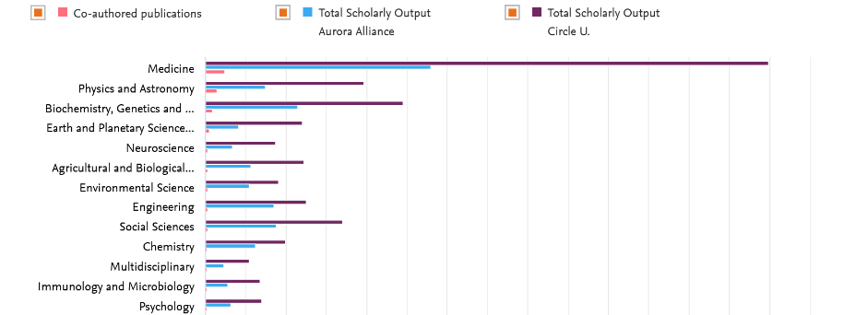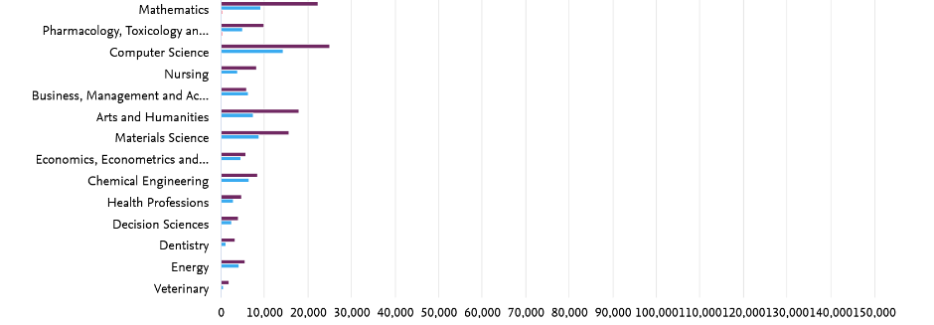
Fig 45 – Details of the collaboration between Aurora and Circle U.

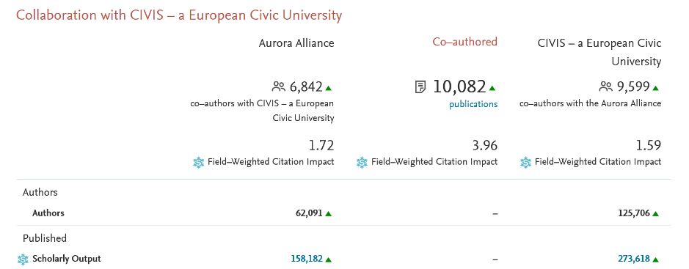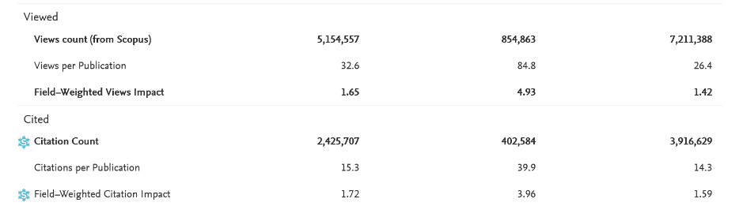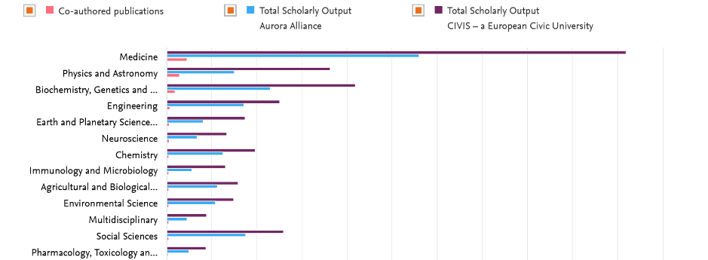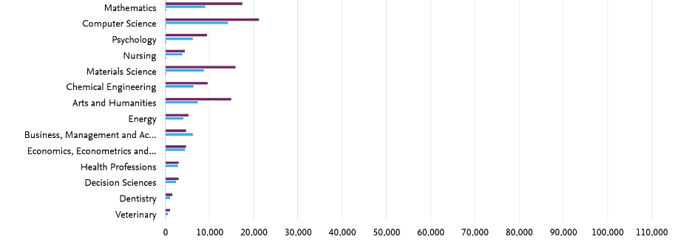
Fig 46 – Details of the collaboration between Aurora and CIVIS
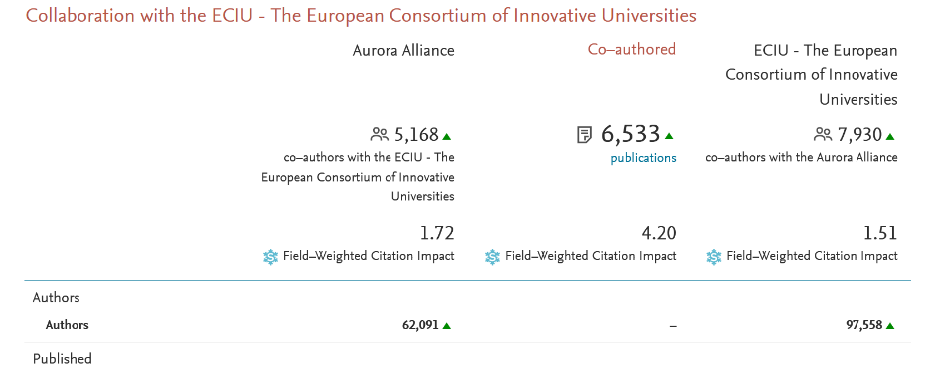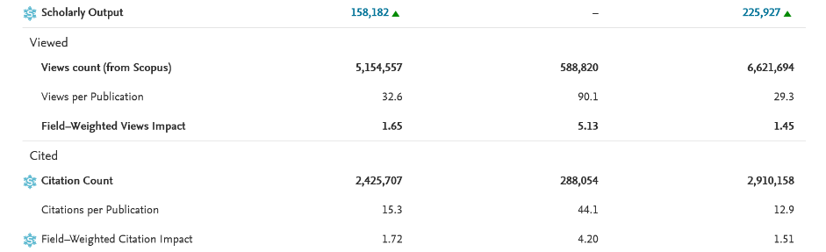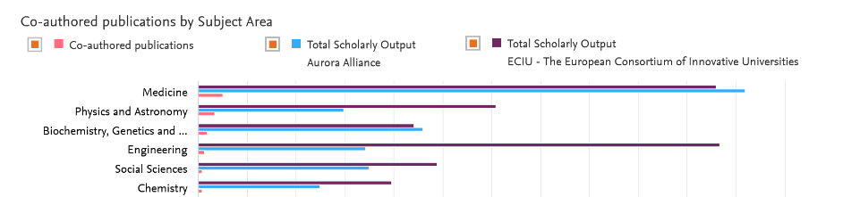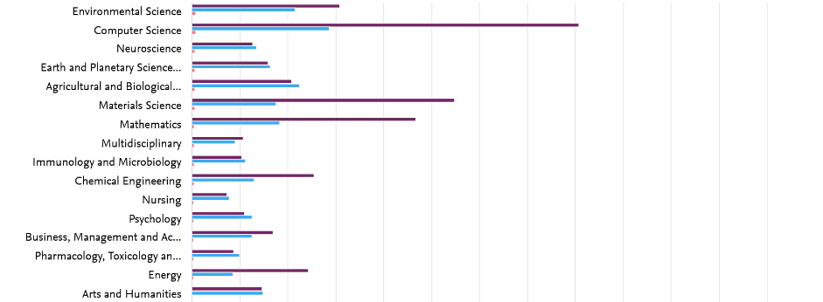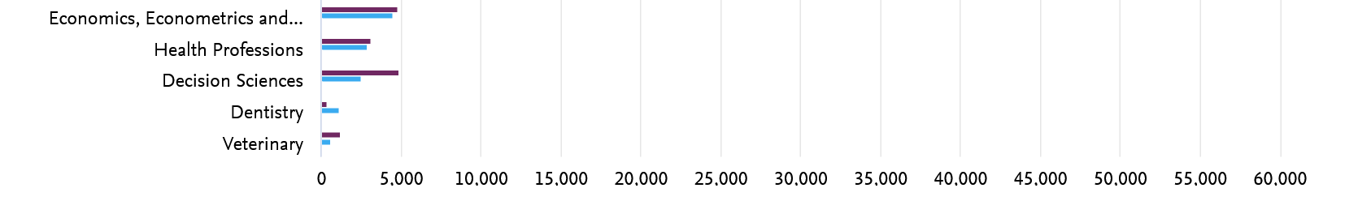
Fig 47 – Details of the collaboration between Aurora and ECIU
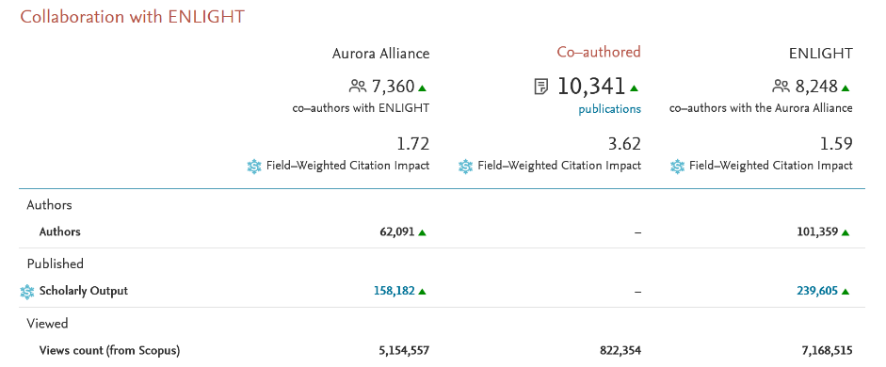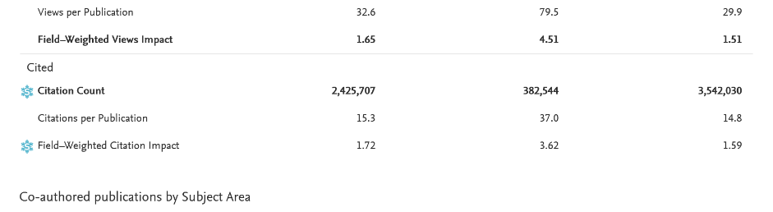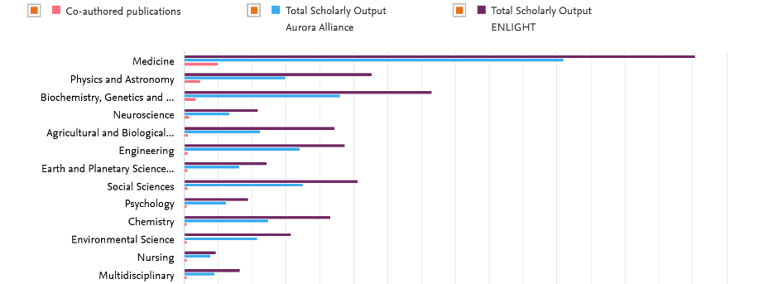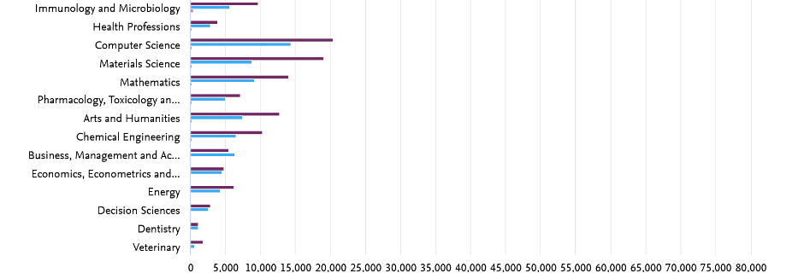
Fig 48 – Details of the collaboration between Aurora and ENLIGHT
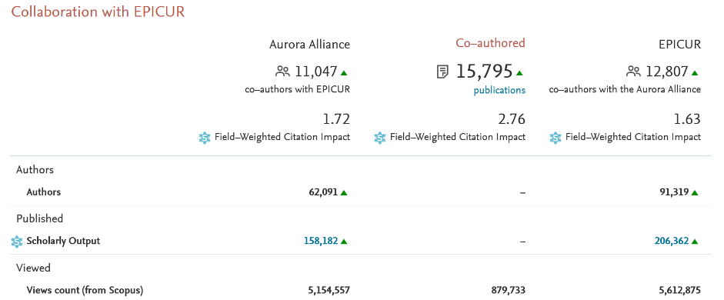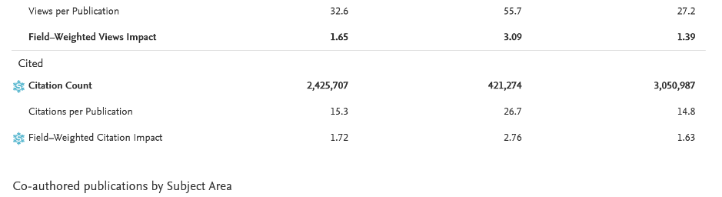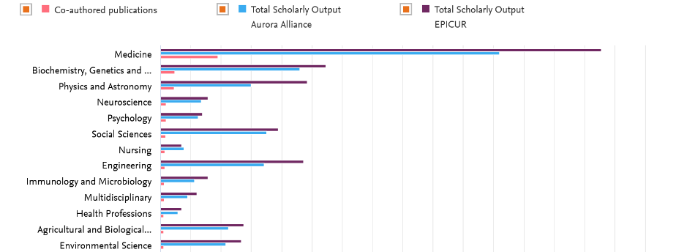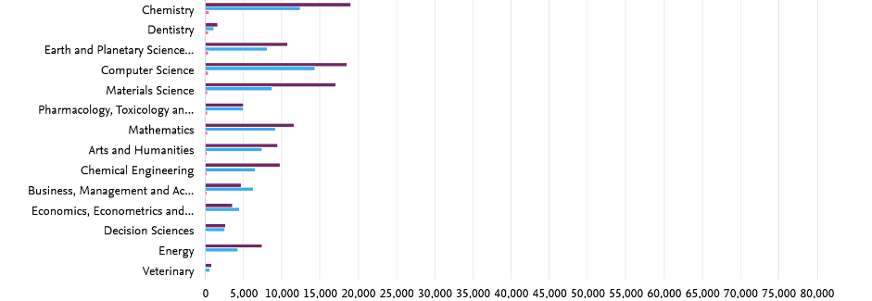
Fig 49 – Details of the collaboration between Aurora and EPICUR
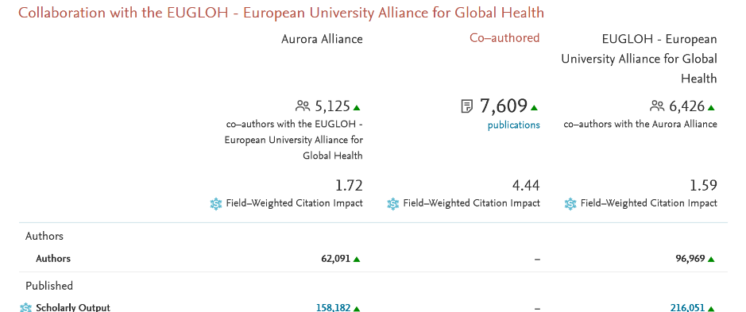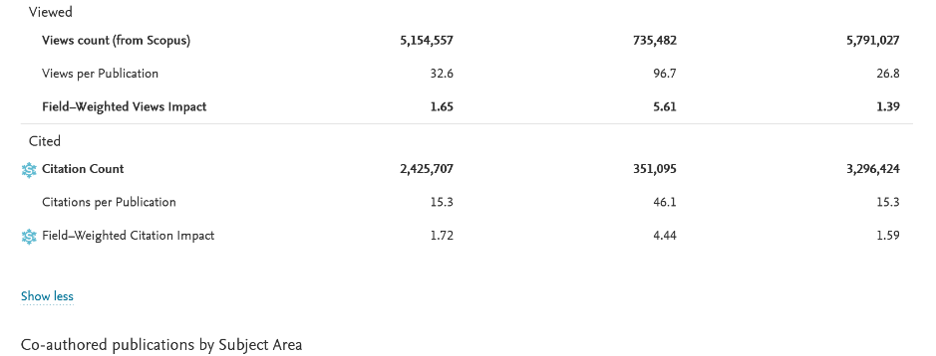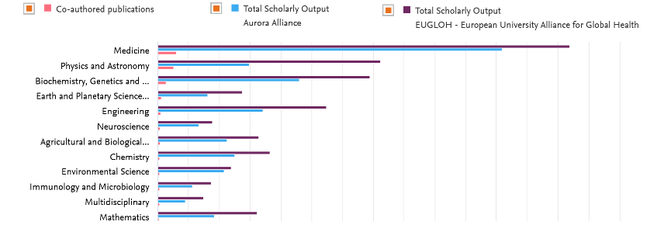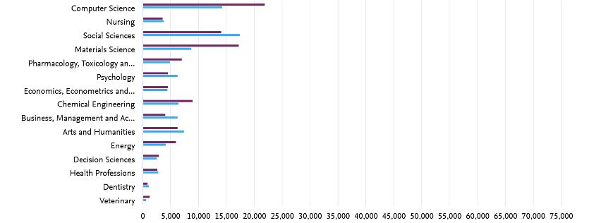
Fig 50 – Details of the collaboration between Aurora and EUGLOH
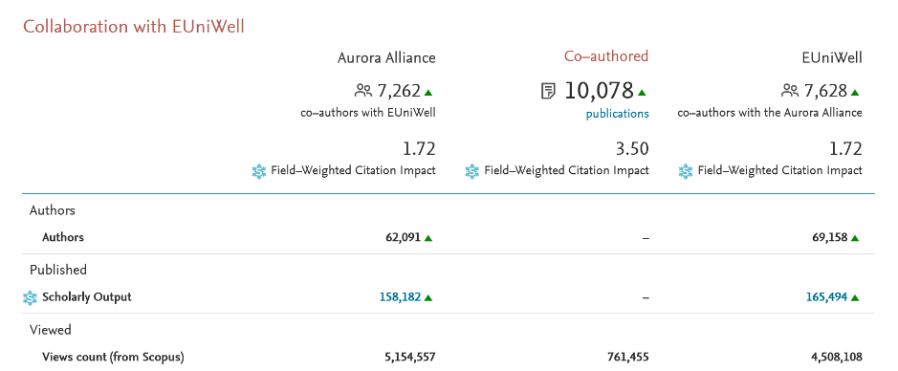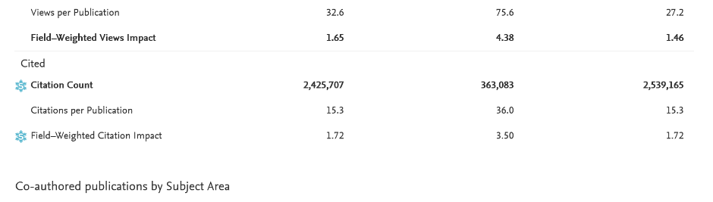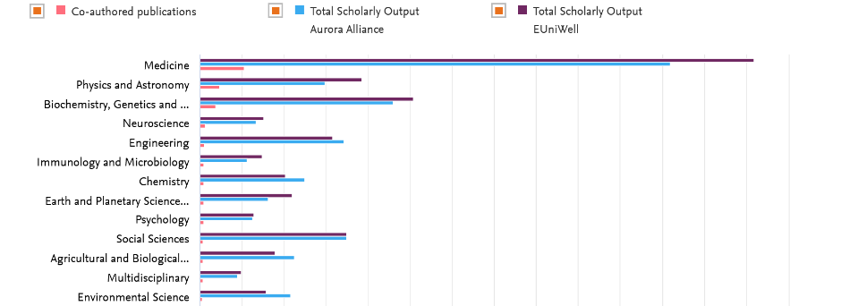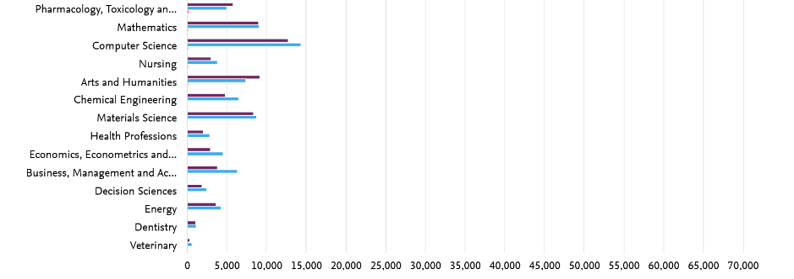
Fig 51 – Details of the collaboration between Aurora and EUniWell
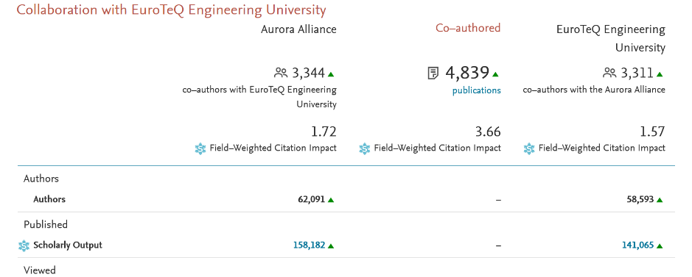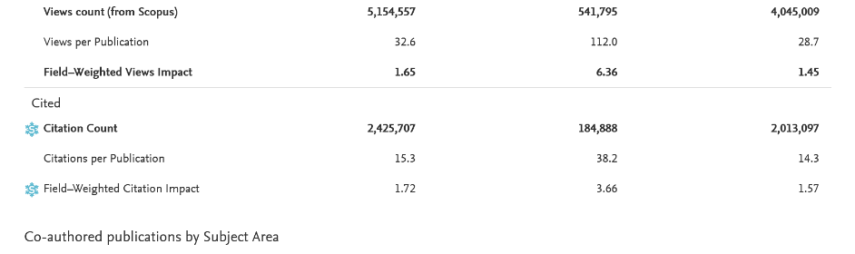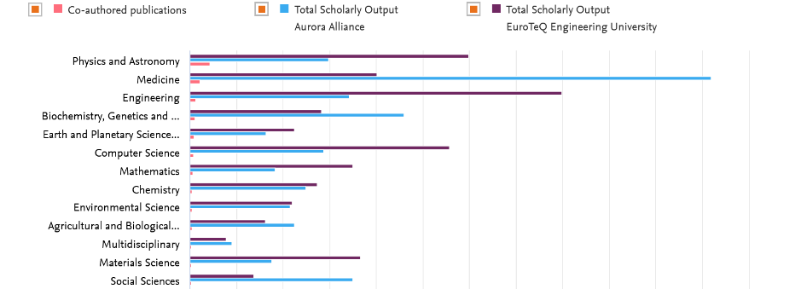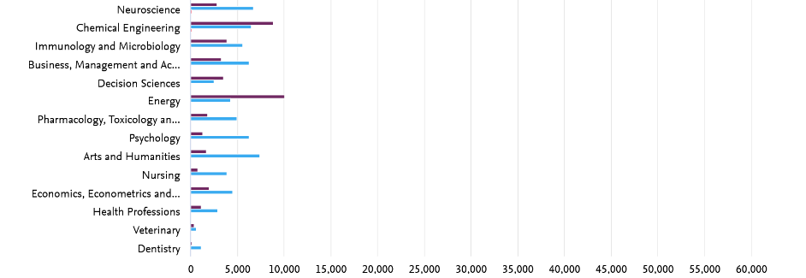
Fig 52 – Details of the collaboration between Aurora and EuroTeQ Engineering University
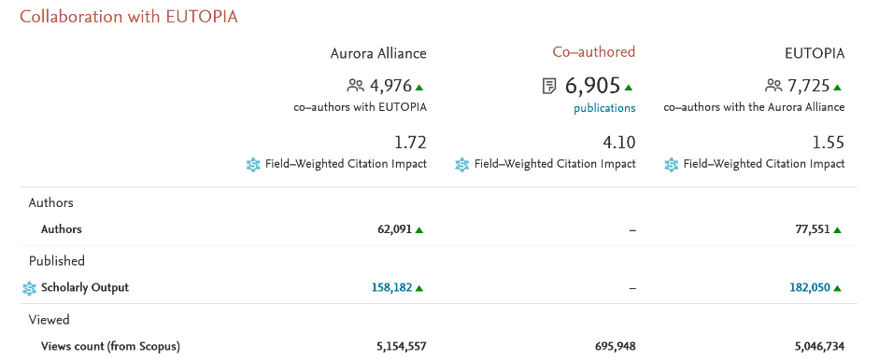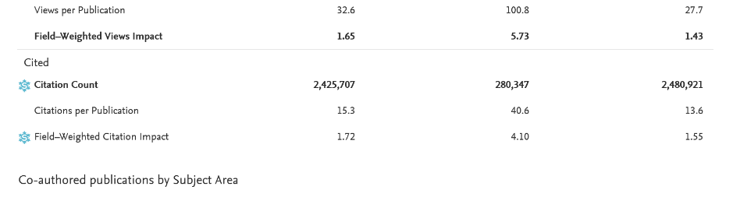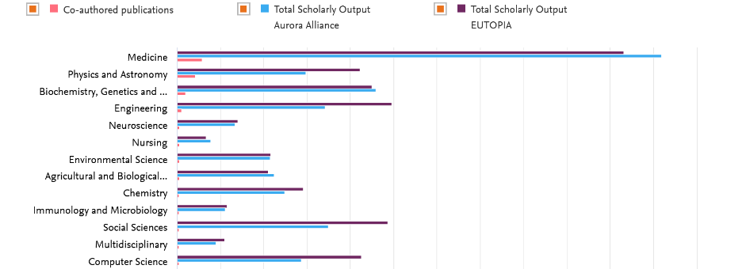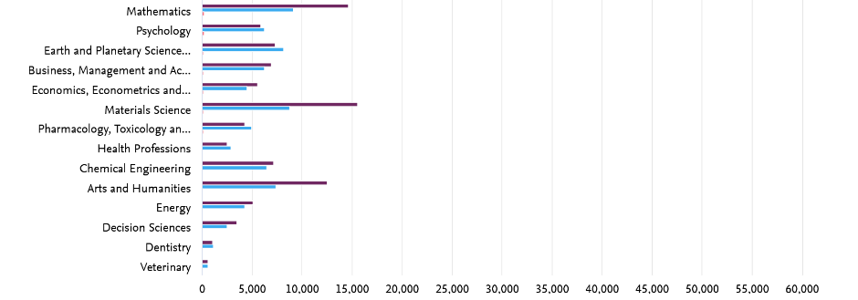
Fig 53 – Details of the collaboration between Aurora and EUTOPIA
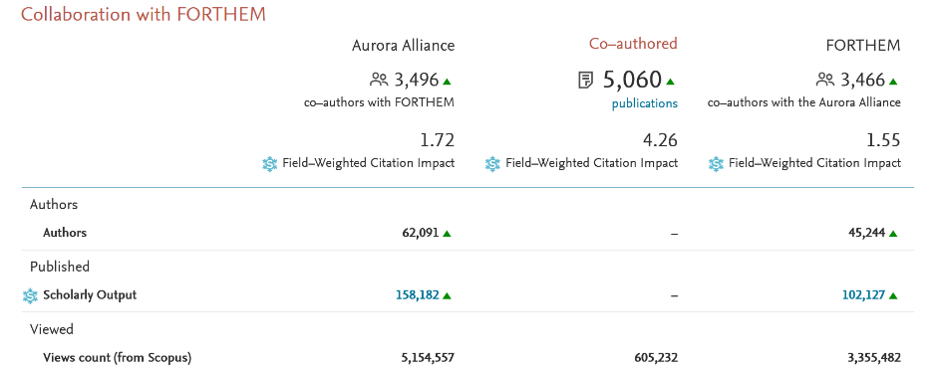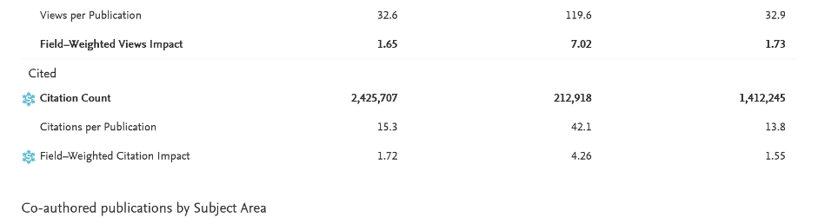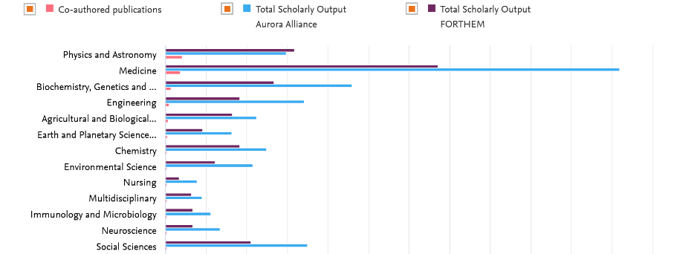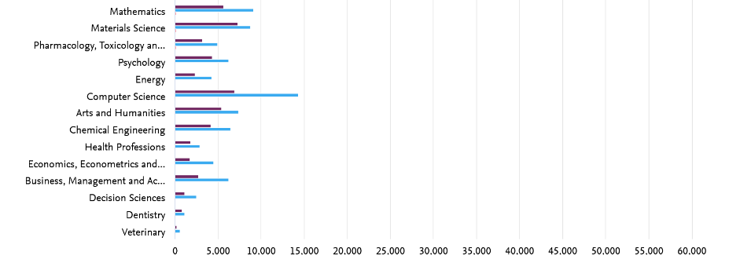
Fig 54 – Details of the collaboration between Aurora and FORTHEM
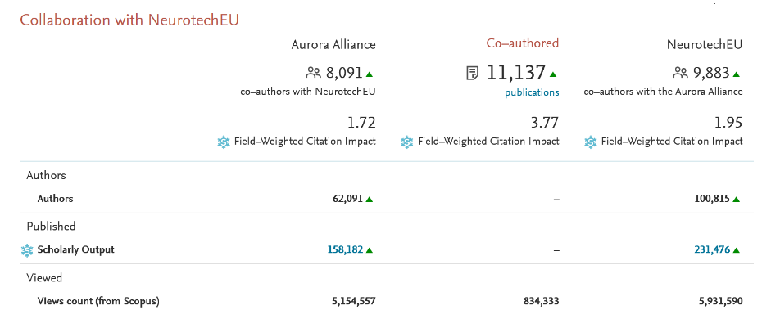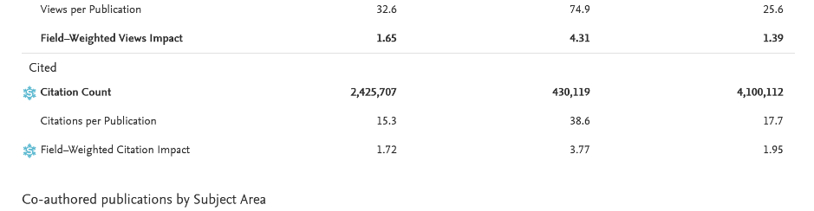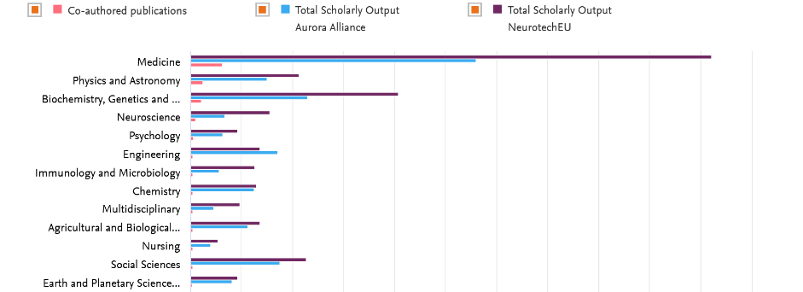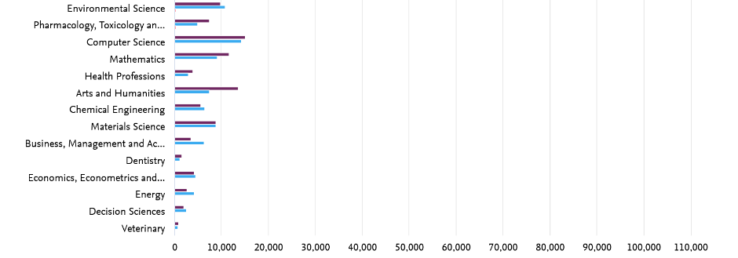
Fig 55 – Details of the collaboration between Aurora and NeurotechEU

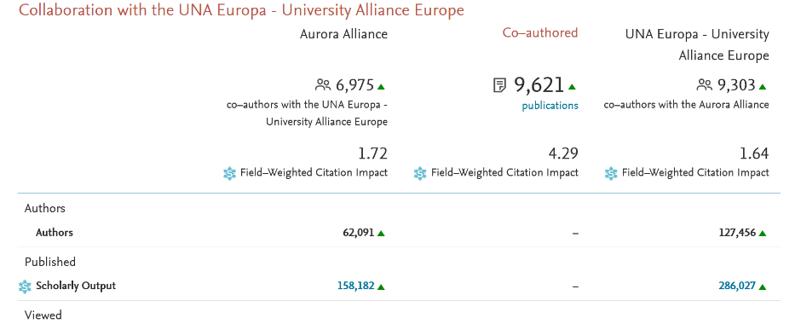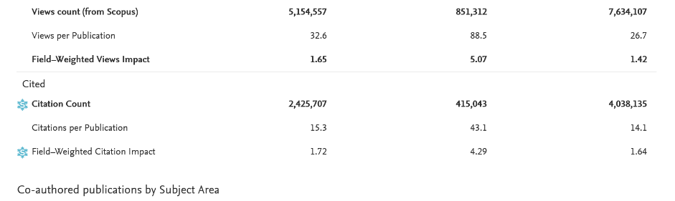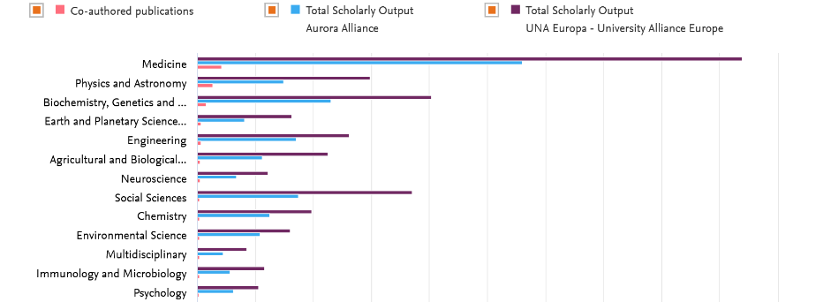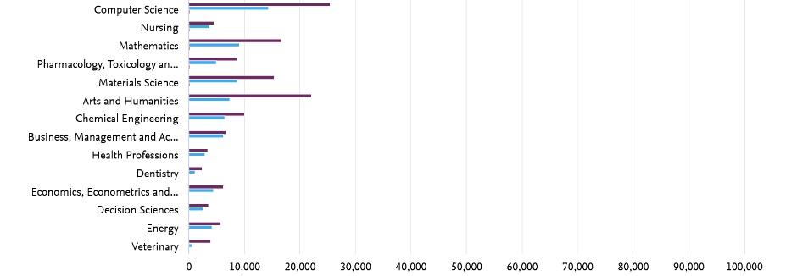
Fig 56 – Details of the collaboration between Aurora and UNA Europa
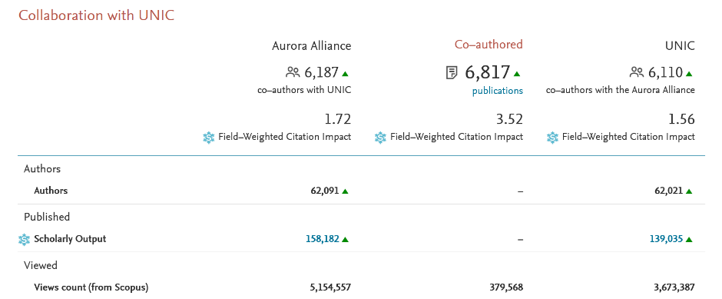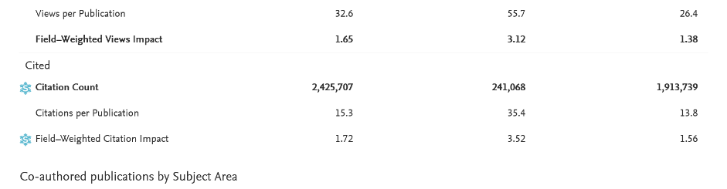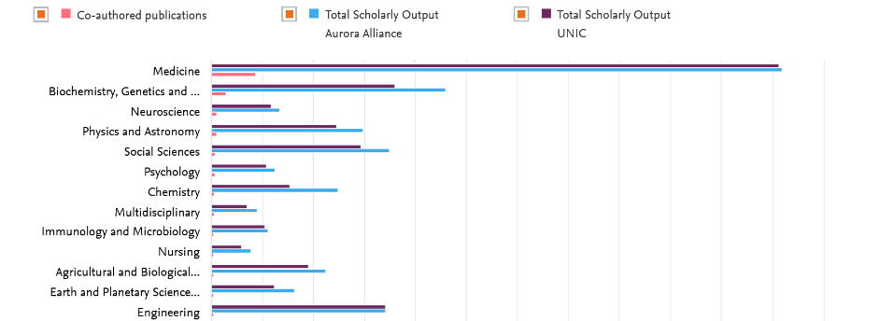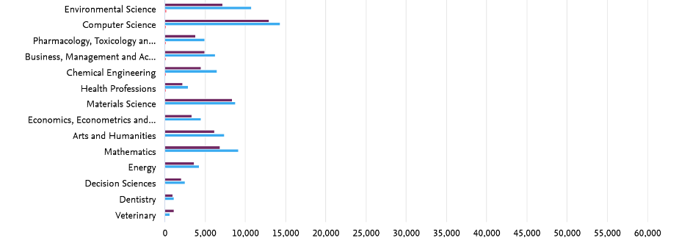
Fig 57 – Details of the collaboration between Aurora and UNIC
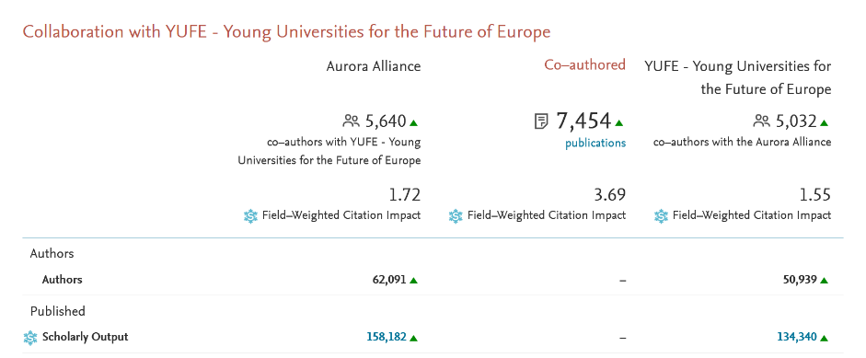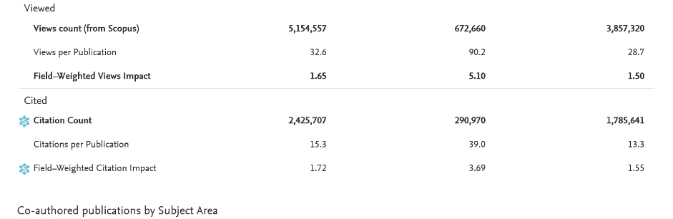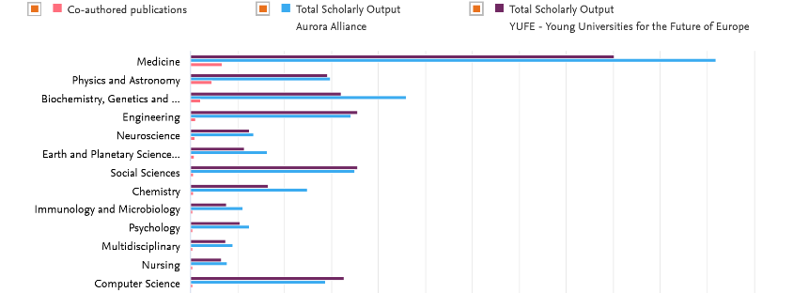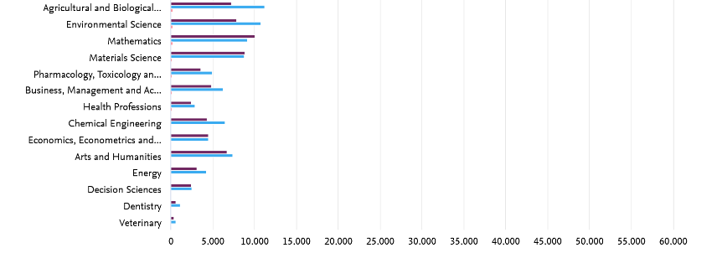
Fig 58 – Details of the collaboration between Aurora and YUFE

ANNEX 9. AURORA PUBLICATIONS BY DOMAINS

Domain 1 | SUSTAINABILITY AND CLIMATE CHANGE 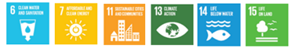
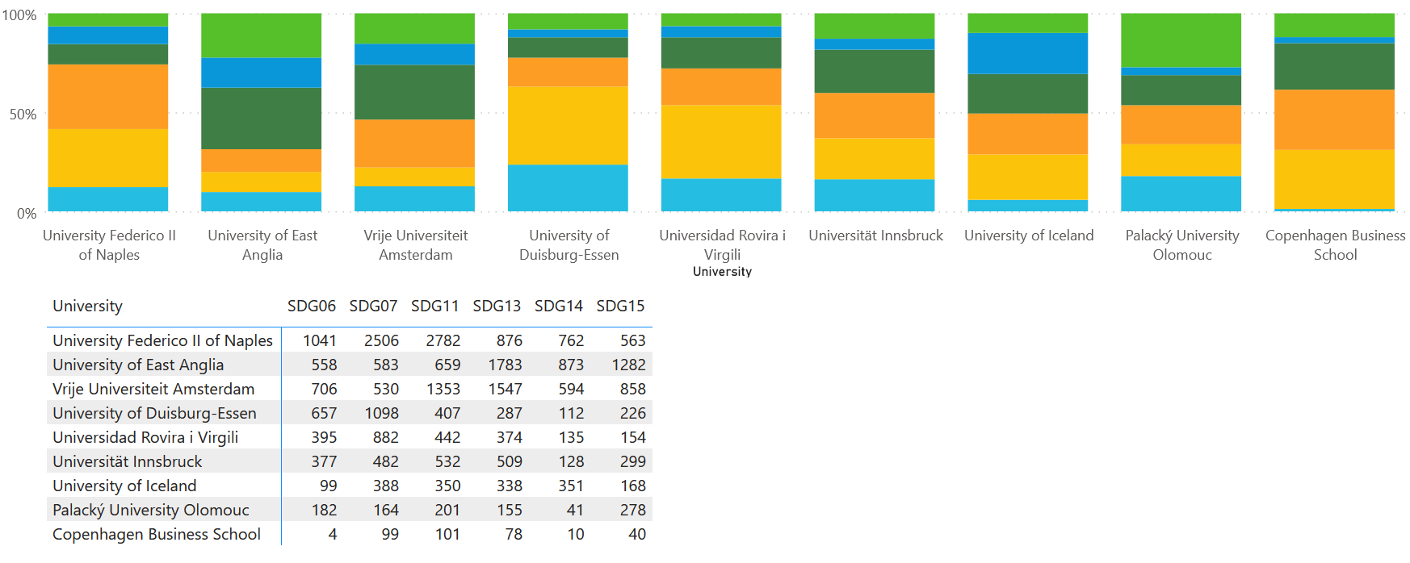

Domain 2 | DIGITAL SOCIETY & GLOBAL CITIZENSHIP 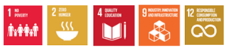
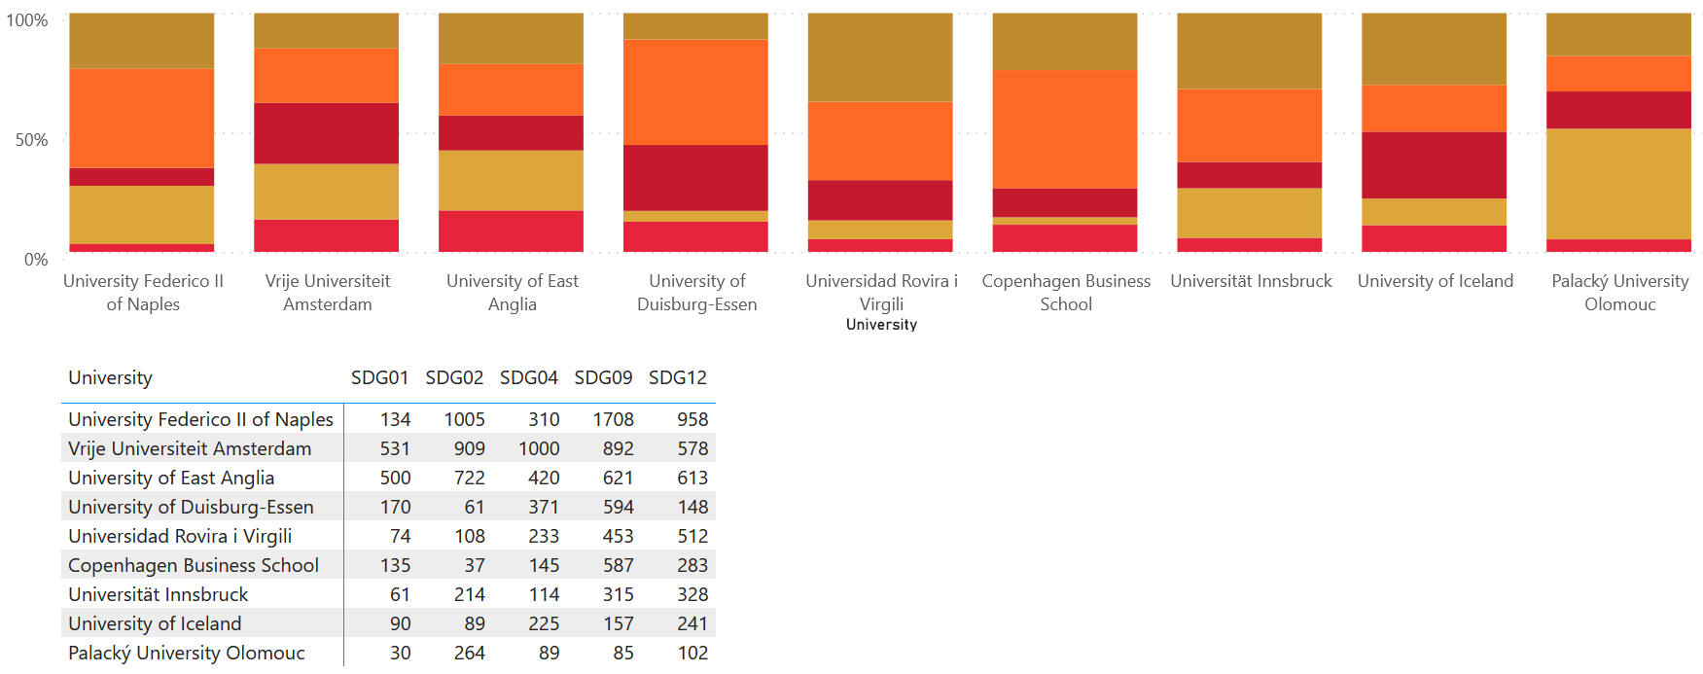

Domain 3 | HEALTH AND WELLBEING 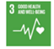
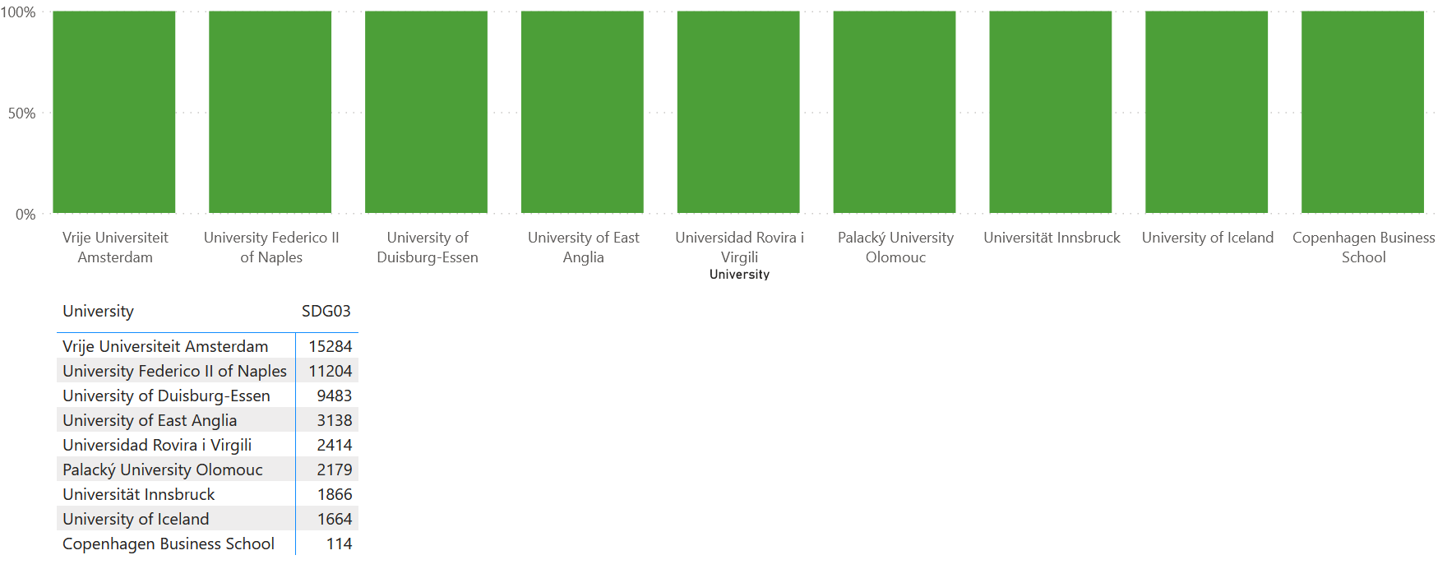

Domain 4 | CULTURE: DIVERSITY & IDENTITY 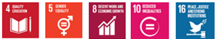
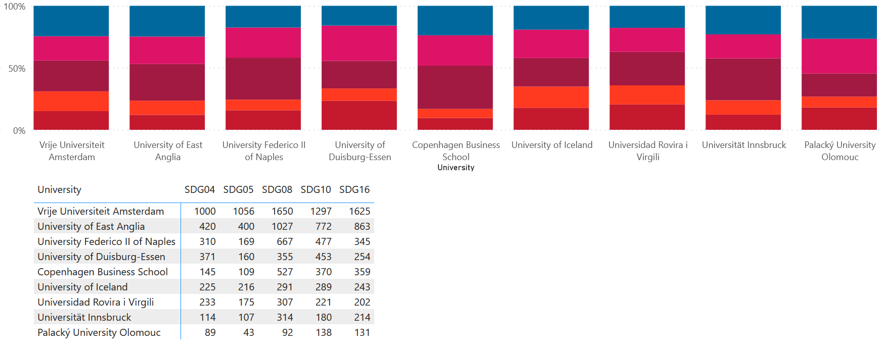

ANNEX 10. AURORA COLLABORATIONS BY DOMAINS

Domain 1 | SUSTAINABILITY AND CLIMATE CHANGE
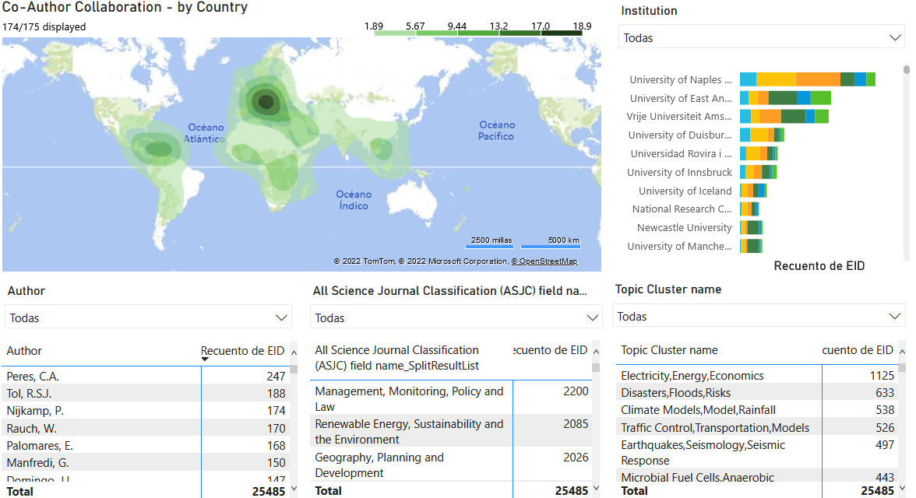
Fig 59 – Heat map and top authors, fields and topic cluster in Aurora collaborations by domain 1

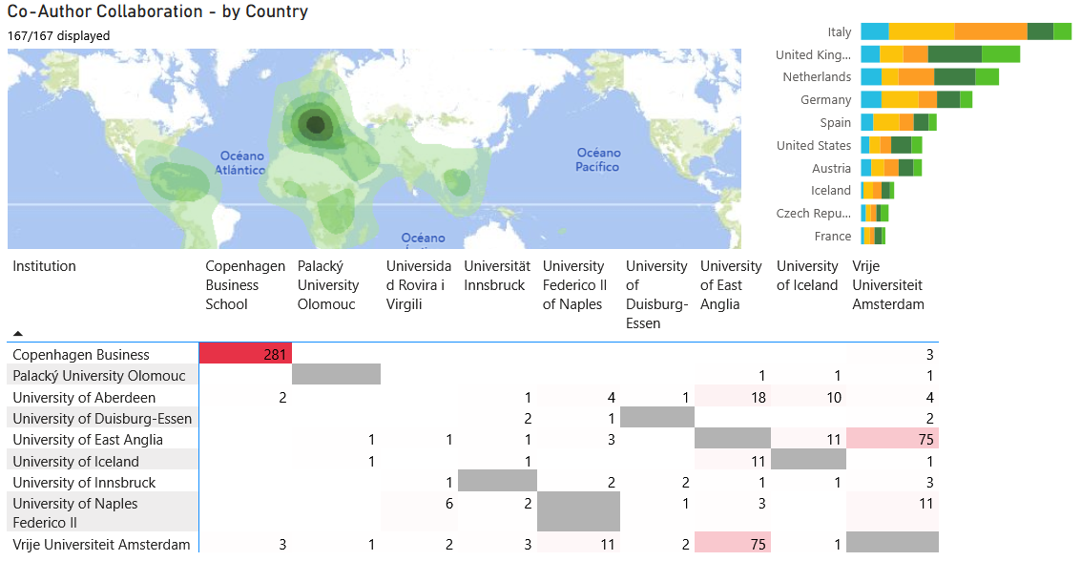
Fig 60 – Heat map and Aurora collaborations by domain 1

Domain 2 | DIGITAL SOCIETY & GLOBAL CITIZENSHIP
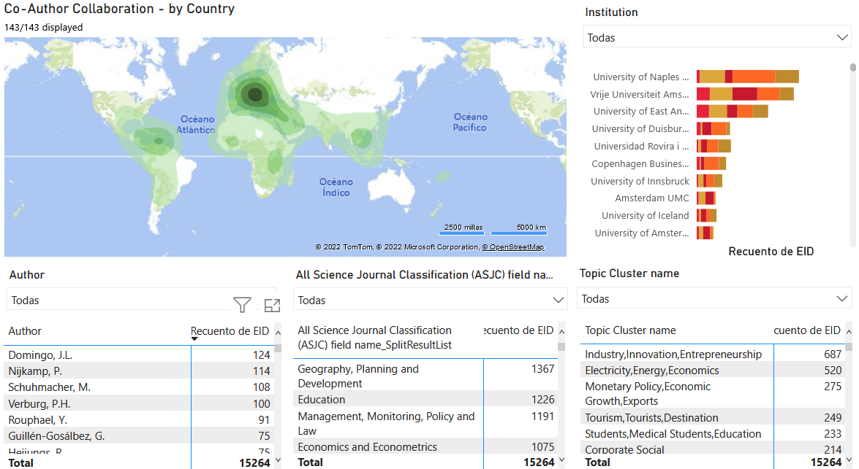
Fig 61 – Heat map and top authors, fields and topic cluster in Aurora collaborations by domain 2

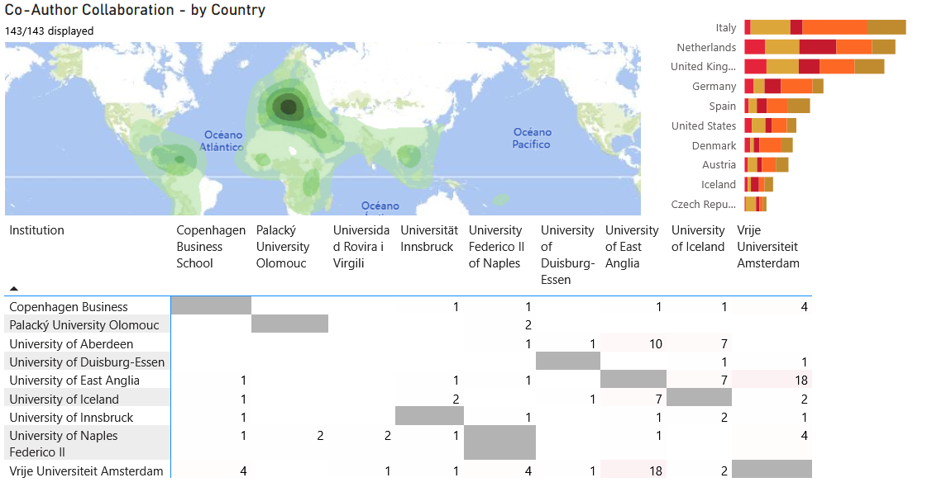
Fig 62 – Heat map and Aurora collaborations by domain 2

Domain 3 | HEALTH AND WELLBEING
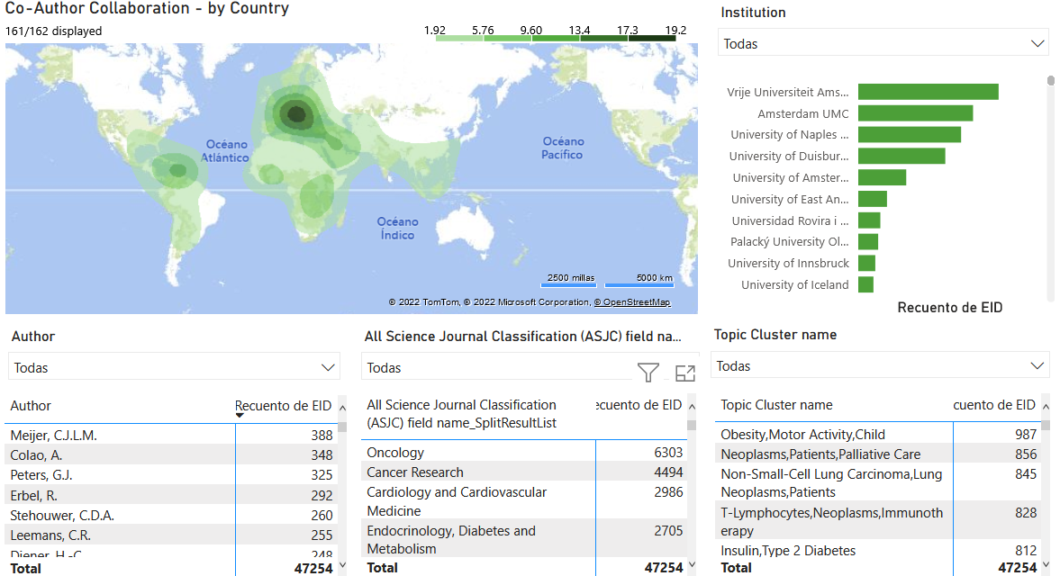
Fig 63 – Heat map and top authors, fields and topic cluster in Aurora collaborations by domain 3

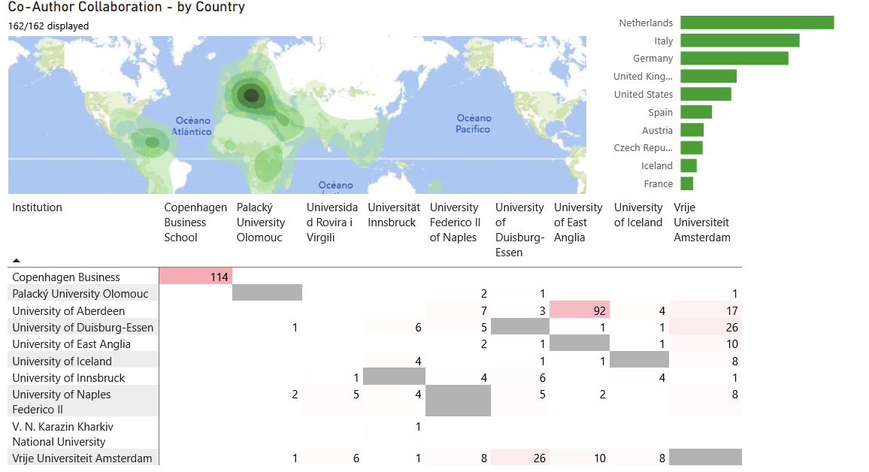
Fig 64 – Heat map and Aurora collaborations by domain 3

Domain 4 | CULTURE: DIVERSITY & IDENTITY
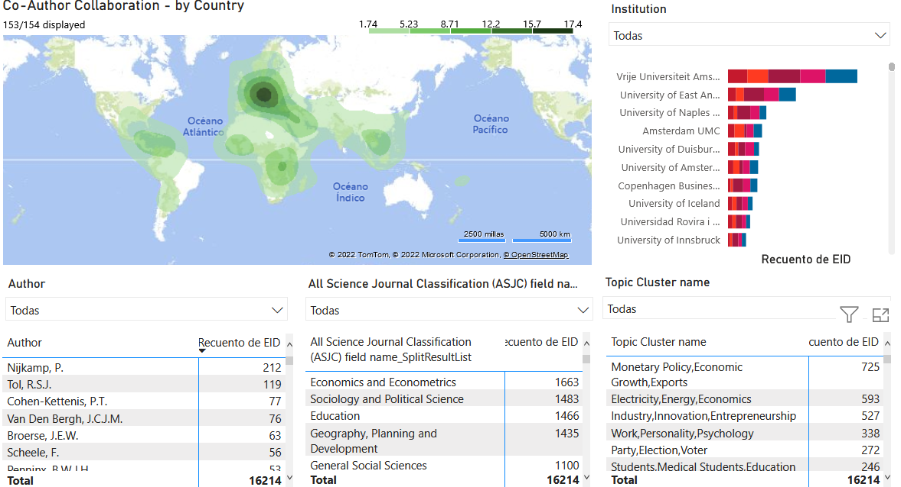
Fig 65 – Heat map and top authors, fields and topic cluster in Aurora collaborations by domain 4

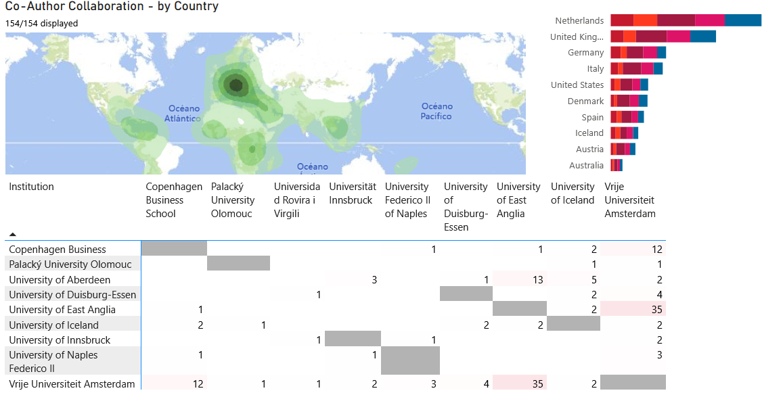
Fig 66 – Heat map and Aurora collaborations by domain 4

