Admissions to Undergraduate Programmes in the Aurora Alliance – Analysis and Recommendations
Deliverable 3.2.4

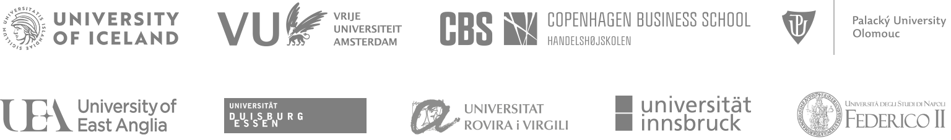

Policy statement
The Aurora Alliance is committed to developing fair, equitable and inclusive approaches to university admissions within the national policy context of each university.

Summary
This deliverable is focussed on how the Aurora Alliance can facilitate social transformation through improving admissions systems. To transform society, young people need to have access to high quality university level education that helps them qualify for the jobs of the future. In addition, as Europe emerges from the pandemic, people already in work may be reassessing their careers. Studies show that as the economy recovers from the pandemic, more skilled workers with more flexibility will be needed. In addition, fair access to quality education is a Sustainable Development Goal and a key aspect of social inclusion.
Inclusive admissions are a key feature of universities which are focussed on social transformation. Although national policy and practice impacts on the extent to which universities can recruit students from diverse communities, there are some steps which universities can take to make admissions more inclusive. These are set out in the recommendations.

Consultation
We have collected and analysed 6 admissions policies, and a short summary of the related issues emerged from the discussion.
- Universitat Duisburg-Essen - Germany
- University of East Anglia – United Kingdom
- Universitat Innsbruck - Austria
- Palakcky University in Olomouc - The Czech Republic
- Universitat Rovira I Virgili – Italy
- Vrije Universiteit Amsterdam – The Netherlands
The issues and related recommendations were further refined by a group of admissions experts from across the Alliance.

Strategic recommendations
- The Alliance should explore how working collectively on outreach would help build good practice and improve student outcomes
- All Aurora Alliance Universities should continue to build their own outreach programme
- The Social Transformation workstream should work with the Competence Framework workstream to enable a better understanding of the skills and understanding needed to a be a successful student and graduate. Where possible these can be used to underpin the pilots on developing alternative routes into higher education (see recommendations on deliverable 2 above)
- Link this work to the teaching competence framework and inclusive teaching and learning policies
- Explore how subject specific entrance requirements can be made inclusive
- Continue to develop awareness of national policy developments and learn from good practice in admissions from across Europe and beyond
- Seek to influence national policy on admissions

Discussion

There are 3 issues which impact on inclusive admissions; national policy, the student journey and qualifications.

The National Policy Context
National policy in each country underpins the admissions policy of each university and leads to a range of constraints on what each university might be able to do to promote diversity and inclusion in admissions. In some cases this is policy governing university admissions, but it is clear from our discussions that related educational policies also play a role in providing barriers to inclusion, include those that, in some countries, define educational routes for younger teenagers.

The student journey
As our societies diversity, the routes students take to universities also diversify. National Policy does not always keep up with this change. However across the Alliance, there are initiatives that support diverse student journeys into our universities. These initiatives are designed to help students who may have additional barriers to engaging in university education. Examples are set out below.

Qualifications
In all Alliance universities, students must meet academic standards for entry. However, there is increasing understanding that such standards may act as a barrier to students from non-traditional backgrounds and there are some pilots and initiatives underway to allow students with non-traditional qualifications to enter higher education. However, in some countries, for example Austria, examinations still dominate the admissions process. In the United Kingdom, however, while the admissions system is based on grades, may universities are developing an approach to admissions that contextualises prior academic achievement and seeks to identify potential rather than attainment as a measure of suitability for university study. Some countries, for example Spain and the Netherlands, are seeking new solutions to enable students without traditional qualifications to access university education. This could enable more equity for students from refugee backgrounds and students who have had disrupted academic journeys and may only be ready for university later in life.
As universities offer a wider range of courses (for example, Nursing and Health Sciences are now graduate occupations across Europe), universities should recognise the different admissions requirements for different subjects. However, some subjects remain exclusive, for example, access to medicine courses remains difficult.
An understanding of the inclusiveness of this approach would be useful to planning the next steps.

