An Aurora Education – Policy Statement
Deliverable 3.2.2

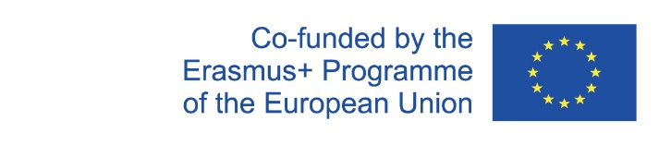

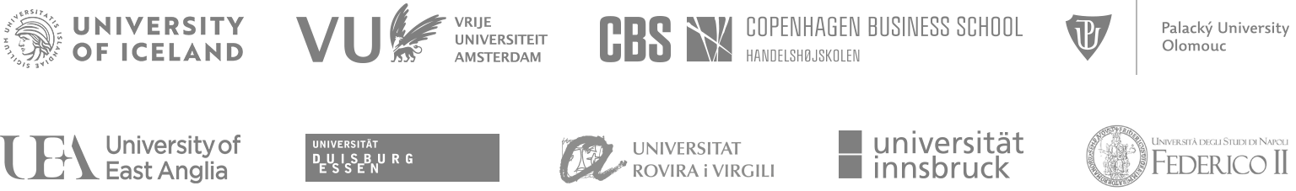

Policy statement – The Aurora Educational Vision

The main goal of Aurora is to support our teachers in equipping their students with the skills and mindset needed for our graduates to thrive in a rapidly changing society and labour market and to turn them into social entrepreneurs and innovators, willing and able to contribute to solving the major challenges of our societies.

To achieve this, Aurora will develop shared education principles and frameworks that enable deeper cooperation between Aurora universities. This includes, but is not limited to, an Aurora “inter-university campus” where students and staff can move between the universities, physically or virtually, to learn, teach, train, research, cooperate and facilitate the delivery of joint courses and degrees that support the Aurora vision.

This is crucial to maximise the positive societal impact of Aurora Universities and is fully aligned with emerging international higher education policies, as demonstrated for example by the 2020 joint declaration of the 49 Ministers responsible for higher education in the European Higher Education Area. This vision is also strongly supported by the Aurora Student Council and a core value of Aurora is to listen to our students and involve them in our work.

Summary

The above educational vision has been developed by the team working on teaching for societal impact in the Aurora Alliance. It is a high level statement of our strategic educational aims and underpins our educational deliverables.

